Thomas Jubb

MMA League Table (MMA companion)
Computer Science NEA

Contents
Post investigation objective amendments 2
Rough Decomposition Flowchart 0
Decomposition 1
Inputs, outputs and processes. 7
User Interface 22
Data structure 43
Methods of Access 0
Database design – ERD 0
Justification of ERD 0
Data Dictionary. 0
Validation 4
Algorithms 8

Post investigation objective amendments

Amendment | Objective | Justification
Adding a new objective | The users/admins will be able to navigate between all pages | The user has to be able to navigate between all of the pages so they can actually access everything the program has to offer. I also made this amendment because I want to add clarity on how my navigation works
Adding a new objective | The admin will be able to edit belts and events from a list using a small pop-up | With these two things, there isn’t enough data to add for me to justify having a whole page dedicated to them, but it is also quite tedious to allocate space on the existing pages to them, so I’m just going to have these pages pop up when the admin clicks on the fields
Adding a new objective | If there is a general exception or error, it will be displayed using a pop-up. | This is so if a user can refer the error to the admin if it’s a problem with servers, and the admin can figure out the problem in a technical sense.
Adding a new objective | The belt will be automatically allocated to the winner of the last declared title fight | This helps ease of use for the admin and decreases the chance of mistakes.
Rewording an objective | Rewording 10 (Upon first use, the system must prompt the user to make a profile so they can answer a short survey about what they find entertaining about an MMA fight. Using this, the system will be able to show how entertaining a fight is going to be to you based on what you like from the survey to just Upon first use, the system must prompt the user to make a profile so they can answer a short survey about what they find entertaining about an MMA fight. | This is because with the second sentence, objective 10 envelops 24 (The system will give each fighter a score according to the fighter’s info to determine how entertaining the user will find the fighter.)
Removing an objective | 22 (The system will take a survey from the user at the beginning and make a profile that says what they find entertaining and not) | Already covered by 10
Rewording an objective | 25 (When the admin makes an update on a table, the program will validate all the data, check for inconsistencies, check for data redundancies, check for statistical anomalies) to just (When the admin makes an update on a table, the program will check for statistical anomalies) | The part I took out is already covered by 14 (The system will validate inputs by rejecting duplicate data and incorrectly formatted records)
Removing an objective | 11. Users will also be able to vote on how entertaining a fight is going to be | I don’t really see it necessary to include this feature since the probability of users calculating the same fight and then voting enough times for the data to have any value to the user is very slim
Adding an objective | Admins will be able to jump to the leaderboard and back from the modification of the fighter list page | This is so the admins can see what the system will look like with their changes.
Rewording an objective | The system will give each fighter a score according to the fighter’s info to determine how entertaining the user will find the fighter. I am going to reword this as: When the user calculates fighter odds, the system will give the fight a score depending on how entertaining they will find it. | I think that the approval rating on the fighter page already is the user-influenced part of the page. I also want to separate the stats and more speculative things, so I think that putting the entertainment score with the odds calculation is a better idea.

Rough Decomposition Flowchart
This diagram I made is a rough vision I made early on in my design to help him home in on what I'm going to do for this project. It shows how the user navigates through the system's processes for each page, which isn’t as decomposed (or directly faithful to the objectives) as the subproblems. When it has a box with two lines on either side, it means that the user is navigating to another page (Except on A, because that shows the program’s navigation in general). When the box is whole, it means that it’s a process. The pages marked in red are Admin-only pages, meaning that only admin accounts can access these pages. (You may need to zoom in a bit, sorry.) The design isn’t too faithful to this, but I think it’s necessary to show this to see the source of some of my ideas.
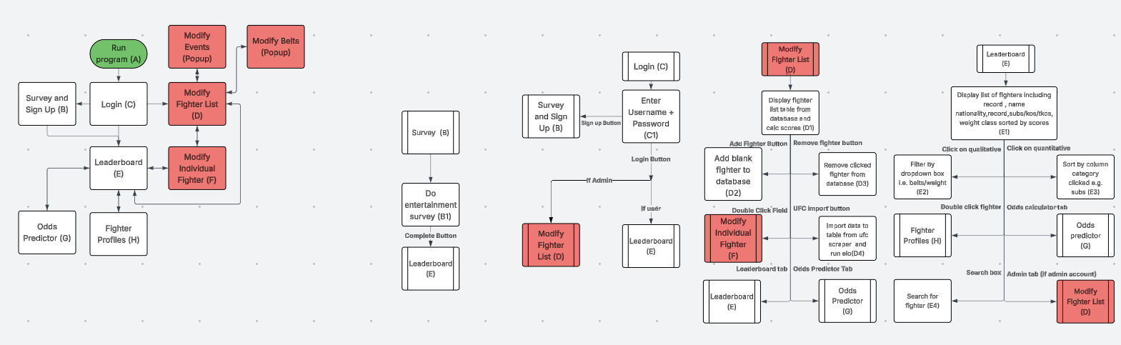
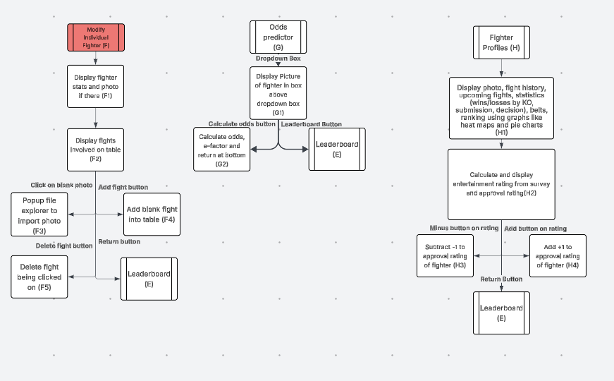

Decomposition
Sub-Problem | Justification |  | Ref
Objective 1:The system will generate ELO scores for every fighter inputted by a system admin using the Glicko 2 model and output a ranked leaderboard (the ELO stuff will be done when the admin updates the table)
Do a search of all the fights in the database, ordered from oldest to newest | I can calculate the ELO changes chronologically |  | 1.1
Start with the oldest fight, get fighter A’s ELO rating and put it into a variable | I can calculate fighter B’s ELO despite fighter A changing |  | 1.2
Convert Fighter A and B’s ELO and Rating Deviation to the Glicko-2 scale | Storing the fighter’s scores in a regular scale makes observation and testing easier and also works better with the odds calculation model. |  | 1.3
Update Rating Deviation based on inactivity | If a fighter is inactive, the system will be a little more sceptical about how they’re going to do when they come back. |  | 1.4
Calculate the impact of the fight | If a fighter has a more uncertain rating deviation, i.e. they are inconsistent, then the model will value winning against them less |  | 1.5
Calculate the expected score of the fight | Rating changes will be relative to how you’re expected to do, i.e. if you do better than expected, then you will get a better rating change. |  | 1.6
Calculate the variance of the fight | The variance affects the fight rating by figuring out how informative a fight is about the fighter’s skill from consistency, past opponents, etc |  | 1.7
Figure out the rating improvement from the fight | The rating improvement figures out how a fighter's rating should change relative to what was expected of them |  | 1.8
Figure out the volatility of ratings | Determines the stability of the rating changes |  | 1.9
Update rating deviation | New update to certainty |  | 1.10
Update main rating | New ELO ratings that reflect the fighter’s skill after the fight |  | 1.11
Reconvert RD and score into normal scales from Glicko’s scale | Same reason as 2 |  | 1.12
Repeat in reverse | This is to handle the changes on the other side |  | 1.13
Repeat for the next oldest fight | Moving on to the next fight |  | 1.14
Display table to User/Admin sorted by external ELO score | Sorting by ranking immediately shows the result of the Glicko algorithm, which is the core component of the hierarchy |  | 1.15
The leaderboard will display the fighter's name, rank number, record, win/loss streak, weight class and methods of winning (number of subs/decisions/kos). (Whenever I refer to displaying the table, this is the general process.)
Connect to the database | This is to I can interact with the SQL database |  | 2.1
Execute a search query of the fighter list (or if we’re doing something else, we do that table), excluding stuff that isn’t necessary for the user to see, such as photo data and ranking data, ordered by whatever order is needed | This brings up all the stuff we’re going to display |  | 2.2
Clear the table we’re inserting into | This is to get rid of whatever was there before; if we don’t, we may risk mixing old stuff and new stuff. |  | 2.3
Iterate through rows and insert each row into the SQL table | This is to display the table to the user properly |  | 2.4
The table will be sortable by all displayed factors, as well as weight class, nationality, and the belts they’ve held
On the user clicking the top bit of their table, sort them by the factor they clicked if it’s quantitative. If they click it again, sort it the other way round | Sorting the info by a factor allows the users to see the table by who has the most of whatever factor they want to look at |  | 3.1
On the user clicking a qualitative top bit of the table, do an SQL selection of all the possible qualitative parts of the table, put them all in a dropdown box and then do an SQL selection of all fighters who have that factor. | This allows the users to see all fighters with the qualitative factor they want to see. |  | 3.2
On the user and admin side, you will be able to search for a fighter's name using a Levenshtein (edit based) distance system.
Find all fighter names after the user presses the search button (if it’s blank, deny search) | This brings up all the fighter names so the system can process the closest matches to the search term. The algorithm can deny the search if it's blank because nobody has a blank name. |  | 4.1
Take the first fighter’s name and create a 2d matrix list based on the fighter name and the search term | This is so we can go through each variation of the search, so that we can see what cost to the edit amount each variation has |  | 4.2
Go cell to cell, finding the least amount of edits needed for each part of the string | This makes it so that the further we go, the closer to the minimum the edits needed will be |  | 4.3
Take the minimum amount of edits (bottom right if you visualise the list like a matrix) and put that minimum edit distance into a list with the fighter’s ID | We are saving the minimum edit distance for later, so we can order it by the smallest edit distance first for the user. |  | 4.4
Repeat these steps for each fighter | This gives us all the Levenshtein distances to the search term |  | 4.5
Quicksort the minimum edit distance list in ascending order | This is because we’re going to display the list by the smallest edit distance first to the user |  | 4.6
Redisplay the fighter list to the user/admin, ordered by the minimum edit distance list | The system will output a list ordered by how close to the search term each fighter's name is, which is what the user wants |  | 4.7
5. On the user and admin side, you will be able to click on a fighter’s row and then see their profile come up
On double click, switch page to the fighter page | This is to show the user the page of the fighter. |  | 5.1
6. The fighter profile will feature a photo of the fighter, their past fight history, win streak, upcoming fights, statistics (wins/losses by KO, submission, decision) and belts
Find the picture of the fighter from the fighter variable and put it onto a widget using a URL | This is to show a photo of the fighter to put a face to the name of the fighters |  | 6.1
Find and display fights where the fighter we’re looking at has fought. | This is to show the user the fighter’s past opponents to contextualise the skill of a fighter they don’t know to other fighters. |  | 6.2
Calculate and display the fighter's win/loss streak | This shows the user what’s at stake if the fighter fights, i.e. they lose their win/loss streak |  | 6.3
Calculate total wins/losses/draws and their individual totals (i.e. total KO losses, total sub wins, etc.) and display in a table | This shows the user what to expect in a fighter's fight (i.e. to expect a submission from the fighter if they are a submission artist) |  | 6.4
Calculate the percentage win rate and percentage finish rate for the user | Same reason as the previous sub-problem (to show what to expect) |  | 6.5
Find belts held by the fighter and display them to the user | You want to show what belts someone has to see what's on the line when they fight. |  | 6.6
The fighter profile will also show a pie chart that shows wins to losses and then decomposes to subs/kos/decisions to help users visualise the info.
Find fight data and calculate total wins and methods of winning, losses and methods of losing | This is so we can put all the data inside the pie chart. |  | 7.1
Create a pie chart for the widget | Like the objective says, this is to allow the user to visualise all the info |  | 7.2
The fighter profile will also show a table that lists the wins that the fighter has against the people who are currently ranked in the top 10 of their division.
Calculate the 10th fighter of the fighter we’re looking at’s division’s score. | This is so we can look at all the ones who have a score equal to or greater than the 10th best fighter (the top 10) |  | 8.1
Find all fighters with ELO equal to or greater than the ELO of the 10th best fighter in the division, and put that result into a table | This is to show the user the more “notable” fights a fighter has had. Also, the user is way more likely to recognise the higher-ranked fighters. |  | 8.2
The system must take an input of two fighters and give the odds of either of them winning by putting the ELO score they have through the Bradley-Terry model.
Display all fighters (only ones in the weight of the other fighter if another fighter has been selected in the other box) in a drop-down box, sorted alphabetically | This makes it all compact for the user, but ordered so they don’t have to search too much |  | 9.1
When the user clicks calculate, calculate the odds of the fight using a logarithmic Bradley-Terry model | The reason why I used a logarithmic version is that a logarithmic adaptation of the Bradley-Terry model works way with the Glicko ratings we have. |  | 9.2
Display odds in a percentage, depending on who has the dominant rating | This is to display the odds calculation of the fighters to give users an idea of how individual fights will go |  | 9.3
Upon first use, the system must prompt the user to make a profile so they can answer a short survey about what they find entertaining about an MMA fight.
When the user signs up, the system checks for a duplicate username and then will hash and salt their password and store it along with their username | This is to keep everything as secure as possible. I know the information being stored isn’t too sensitive, but people reuse their passwords, so passwords are sensitive information. |  | 10.1
The user will be able to log in again using their username and password. | This is so users can access their approvals and entertainment data again. |  | 10.2
When the user logs in, if everything is valid, the session will be connected to the user by a variable. | This is so the session can figure out what user is using it. |  | 10.3
If the user has an admin account, the session will be an “admin” session (declared by a variable), meaning that they will be able to access admin tabs. | This is so the admin can use their admin tools during their session |  | 10.4
When the user clicks submit on the survey (what they like out of 5 stars), put the 5-star score into another scale and store it in the user’s records | This is so we can use bad opinions as a divider and good opinions as a multiplier |  | 10.5
Admins will be able to manually input fighters and fights
When the admin selects Add Fighter create a blank fighter, the admin can go onto their page and edit | This is so the admins can add more fighters manually to the database |  | 11.1
On the individual fighter editing page, when the admin clicks add fight adds a blank fight to the fighter list that you can edit with dropdown boxes and such | This is to make the admin's life easier, so they don’t have to manually put in names/ids |  | 11.2
Admins will also have the option to use a UFC scraper.
Insert every event since the given date onto the database | From the events, we can link the fights which happen at the events to individual fighters as well. |  | 12.1
Find every fight from every event and add it to the database | This is so we can link all the fights as a baseline, so you don’t have any fights without known fighters |  | 12.2
Link every fight to a fighter and build the fighter’s profile. | This is so that each fighter has their profile for people to use the system to see UFC stats |  | 12.3
Run Glicko Scores | This is so we can use all the other system stuff with our UFC scraped stats |  | 12.4
The system will validate inputs by rejecting duplicate data and incorrectly formatted records
Find duplicates in the data, tell the user and make them delete it before all the updates are made | This is so we can make sure all the statistics we do are accurate and that data entry and deletion are way less complicated |  | 13.1
Find incorrectly formatted data, and show the user what’s wrong and make them delete it before the updates are made | This is so that the calculations we do on the data work |  | 13.2
Find data of unnecessary length and make the admin delete it  before updates are made. | This is to avoid obviously fake data |  | 13.3
Do all necessary presence checks | This is so we can do all the manipulations we want to do |  | 13.4
Make sure all data is the type its supposed to be | This is so all the manipulations we do actually work and don’t come up with errors |  | 13.5
Users will be able to vote on fighters and give them a percentage approval rating
When the plus button is clicked (if not already), store the user's vote in the database | This is to show the user’s approval of the fighter |  | 14.1
When the minus button is clicked (if not already), store the user’s vote in the database | This is to show the user’s disapproval of the fighter |  | 14.2
When the user brings up the fighter’s page, view the approval rating as a percentage positive if mostly positive or a percentage negative if mostly negative | This is to show other users’ approval of the fighter |  | 14.3
When the user calculates fighter odds, the system will give the fight a score depending on how entertaining the user finds it.
When the user uses the odds calculation, match each answer the user put on the survey to an attribute of the fighter | This is so we can figure out which attributes the user likes, and what attributes the user doesn’t like and how the fighter scales up to it |  | 15.1
Go through each of the attributes relative to the average fighter to figure out what they do more than average (aforementioned), and both fighters are being calculated (this part happens when the user calculates the odds). | This is so we figure out how entertaining the fights will be for the user based on what they like in a fight, which gives them a better idea of how good the fight will be and if it's worth anticipating. |  | 15.2
Calculate the average score of both fighters and output that as the entertainment score | This is to find the midpoint between the two fighters’ potential to entertain. This means that if one fighter brings the general entertainment down, the whole rating accounts for that. |  | 15.3
The UI needs to be two-toned and quite saturated to make everything easily readable (be accessible for colour-blind people if possible
Avoid red to green where I can if it is crucial to convey data, just use purple to green instead | This is because deuteranopia (red blindness) is the most common form of colour blindness.
When the admin makes an update on a table, the program will check for statistical anomalies
Check for impossible fight outcomes (fight lasts 0s) | This is to filter out data that is clearly entered wrong |  | 16.1
Check that every fighter has fought in amounts that are statistically possible (fewer than 12 fights a year) | This is to filter out data that is clearly entered wrong |  | 16.2
The users/admins will be able to navigate between all pages
When the user navigates to another page or is redirected, specify that all other pages are hidden away from view |  | This is because the user only wants to see the page they are looking at the time. | 17.1
Make sure that all page-specific processes don’t happen when the user is away unless specified otherwise |  | This is so the user doesn’t accidentally make things happen that they don’t want to happen. | 17.2
The admin will be able to edit belts and events from a list using a small pop-up
When the user clicks a belt button on the edit fighter list page, a list of belts automatically comes up with each holder and division shown (auto-filled from ID) |  | This is so the admin can edit the belts of the promotion they’re working with. Belts are very important because they show who is the champion in an MMA championship. | 18.1
The admin can add new belts |  | This is if a new belt is introduced or the data is incomplete, meaning that you must add titles manually. It could also be for non-divisional belts like the BMF belt in the UFC. | 18.2
The admin can delete belts |  | This is for if a division is discontinued | 18.3
If a belt is deleted, the title fight status of the belt's fights will be turned to retired |  | This is to avoid it messing with the automatic allocation feature I’m about to bring up. | 18.4
The admin can edit the holder of the belt |  | This is for a non-title fight belt change, e.g. a vacation of the belt | 18.5
If there is a general exception or error, it will be displayed using a pop-up.
Open a pop-up window |  | This is so that the error is brought to the absolute forefront of the UI | 19.1
Declare the error in the pop-up window |  | This is so that the user can see the error that is affecting their program and pass it on to an admin if they are not technically proficient enough | 19.2
The belt will be automatically allocated to the winner of the last declared title fight
Figure out how many weight classes there are |  | This is so we can figure out how many belts we need | 20.1
For each weight class, find the last declared title fight |  | This is so we can find who won the fight | 20.2
Set the belt of the weight class to belong to the last winner of the weight class |  | This is so we can give the belt to the person who won the last title fight | 20.3
Admins will be able to jump to the leaderboard and back from the modification of the fighter list page
If the user is an admin, when they click the View as User button redirected to the leaderboard |  | This is so the admin can see what their system looks like in action without having to make a whole user account | 21.1
If the user is an admin, display an admin icon on the sidebar |  | This is so the admin can go back to editing the tables | 21.2
The system will make sure that the admin has validated all the data before they exit. (This isn’t an objective because it fits in too well with the other objectives, but I want to separate this aspect to emphasise how it works)
When the admin makes an edit to the data, toggle in the system that they have. |  | This is so if the admin is just looking at the data, they don’t have to submit and validate everything | 22.1
If the admin has made an edit, when they exit, submit the data and run algorithms as usual |  | This is so they can’t just shut down the program and mess up their data. | 22.2
I have appended some of the objectives from the sub-problems, despite them still being valid. For 16(Rankings need to update when you enter fight results automatically), it is covered through other sub-problems. For 17,18,20,21, they are UI related things that I don’t really have to break down.

Inputs, outputs and processes.
Sub Problem | Input | Process | Output | Ref
Do a search of all the fights in the database, ordered from oldest to newest | Each fight in Fighter Fights is referenced to a fight and its fighters  Admin clicks the Submit button | SQL search of all fights, ordered by oldest to newest | The fight table, ordered from oldest to newest. | 1.1
Start with the oldest fight, get fighter A’s ELO rating and put it into a variable | Elo of fighter A | Store ELO into a variable | ELO in variable | 1.2
Convert Fighter A and B’s ELO and Rating Deviation to the Glicko-2 scale | Fighter A and B ELO rating  Fighter A and B rating deviation | 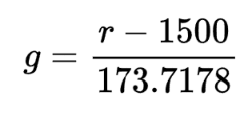  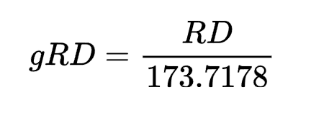  g = Internal Glicko rating  r = External ELO rating  gRD = Glicko rating deviation  RD = external rating deviation  If fighters don’t have an ELO set it to 1500, If they don’t have an RD set it to 350, If they don’t have volatility set it to 0.06 | Internal Glicko rating  Glicko Rating Deviation | 1.3
Update Rating Deviation based on inactivity | Old rating deviation  Volatility  Months since last fight | 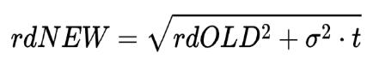  rdNEW New Rating deviation  rdOLD = Old rating deviation  sigma = volatility (updated later, but we use the old fighter volatility)  t = months since last fight | New rating deviation | 1.4
Calculate the impact of the fight | Opponent’s rating deviation | 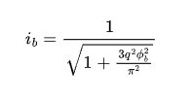  Phi = opponent’s rating deviation on internal scale  Q = ln(10)/400 (a constant used in Glicko-2 formulas) | Impact factor of fight | 1.5
Calculate the expected score of the fight | Impact factor  Ratings of each fighter | 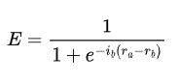  i = impact factor from fighter b  r= rating of fighter a/b internally  E= Expected score | Expected score as fighter a vs fighter b | 1.6
Calculate the variance of the fight | Impact factor  Expected score as fighter a vs fighter b  Number of fights b has (we’re going to keep this at 1) | 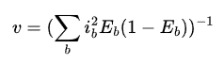  V=Variance  B=1 (I’m keeping it here to make the comparison cleaner, as I have switched around some letters)  I= Impact factor  E = Expected score | Variance of opponent | 1.7
Figure out the rating improvement from the fight | Variance  Expected Score  Impact factor  Result from fighterfights | 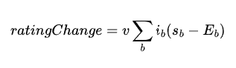  V = variance  S = Result of fight (1=win, 0.5=draw/NC 0=Loss)  E = Expected result | Amount by which the fighter’s rating should change | 1.8
Figure out the volatility of ratings | V= Variance  Sigma = Old volatility  Delta = Rating change  Phi = Rating Deviation | 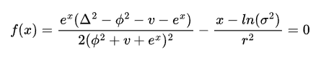  Sigma= volatility  r = constant controlling volatility change (around 0.5)  f(x)= this function’s roots should give the new volatility  Solve for x = ln(sigma) in this equation using a binary search  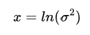  Then the new volatility = e^(x/2) | New volatility | 1.9
Update rating deviation | Old rating deviation  Volatility | 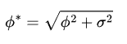  Phi* = Intermediate rating deviation  Sigma = volatility  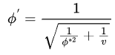  Phi’ = new rating deviation  V = Variance | New rating deviation | 1.10
Update main rating | Old rating  Impact factor  Outcome loss = 0 draw/nc=0.5 win=1  Expected outcome  Rating Deviation | 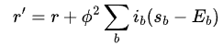  r = old rating  r’ = new rating  phi = rating deviation  i = impact factor  s = outcome  e = expected outcome | New rating | 1.11
Reconvert RD into ELO from Glicko’s scale | Internal rating  Internal rating deviation | e = external rating  i = internal rating  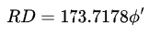  RD = external rating deviation  Phi = internal rating deviation | External rating  External rating deviation | 1.12
Repeat in reverse | Stats from the other fighter  Variables saved from before | Whole process here, but flipped | New stats updates | 1.13
Repeat for the next oldest fight | Stats from the next fighters | Whole process, but with the fighter from the next fight | New stats updates | 1.14
Display fighter stats to User/Admin sorted by ELO | Fighter table excluding rating, volatility, and deviation if user | SQL select function for all relevant info, ordered by highest ELO score first, and push to the relevant table | Table viewable to admin/users | 1.15
Connect to the database | Server  Username | Establish an SQL connection to the server with the parameters we have in the code | Connection to SQL Server | 2.1
Execute a search query of the fighter list (or if we’re doing something else, we do that table), excluding stuff that isn’t necessary for the user to see, such as photo data and ranking data, ordered by whatever order is needed | Query to sort by/ filter | Do an SQL search from the fighter list by the filters (if any), ordered by the quality you want to order by (if there is no order, order by ELO by default) | SQL table to queries and filters | 2.2
Clear the table we’re inserting into | The table we are inserting into | Iterate through each row and clear each row | A clear table ready to have the data put into it | 2.3
Iterate through rows and insert each row into the SQL table | The search result from the table | Iterate through each row of the SQL table and add its result to the table | A table with the desired results inside it | 2.4
On the user clicking the top bit of their table, sort them by the factor they clicked if it’s quantitative. If they click it again, sort it the other way round | User clicks on one of the titles for the columns of the leaderboard table | Do an SQL search for all the qualitative factors you can get from the column the user has pressed, and put those factors into a drop-down box that comes up. When the user selects something from that drop-down box, sort the SQL table by what has that quality. | Table sorted by whatever qualitative factor | 3.1
On the user clicking a qualitative top bit of the table, do an SQL selection of all the possible qualitative parts of the table, put them all in a dropdown box and then do an SQL selection of all fighters who have that factor. | User clicks the qualitative factor on the leaderboard table | If they haven’t clicked it yet, sort the table by the highest quantity to lowest. If they have, sort from lowest quantity to highest | Table sorted by whatever quantitative factor | 3.2
Find all fighter names after the user presses the search button (if it’s blank, deny search) | User clicks the search button | If blank, deny search, and if not blank, search for all fighter names in the database. | List of fighter names | 4.1
Take the first fighter’s name and create a 2d matrix list based on the fighter name and the search term | List of 2 fighter names | Separate the search term and the first fighter's name. Make a 2d matrix where the rows are the first term you just brought up from the list, and the columns are your search term | A matrix, we can make a Levenshtein distance search | 4.2
Go cell to cell, finding the least amount of edits needed for each part of the string | Matrix of two words | Go through each cell and pick the cheapest option from deletion, insertion and substitution. | Levenstein distance “matrix” | 4.3
Take the minimum amount of edits (bottom right if you visualise the list like a matrix) and put that minimum edit distance into a list with the fighter’s ID | Levenstein matrix | The bottom right number on the matrix tells you the minimum edits to get to the fighter name from your search term | Minimum edit distance with the fighter ID in the list | 4.4
Repeat these steps for each fighter | Each fighter’s name and the search term | Repeat the Levenshtein process for each of these fighters | A list with each fighter and their edit distance to the search term | 4.5
Quicksort the minimum edit distance list in ascending order | List, with edit distances | Quicksort | List sorted by the smallest edit distance first | 4.6
Redisplay the fighter list to the user/admin, ordered by the minimum edit distance list | Sorted list | Clear the table, iterate, and insert a new sorted table | Sorted table | 4.7
On double click, switch page to the fighter page | Double-click on the fighter’s record | Put the fighter page to the front with the fighter ID to display the fighter you just clicked. | Fighter page with the fighter you just clicked as the subject | 5.1
Find the picture of the fighter from the fighter variable and put it onto a widget | Fighter ID in a variable | Search the fighters table of the database for the photo URL from the fighter ID, request the image from the URL, load it into a pixmap and display it on a label. | The fighter page has a photo of the fighter on it | 6.1
Find and display fights where the fighter we’re looking at has fought. | Fighter ID from a variable | Search the fights table of the database for all the fights where the fighter we’re looking at has fought. Output the data we get from this to an array. Clear the fights table on the fighter page and iterate through the fights table, and insert everything. | Table of fights | 6.2
Calculate and display the fighter's win/loss streak | Query results of 6.2  Fighter ID  Result from fighterfights table | Go to the most recent fight. If it’s a win, add one to a win streak variable. If it’s a loss, take one off the win streak variable. Keep going through the fights until the fighter has the opposite value (i.e. a loss after 2 wins would be a streak of +2 ). Edit a text label with the number, make it red if it’s a loss streak, make it green if it’s a win streak | Win/loss streak text label | 6.3
Calculate total wins/losses/draws and their individual totals (i.e. total ko losses, total sub wins, etc.) and display in a table | Query results of 6.2 | Total the number of fights in the table where the fighter in question lost  Total the number of fights in the table where the fighter in question won  Total the number of fights in the table where the fighter in question got a draw/NC  Total the number of fights in the table where the fighter in question had a knockout win/loss  Total the number of fights in the table where the fighter in question had a submission win/loss  Total the number of fights in the table where the fighter in question had a decision win/loss | Total wins/losses/draws with each method sectioned off under it, displayed in 3 labels, 2 of them having 3 sublabels (draws don’t have a method) | 6.4
Calculate the percentage win rate and percentage finish rate for the user | Query results from 6.2 | Total up the number of fights that are in the fight table,  Find the number of wins that are in the fight table  Find the number of KO and Submission wins in the fight table (add them up)  Do (100/fights) * Wins  And (100/wins) *(KOs+Subs) | Finish and win rate are displayed in labels to the user | 6.5
Find belts held by the fighter and display them to the user | Belts Holder ID | SQL SEARCH for belts where the holder ID matches the fighter ID | Display belts in list in a text widget to user. If the belts have an image associated with them display that | 6.6
Find fight data and calculate total wins and methods of winning, losses and methods of losing | Results of query from 6.2 | Total the number of fights in the table where the fighter in question lost  Total the number of fights in the table where the fighter in question won  Total the number of fights in the table where the fighter in question got a draw/NC  Total the number of fights in the table where the fighter in question had a knockout win/loss  Total the number of fights in the table where the fighter in question had a submission win/loss  Total the number of fights in the table where the fighter in question had a decision win/loss  Put wins and methods inside of a list with the structure [wins, submissions, decisions,knockouts,draws/NCs]  Do a list of losses as well with the structure of [losses,submissions,decisions,knockouts,draws/NCs] | Data from fights ready to display in an array | 7.1
Create a pie chart for the widget | Data on wins | Use the plotting library to display a chart on a widget | Pie chart of wins and losses with the methods of victory/defeat as segments inside the actual parts | 7.2
Calculate the fighter of the fighter we’re looking at’s division’s score. | Fighter table (weight class, fighterID, ELO) | SELECT fighters from the fighter table where the fighter’s weight class is the same as the fighter we’re looking at. Get the ELO of the 10th-ranked fighter. | ELO of the 10th-ranked fighter, so we can find notable fights for the fighter's profile | 8.1
Find all fighters with ELO equal to or greater than the ELO of the 10th best fighter in the division, and put that result into a table | ELO of the 10th-ranked fighter  Fights Table  Results of 8.1 query | Get fighters from the fighter table where their ELO is greater than or equal to the 10th-ranked fighter and where they have fought the fighter we’re looking at (Matches one of the fighter IDs in the fights table where the other matches the ID of the fighter we’re looking at). Clear the notable fights list and insert the fighter data we just got. | List of high ranked fighters the fighter we’re looking at has gone up against | 8.2
Display all fighters (only ones in the weight of the other fighter if another fighter has been selected in the other box) in a drop-down box, sorted alphabetically | Fighter table (weight class, name) | SELECT all fighters to be displayed in the dropdown box. If another fighter has been selected in the other box, SELECT all fighters that are the same weight as the other fighter. | Dropdown boxes to select all the fighters | 9.1
When the user clicks calculate, calculate the odds of the fight using a logarithmic Bradley-Terry model | The ELOs of the fighters we’ve just selected | 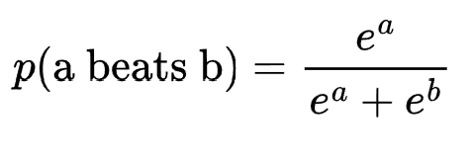  a=Fighter a rating  b=Fighter b rating | Odds of fighter A beating fighter B | 9.2
Display odds in a percentage, depending on who has the dominant rating | Odds of Fighter A beating Fighter B | If fighter A is the favourite (i.e. the number is over 0.5 don’t change the odds (just multiply it by 100 to make it a percentage)  If fighter B is the favourite (under 0.5), then invert the odds (1-odds) and multiply by 100 | Display odds and display favourite (e.g. Fighter B favourite at 58%) | 9.3
When the user signs up, the system checks for a duplicate username and will hash and salt their password to store it along with their username | New Username  New Password  Sign-up button pressed | Check for a duplicate username. Reject if there is one  When the sign-up button is pressed, generate a random salt  (I am going to use PBKDF2-HMAC, so I don’t need a salting algorithm)  Derive a hash with the salt and the password (which is converted to bits) using a SHA-256 algorithm.  Insert a new row into the users table with the username and the hashed password | New profile in the users table  If it’s a duplicate username displays an error  Redirect to Survey | 10.1
The user will be able to log in again using their username and password. | Username  Password  Log in button pressed | SELECT from the users table where the username matches the one entered  Separate the hash and salt of the password  Recompute the hash for the entered password and then compare it to the one we have. | Login user is it’s a match  Redirect to leaderboard  If not matched, display an error | 10.2
When the user logs in, if everything is valid, the session will be connected to the user by a variable. | Successful Login  UserID | Set the session Token variable to the UserID | Display the UI relevant to the user with their entertainment scores and approvals | 10.3
If the user has an admin account, the session will be an “admin” session (declared by a variable), meaning that they will be able to access admin tabs. | Successful Login  UserID | SELECT the isAdmin field from the users table for the user we just logged in as, to see if they’re an admin or not. If they set the variable isAdmin to true, which will allow them to see all of the admin pages. | Display the Admin part of the UI if they’re an admin. Automatically redirect to Edit Fighter List  If they’re a user, redirect to Leaderboard | 10.4
When the user clicks submit on the survey (what they like out of 5 stars), put the 5-star score into another scale and store it in the user’s records | Survey responses  Submit button  UserID | Turn the survey into a scale of 1-5, going up in increments of 1 for each star. Update the user table with these results where the userID matches. | Redirect to Leaderboard | 10.5
When the admin selects Add Fighter create a blank fighter, the admin can go onto their page and edit. | Admin clicks the Add Fighter button | Insert blank fighter into the fighter table, e.g. [John Smith, United Kingdom, Welterweight, 6’’0, default picture] | Blank fighter inserted into the database | 11.1
On the individual fighter editing page, when the admin clicks add fight adds a blank fight to the fighter list that you can edit with dropdown boxes and such | Admin clicks the Add fight button | Insert a blank fight where one of the fighters is the fighter whose page we are editing. When the admin enters the ids of each fighter in and then the method, put that info into fighter fights. | Insert a blank fight into the database | 11.2
Insert every event since the given date into the database | Given Event number to import from  Admin clicks the import button | Firstly, check that the UFC API is available; if not, then open a web page. If it is, iterate through the UFC event numbers until the UFC API can’t generate a response. For each of the event numbers save the location and the date. | UFC Events imported onto the system or web redirect to the UFC API download page | 12.1
Insert every fight since a given date and  Add it to the database | On the completion of the import of the events | Use the UFC API to chronologically iterate through every event since the given event and add each fight on the card into the fights table, including the fighters on the event, the event number, who won and how they won. | UFC fights on the fighter table and results onto fighter fights table | 12.2
Link every fight to a fighter and build the fighter’s profile. | Fights table with UFC import | Now go through each fight chronologically again but now gather data from the API about each fighter in each fight. Gather their name, nationality, associated gym, birthday, height and weight class. | UFC fighters on the fighter table | 12.3
Run Glicko Scores | Fights and fighter tables | Do sub-problem 1-17 as if you did the editing manually | ELOs and other prob stats | 12.4
Find duplicates in the data, tell the user and make them delete it before all the updates are made (56) | All available, user inputted, data (promotion/weight in belts, all the content in Events, Method/EndRound/Endtime/Title in fights,  Name/Weight/Birthdate/Gym in fighters, corner, and result in fighterfights) | Use an SQL GROUP BY query to figure out fighters that have the same [name and birthday] (the chance of this happening is one in 18 million, which we are going to assume is statistically impossible)  Use another GROUP BY to figure out events that are called the same thing and happen at the same time,  Use another GROUP BY to figure out fights that have the same opponents and happen on the same event,  Use another GROUP BY to find belts that are held by the same person in the same weight class (I’m not doing just weight class because you get interim champions that also get a belt in a division sometimes)  Put these in a 2d list, their cell containing the table and their primary key | Display the list we just made to the admin when they try to submit the data they just made in order the make them correct everything. If it’s a duplicate in FighterFights, refer them to the fights that they input instead of the FighterFights table, which they can’t directly manipulate. | 13.1
Find incorrectly formatted data, and show the user what’s wrong and make them delete it before the updates are made | All available, user inputted, data (weight in belts, all the content in Events, Method/EndRound/Endtime/Title in fights,  Name/Weight/Birthdate/Gym in fighters, fighterfights result and corner)  When the admin makes updates to the data and clicks the submit button | Do lookup checks for exclusively formatted fields (dates in birthdate and event date are in dd/mm/yyyy format, Method is either KO/SUB/DEC, Endtime is in a m:ss format, Corner and result is A/Red or B/Blue. Title in fights is either Y/N/RETIRED)  If we find an error, put the error into a 2d list which is formatted like [[Error, Table, ID(if missing, just put null)]…] | Display the list to the admin when they try to submit changes. | 13.2
Find data of unnecessary length and make the admin delete it  before updates are made. | All available, user inputted, data (weight in belts, all the content in Events, Method/EndRound/Endtime/Title in fights,  Name/Weight/Birthdate/Gym in fighters, fighterfights result and corner)  When the admin makes updates to the data and clicks the submit button (query results from previous subproblem ideally) | Do length checks where appropriate (Names up to 60 to account for cultural variations and big names, Weight classes up to 30 for long weight classes like women’s super-bantamweight)  If we find an error, put the error into a 2d list which is formatted like [[Error, Table, ID (if missing, just put null)] …] | Display the list to the admin when they try to submit changes. | 13.3
Do all necessary presence checks | Fighter ids for fights when entered, event Ids for fights, userID and fighterID in approvals, fighterID and fightID in fighterfights, all other primary keys and foreign keys, ELO Rating Deviation, Volatility in fighters)  When the admin makes updates to the data and clicks the submit button | Do presence checks for everything we are manipulating (All FKs and PKs, Weight class wherever, Event dates, Fight methods, Not fight title in fights because not all fights are for titles, corner and result in fighterfights, names)  If we find an error, put the error into a 2d list which is formatted like [[Error, Table, ID(if missing, just put null)]…]. If it’s an error with the ELO rows then their Elo will be reverted to the default value | Display the list to the admin when they try to submit changes. | 13.4
Make sure all data is the type it's supposed to be | All available, user inputted, data (weight in belts, all the content in Events, Method/EndRound/Endtime/Title in fights,  Name/Weight/Birthdate/Gym in fighters, fighterfights result and corner)  When the admin makes updates to the data and clicks the submit button | Do type checks  (Weight classes are text only, EndRound is in one-digit format) If we find an error, put the error into a 2d list which is formatted like [[Error, Table, ID(if missing, just put null)]…] | Display the list to the admin when they try to submit changes. | 13.5
When the plus button is clicked (if not already), store the user's vote in the database | User clicks the plus button next to the fighter rating on the fighter page | Check using SQL select where fighter id=fighter on page and userid = logged in user to make sure that the user hasn’t already voted the same way. If they haven’t, add a record to the fighter's approval rating with a plus one | User sees the rating percentage go up | 14.1
When the minus button is clicked (if not already), store the user’s vote in the database | User clicks the minus button next to the fighter rating | Check using SQL select where fighter id=fighter on page and userid = logged in user to make sure that the user hasn’t already voted the same way. If they haven’t, add a record to the fighter's approval rating with a minus one | User sees the rating percentage go down | 14.2
When the user brings up the fighter’s page, view the approval rating as a percentage positive if mostly positive or a percentage negative if mostly negative | Approvals Table | SELECT all the approvals where the fighterID matches the fighter whose profile we are looking at. Make a total amount of user votes and then divide 100 by that number. Multiply that number by the number of fighters who give a positive rating. If the percentage is less than 50, then invert it (100 - the percentage) and display it as **% negative. If it's more than 50, display it as **% positive | The percentage rating is shown to the user | 14.3
When the user uses the odds calculation, match each answer the user put on the survey to an attribute of the fighter | Users table  Calculate odds button | Search for and calculate both fighters' submission rate, and match the number of subs to submission preference  Search for and calculate both the TKO/KO rate of both fighters, and match the number of KOs/TKOs to the TKO/KO preference  Search for and calculate the decision rate of both fighters and match it to the decision preference | Matched up rates in a list, ready to calculate for the entertainment test | 15.1
Go through each of the attributes relative to the average fighter to figure out what they do more than average (aforementioned), and both fighters are being calculated (this part happens when the user calculates the odds). | Match up rates in a list  Methods in fights table | Total the number of fights that finish by each method in fights and divide them by the amount of fights to find the average amount of each method.  Give both fighters their own individual score of 100%  Check fighters A and B’s submission rate against the average submission rate. If they have an above-average submission rate, the formula is  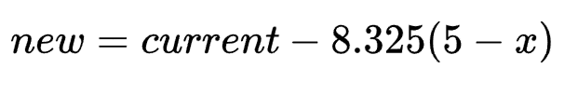  With x being the number of wins the fighter has had in the method (for this example, it's submissions)  Repeat this process for TKO/KOs and decisions | Display the entertainment score underneath the odds | 15.2
Calculate the average score of both fighters and output that as the entertainment score | Fighter A's entertainment value  Fighter B's entertainment value | Find the mean of these two values | Display the entertainment value as a label | 15.3
Check for impossible fight outcomes (fight lasts 0s) | Fights table  User clicks submit | SELECT all fights where the length is equal to or less than 1s, and put all of these into the same 2d list as the errors with their cell structured as [[anomaly, table, id] …] | Output the errors to the admin when they try to submit the table | 16.1
Check that every fighter has fought in amounts that are statistically possible (fewer than 12 fights a year) | FighterFights table  User clicks submit | For each year, SELECT by unioning and grouping the fighters who have fought more than 12 times in a year, and put all of these into the error list, structured in  [[anomaly, table, id] …] | Output the errors so the admin can fix them when they try to submit the table | 16.2
When the user navigates to another page or is redirected, specify that all other pages are hidden away from view | User navigates to another page | Whenever the user navigates, a function will be invoked with the parameter of the page they want to go to. If you are not on the page in that parameter, you are hidden. If you are, then you are shown. It will also make a Boolean variable linked to the page in a list (each page will have its own variable, I will structure it like [[page, status]…] | The user goes to the page they were meant to navigate to. | 17.1
Make sure that all page-specific processes don’t happen when the user is away unless specified otherwise | User navigates to another page | Ensure that all page-specific processes that aren’t supposed to happen when closed are wrapped in an if function based on 17.1 (we know the index already, so no need for searching) | Page-specific processes don’t happen when they’re not supposed to | 17.2
When the user clicks a belt button on the edit fighter list page, a list of belts automatically comes up with each holder and division shown (auto-filled from ID) | Belts table  User clicks the “Edit belts...” button | Popup dialogue box. Clear the dialogue table and then iterate through with belt data. When iterating, replace fighterID with the fighter's name. | Belts pop-up that the admin can edit | 18.1
The admin can add new belts | Admin clicks the plus button under the belt list  Belts table | Insert blank belt into the belts table and regen table (iteration) | New belt in the table | 18.2
The admin can delete belts | Admin clicks a belt and then clicks the minus button  Belts table  Fights table | Find the ID of the belt that the admin just clicked. Remove this belt from the database. | One less belt | 18.3
If a belt is deleted, the title fight status of the belt's fights will be turned to retired | Belts table  Fights table | Go through the fights table and find all fights in the division that the belt was for and set the title fight status to RETIRED | All title fights under the retired belt are marked as RETIRED | 18.4
The admin can edit the holder of the belt | Admin clicks on and edits the fighter holding the belt, and then clicks off or presses ok  Fighter table | If the fighter’s name entered is a number, then assume that’s the ID. Find the fighter ID from the fighter’s name and autofill. If there are multiple fighter names, then let the user know and blank the edit. | Change put into the database or an error message tells user to “find individual fighter ID” | 18.5
Open a pop-up window | User or admin gets a code error | Open a pop-up window as a dialogue box | Popup window opens | 19.1
Declare the error in the pop-up window | Exception | Display the exception in the pop-up | The error is displayed | 19.2
Figure out how many weight classes there are | Admin clicks submit and validate button  Belts table | If a weight class doesn’t have a belt, do a SELECT DISTINCT SQL function on the weight classes, which will show me all of the individual weight classes. Then, for each of these weight classes, search through the belts table. If a weight class doesn’t have a belt, put the results of this query into a list. | List of weight classes | 20.1
For each weight class, find the last declared title fight | List of weight classes  Fights table (title, | SELECT IDs from fights where it’s a title fight and it’s the weight class we are looking at. Order by date. Look at the most recent title fight and get the fight ID of it. Put this into a list which looks like [fightID,weightclass]. Iterate through each weight class. | List of the most recent title fights for each weight class. | 20.2
Set the belt of the weight class to belong to the last winner of the weight class | Fighterfights table  Recent title fights list | Look through the fighterfights table to figure out which corner won, get that fighter's ID and then add a belt onto the belts table based on their weight class and ID | Automatic new belt | 20.3
If the user is an admin, when they click the View as User button redirect to the leaderboard | Admin clicks the View as user button | Redirect to the leaderboard using the page transfer processes | Admin gets to see the leaderboard and user pages | 21.1
If the user is an admin, display an admin icon on the sidebar | Admin clicks the View as user button | If the user is an admin, put an admin icon on the sidebar that they can click on and go back to the edit fighter list page with | Admin has returned to the admin pages | 21.2
When the admin makes an edit to the data, toggle in the system that they have. | Admin makes an edit | Toggle an editMade Boolean that will be triggered whenever an edit is made. | editMade bool is triggered | 22.1
If the admin has made an edit, when they exit, submit the data and run algorithms as usual | Admin tries to exit the program | If the editMade Boolean is triggered, then go through all the checks, processing and validations you would do if the admin were to click submit | Error messages if the admin has messed up editing, auto belt assignment and ELO algorithms ran | 22.2

User Interface
Don’t be deceived by the title, you need to design every form you will be creating, including error messages. These need to be fully annotated, you will be showing these to your peers, they should have enough detail to be able to pick up your idea and program it. You should link these with the objectives in the design or your decomposition tasks.
General exceptions or other code errors:
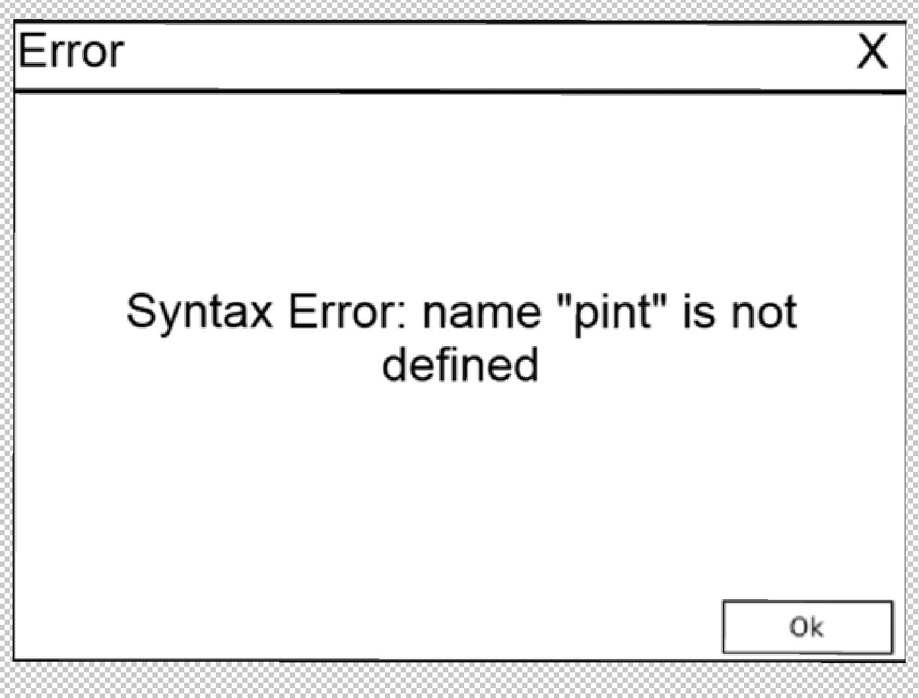
The only content this pop-up will have is the pure exception.

Login
*Annotations in green
You will be able to type in your username and password into the two text boxes and then click login if you already have an account, but if you don’t, you can click sign up.
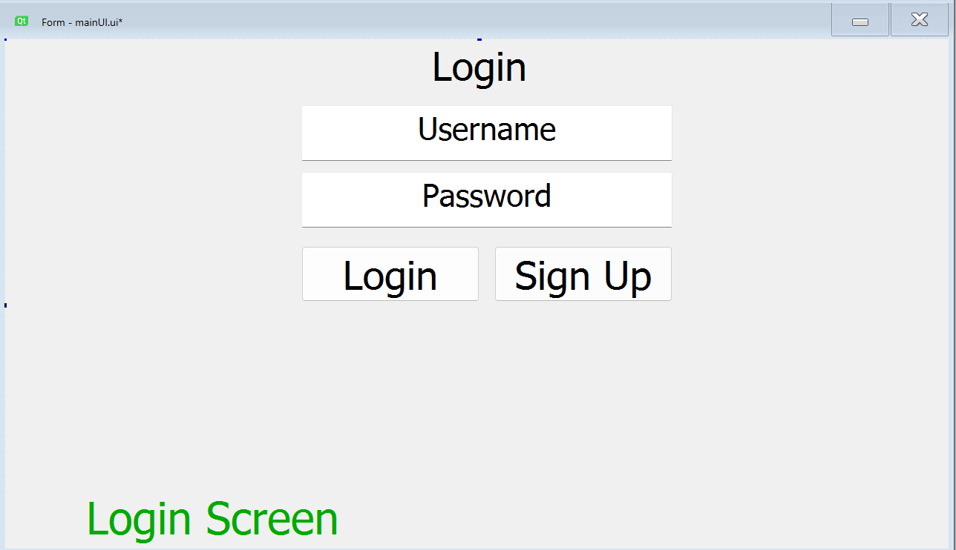
When you login with a wrong password you will get a screen like this:
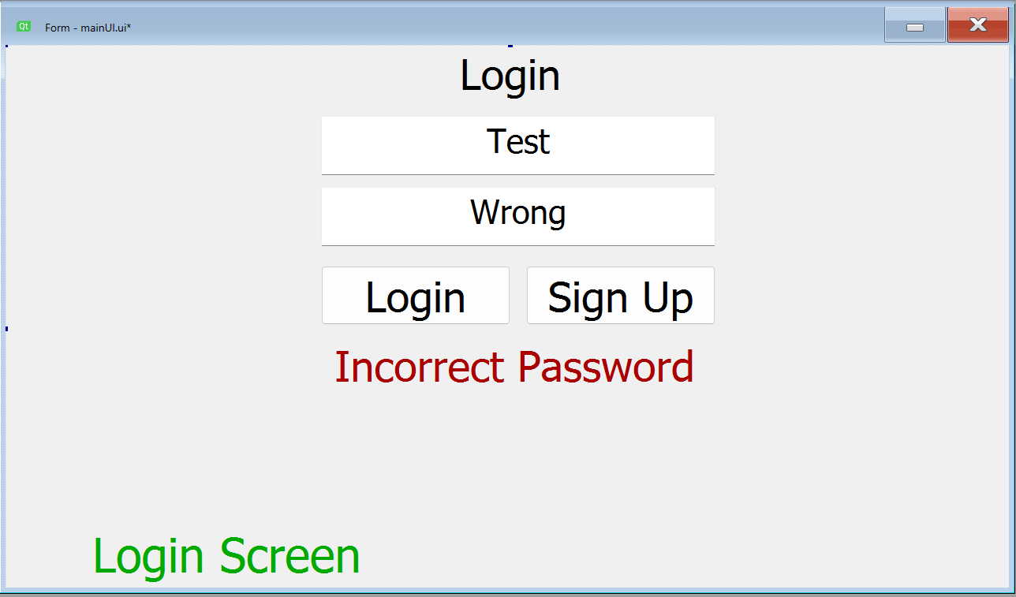
If the account doesn’t exist you will get this message:
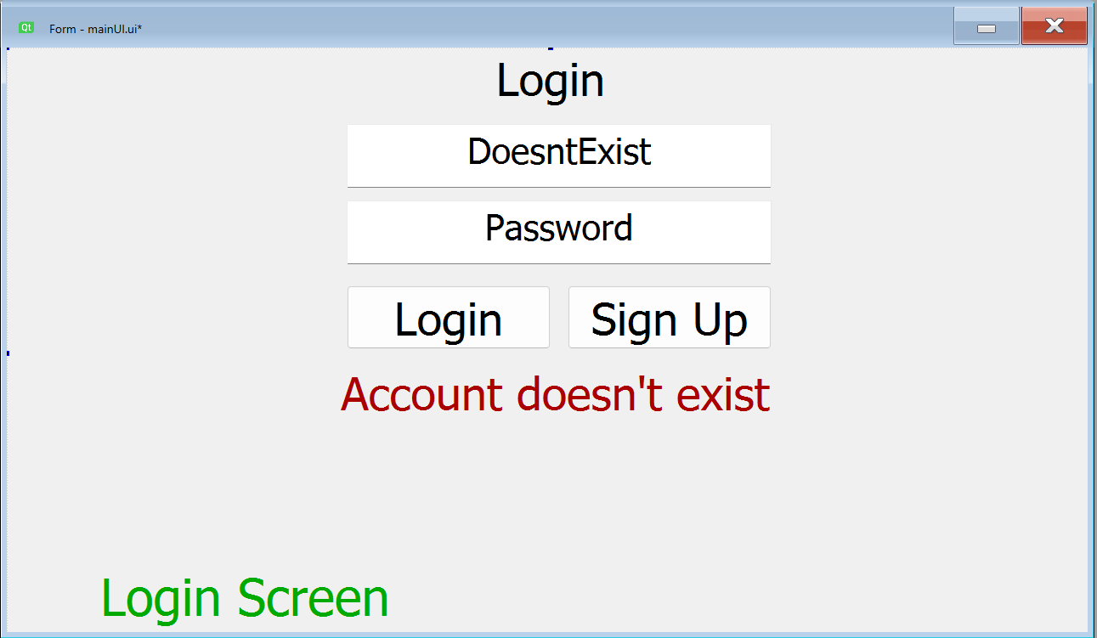

If you try and sign up with a username that already exists, you will get this screen:
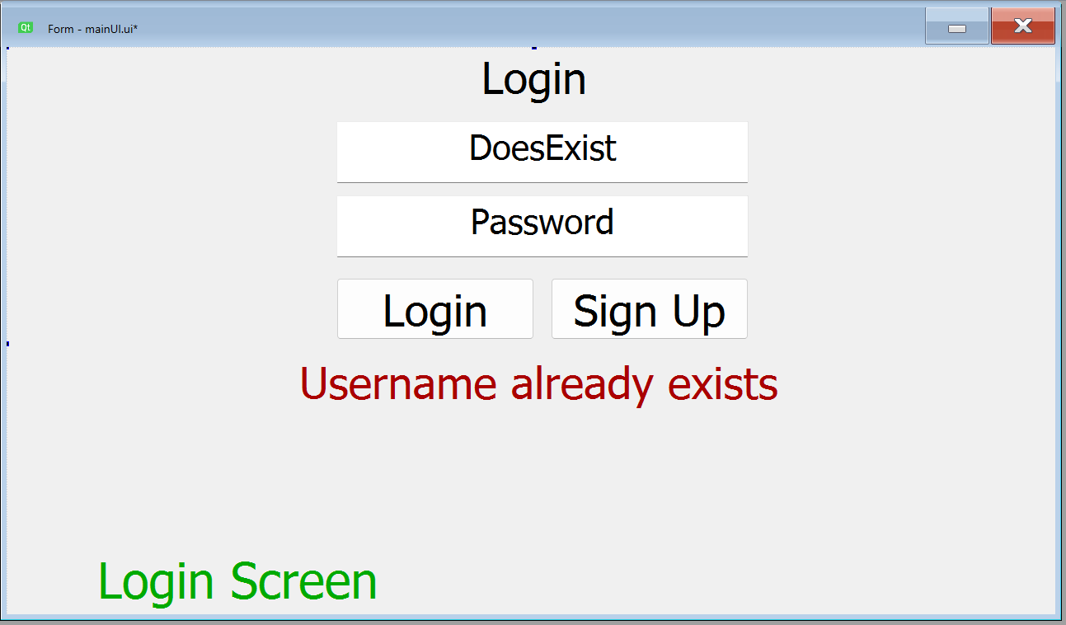
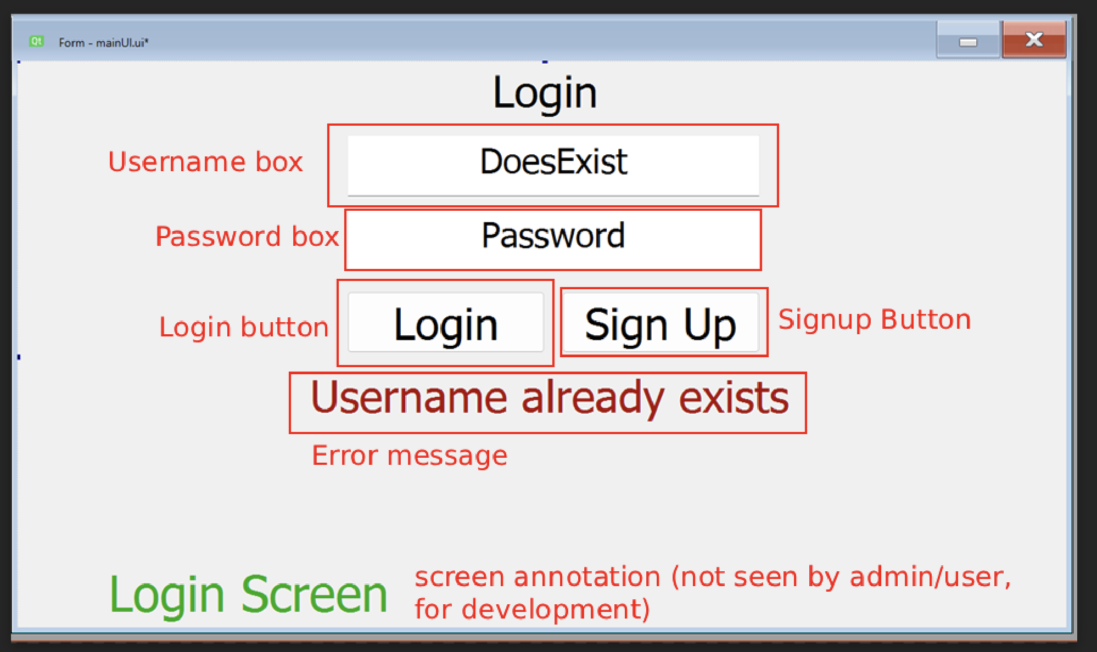
If you press Sign Up, you will be redirected to the survey screen:
Survey
This is what you start with:
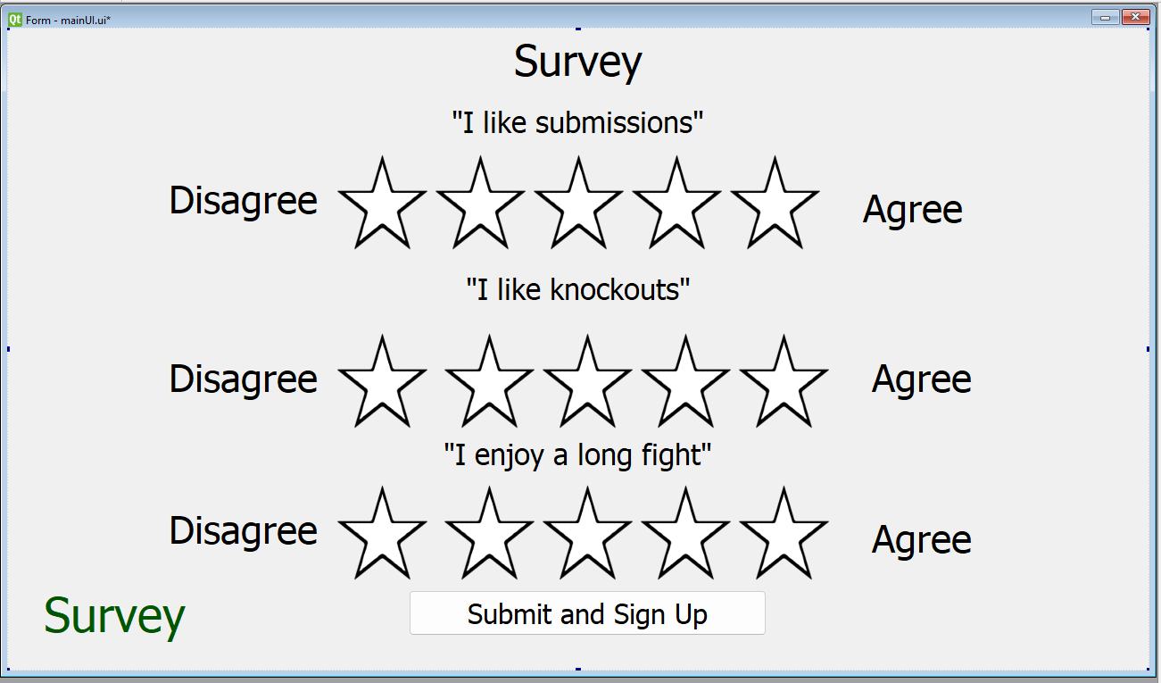

Each star row is adjustable, and each star is clickable and autofills up.
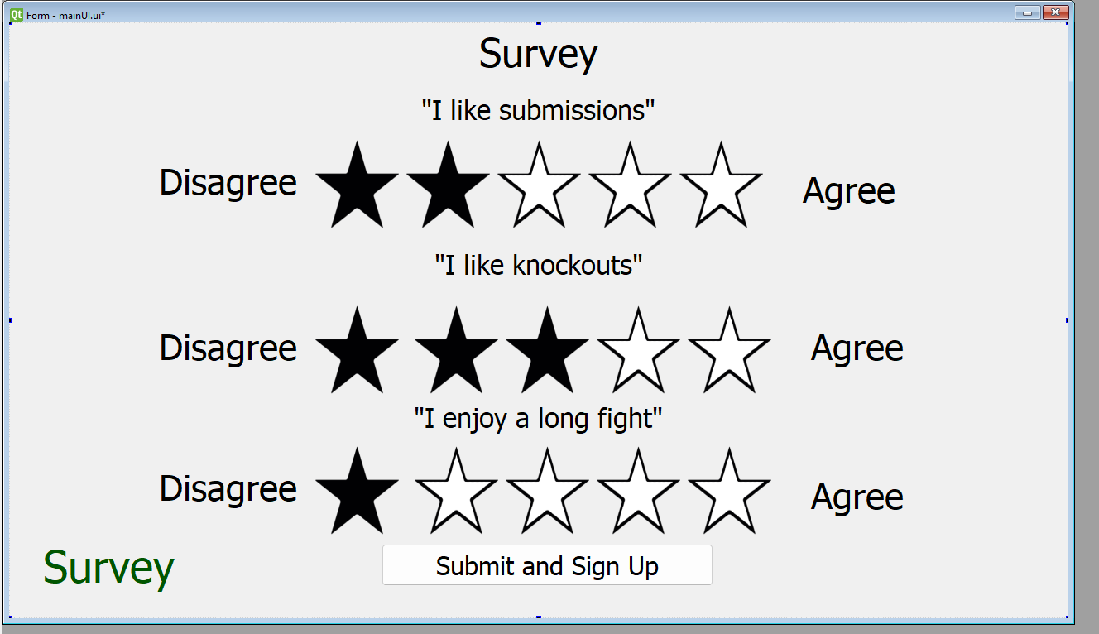

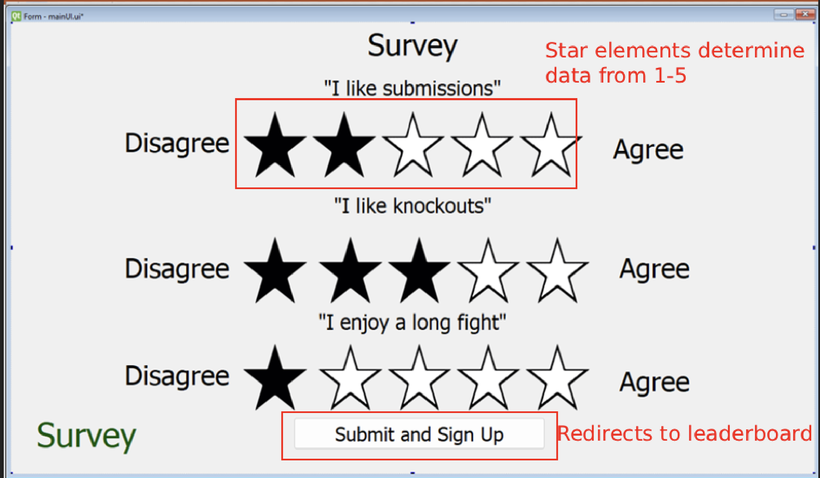

Odds Calculator

Fighters are selected from a dropdown box
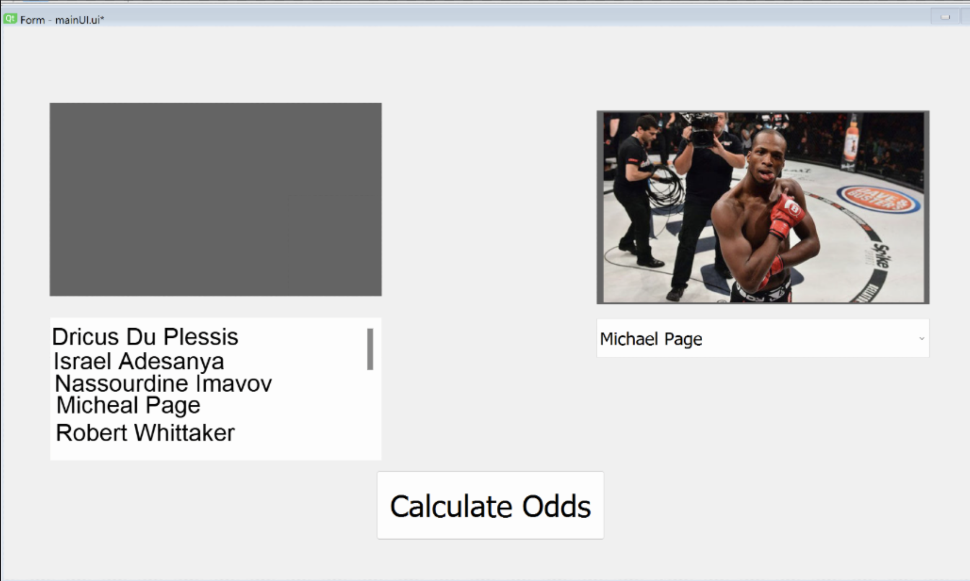

When you select a fighter from the dropdown boxes, their picture will appear
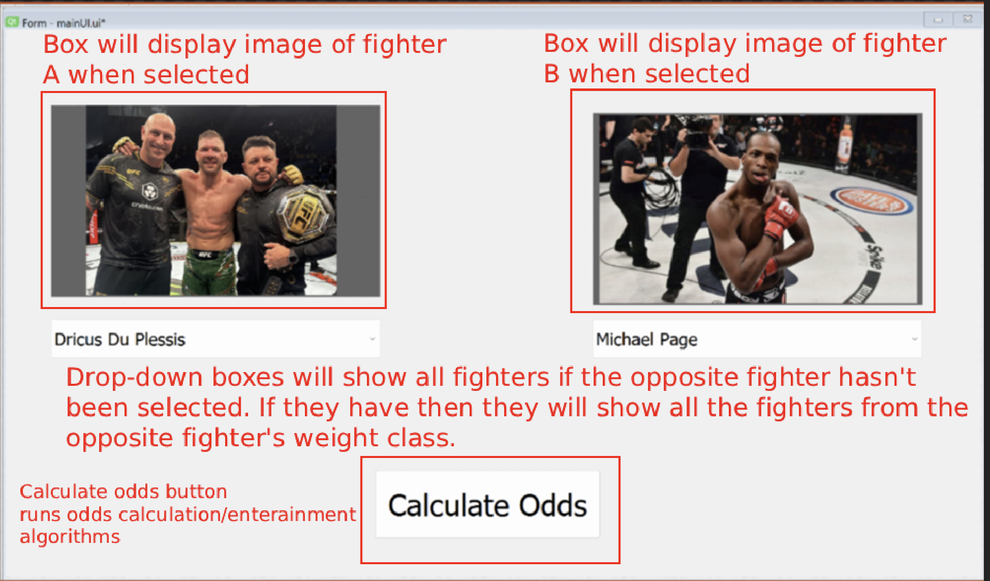
(When clicking the Calculate odds button)

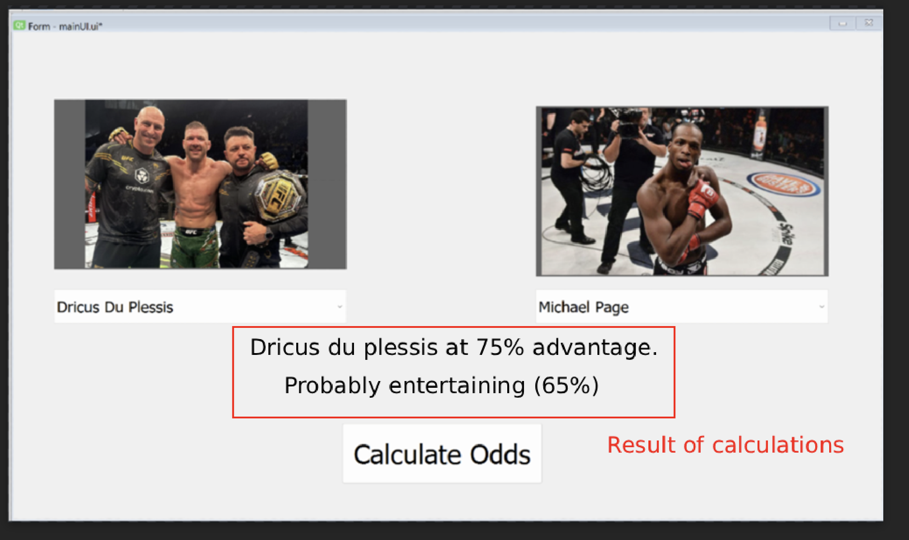

(When clicking the button when one or both fighters are missing)
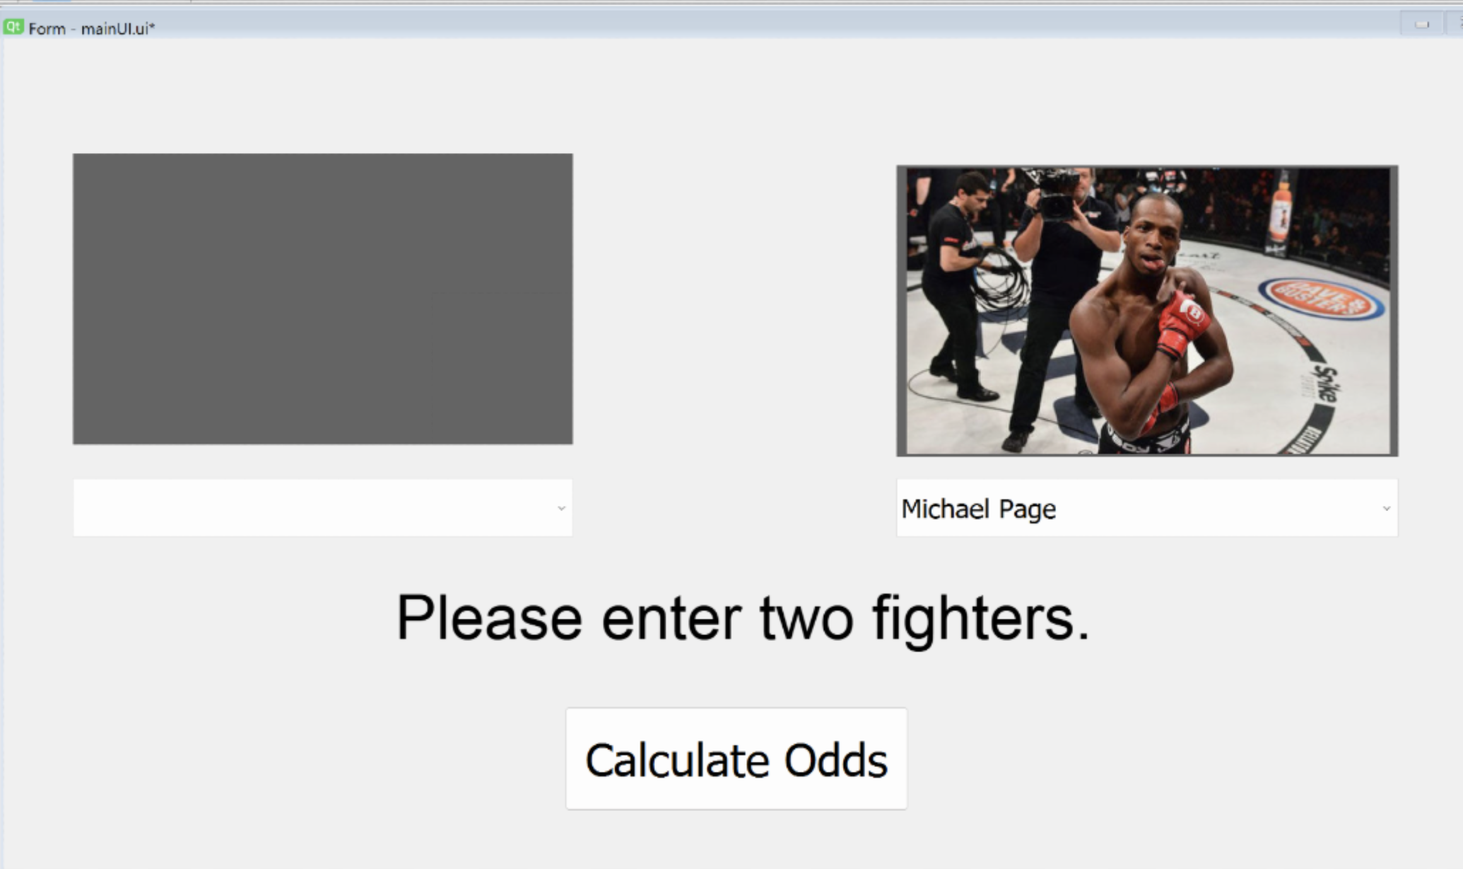
Modify the fighter list
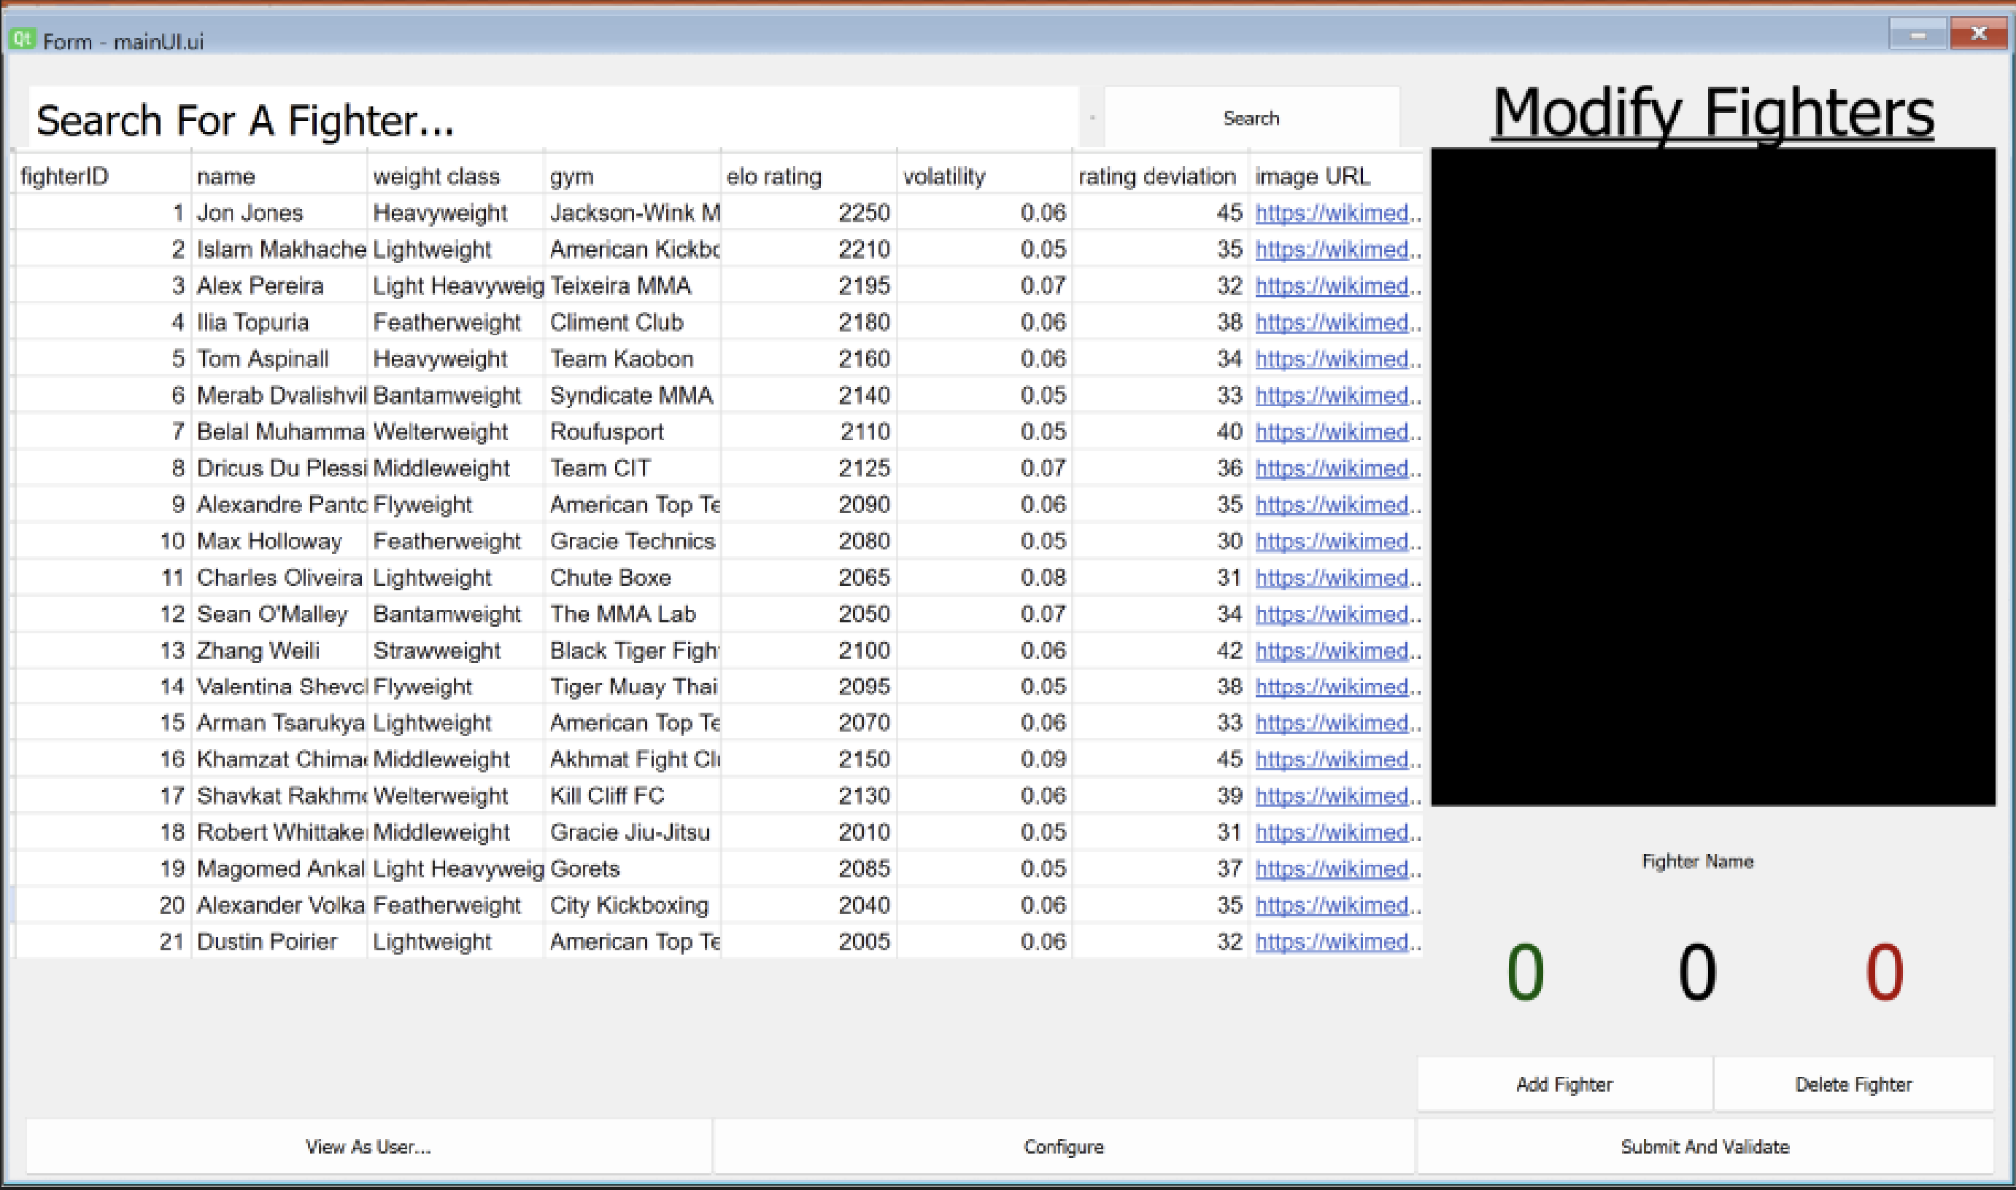
Start screen will look something like this.

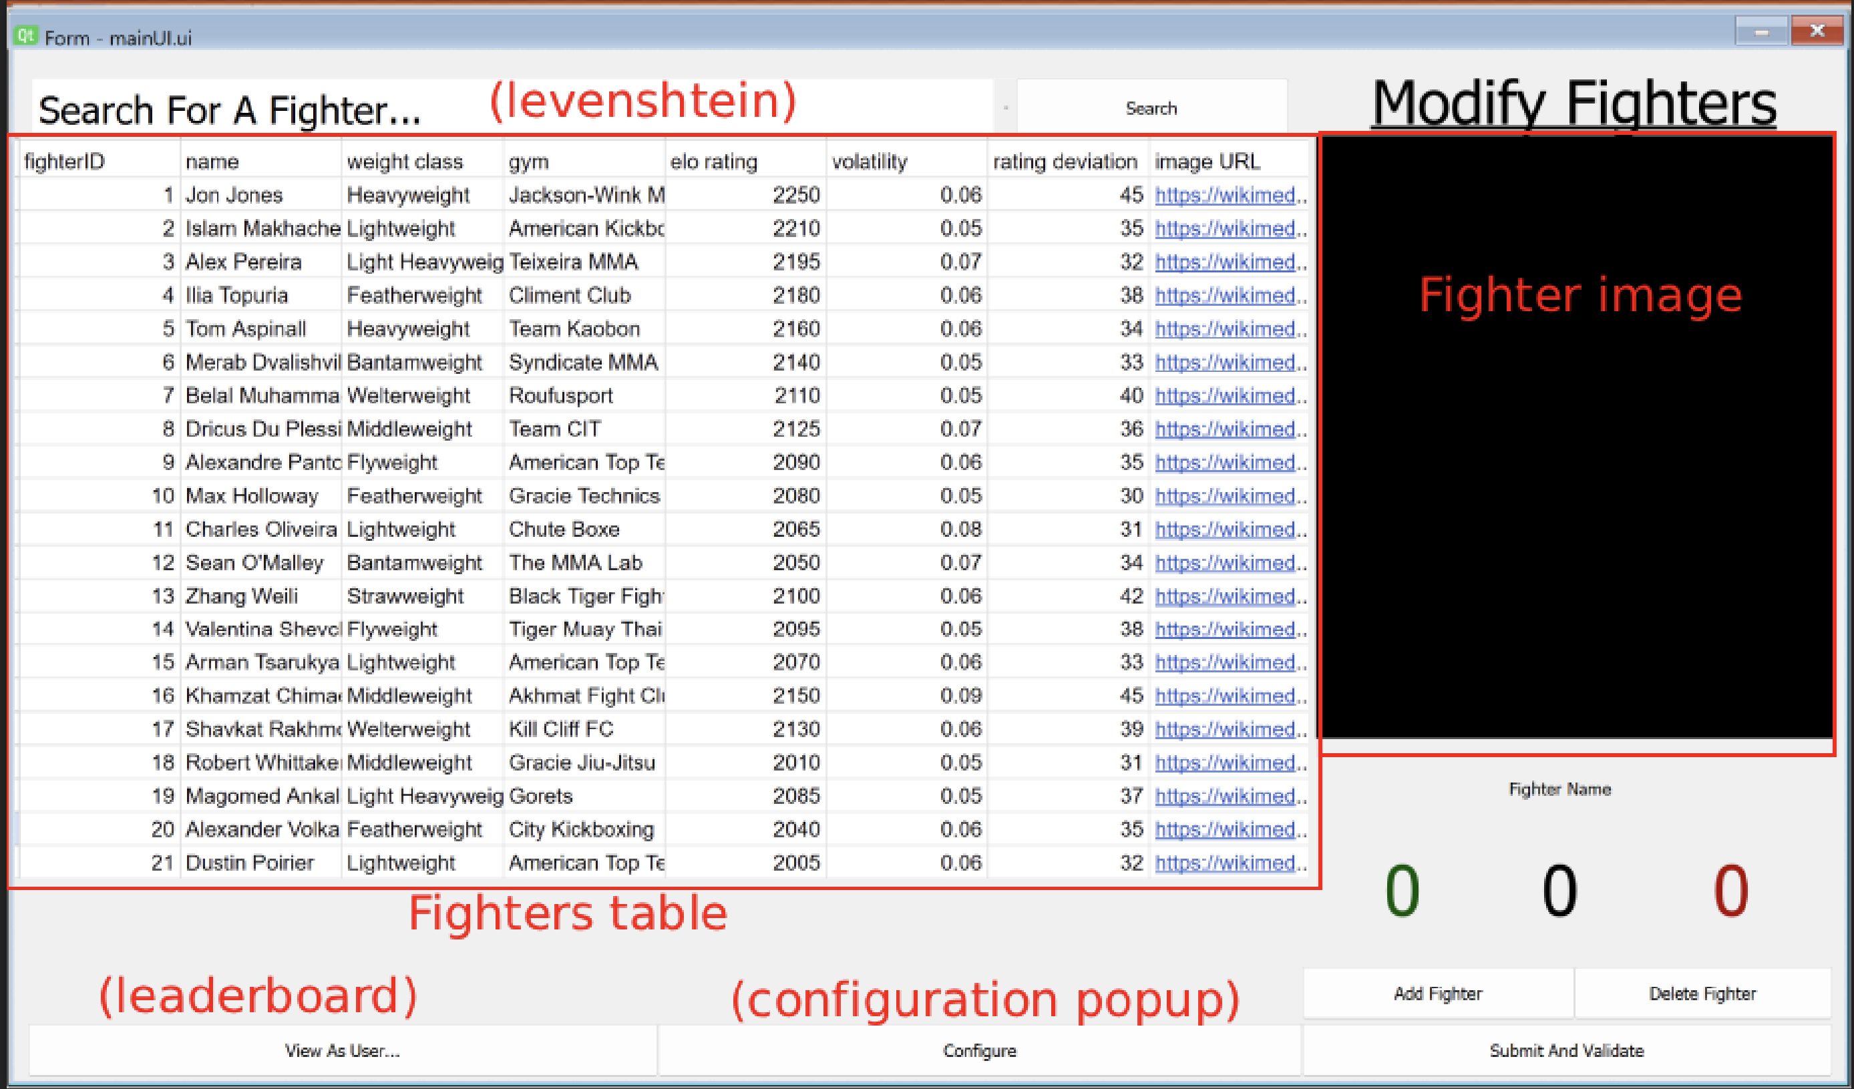
When the fighter clicks add fighter it will add a dummy fighter for the admin to edit.
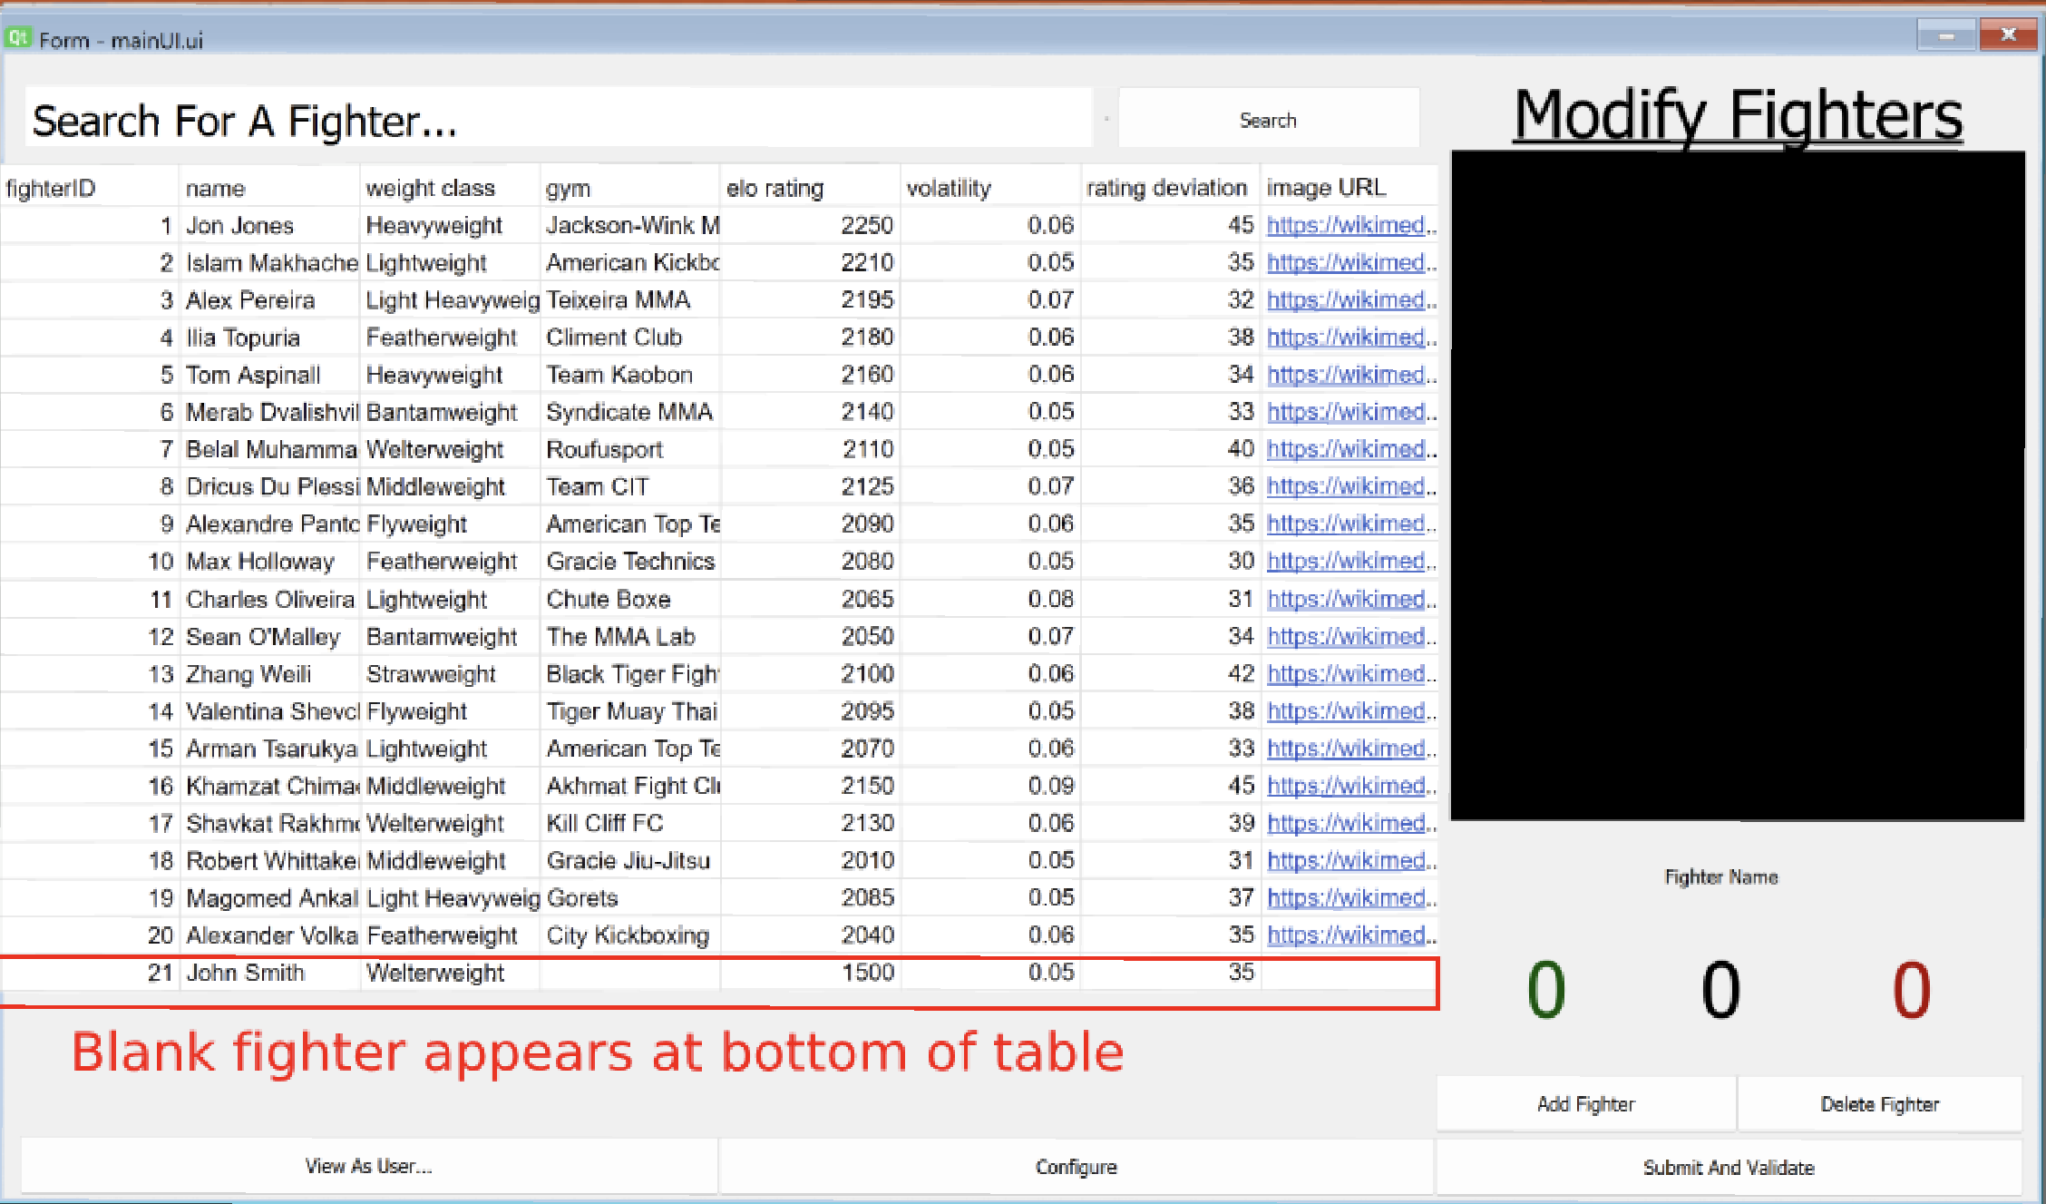
If the user selects a fighter they will get a base overview of them.
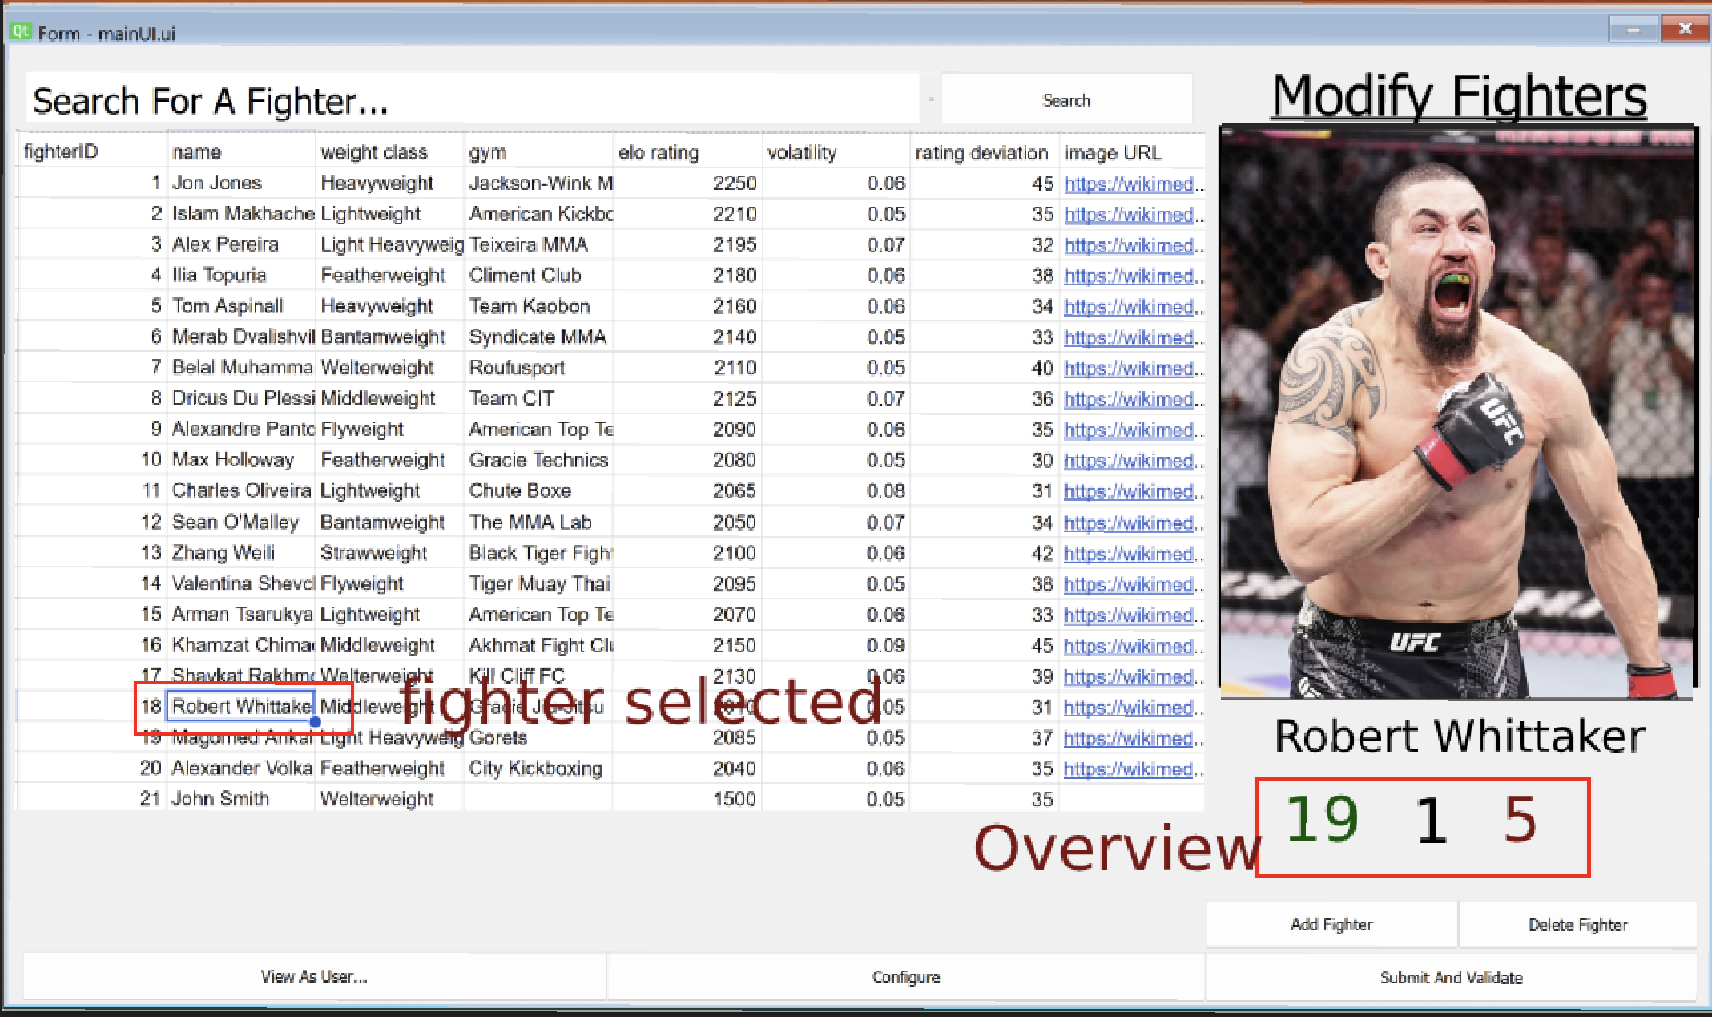
If the user selects delete fighter with a selected fighter, the fighter will be removed from the table.
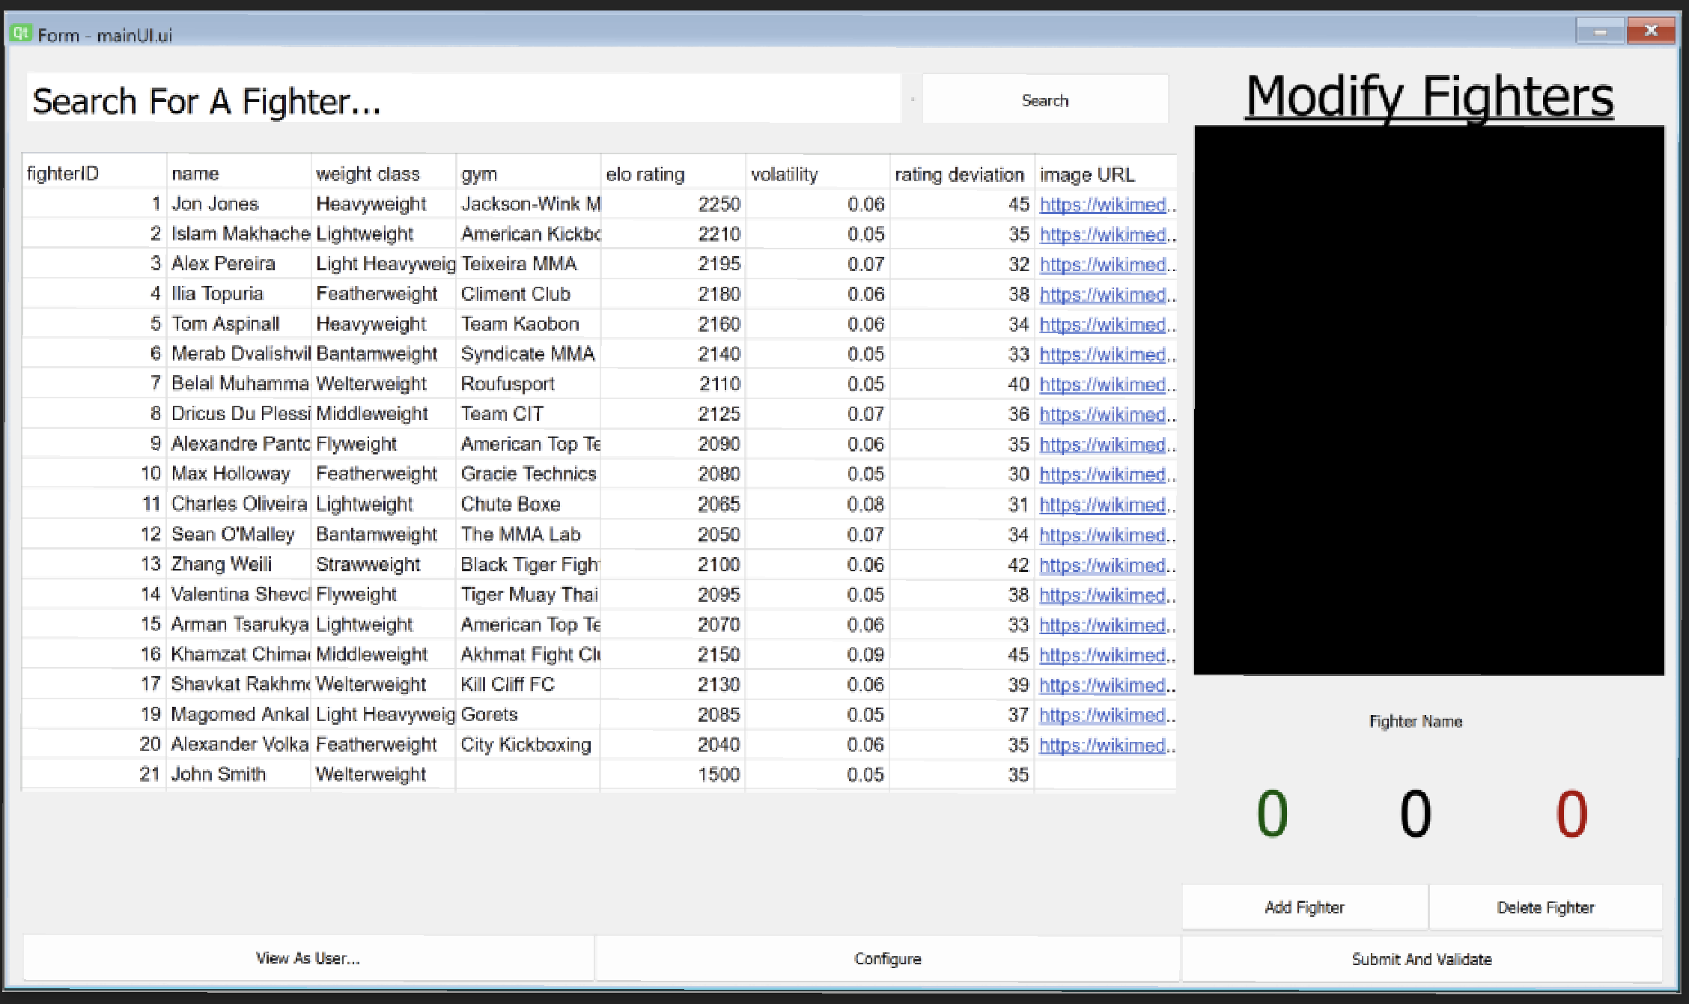
If the user clicks delete fighter and there is no fighter selected they will get this popup:
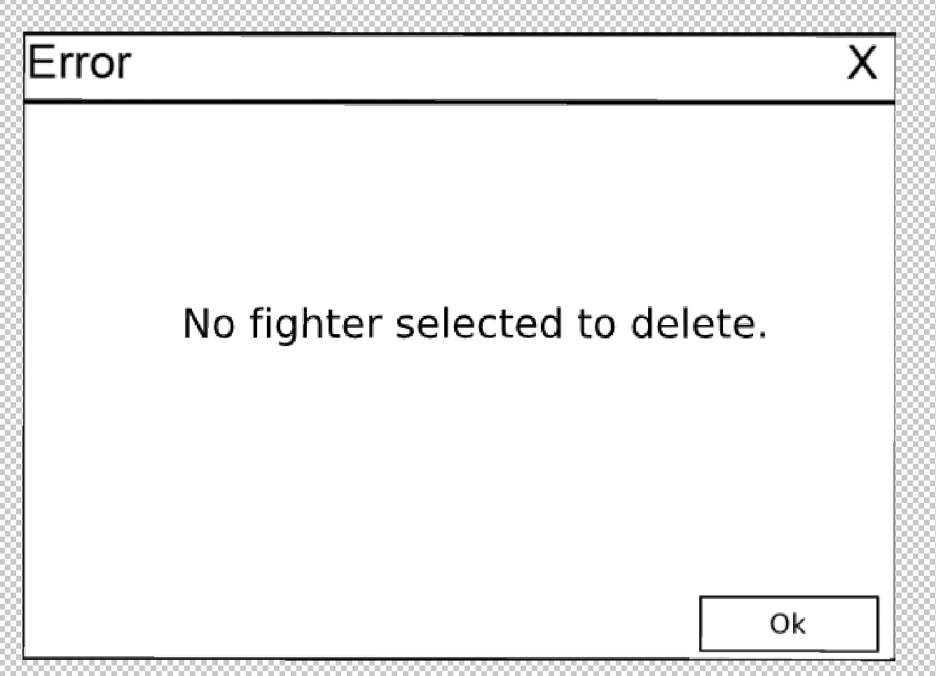

If the user clicks “submit and validate”, and everything is all good, the table will give them this message.
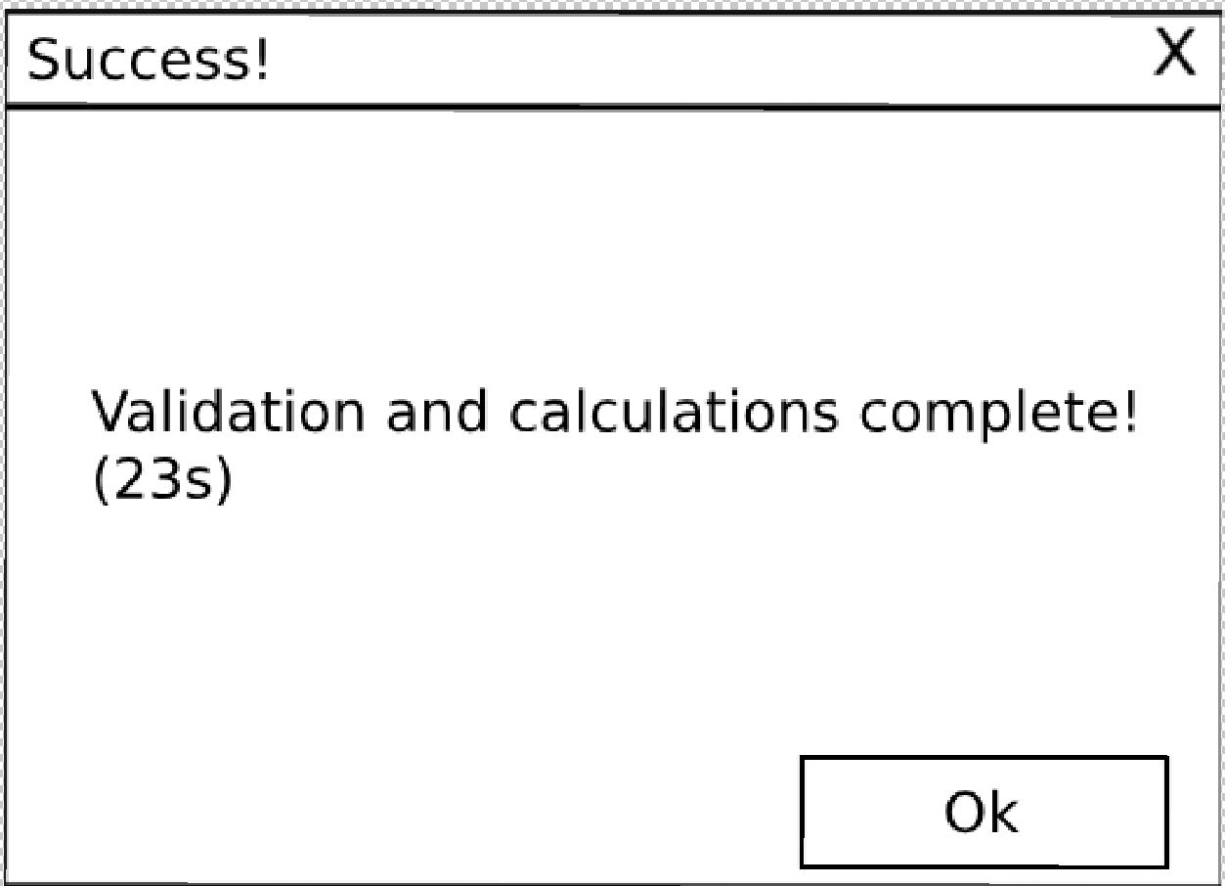

If there is admin-caused validation errors it will output this popup: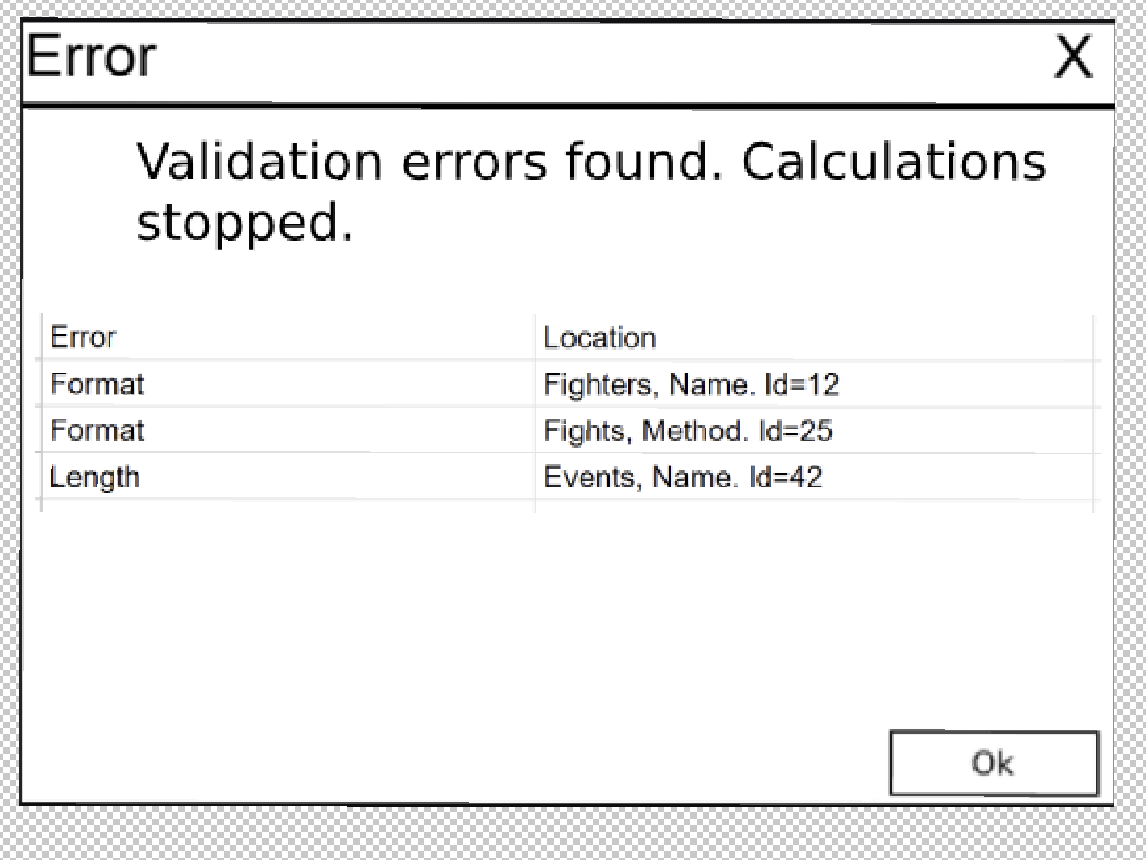
If the admin directly tries to exit the program and they’ve made an edit to the database, it will show them this.
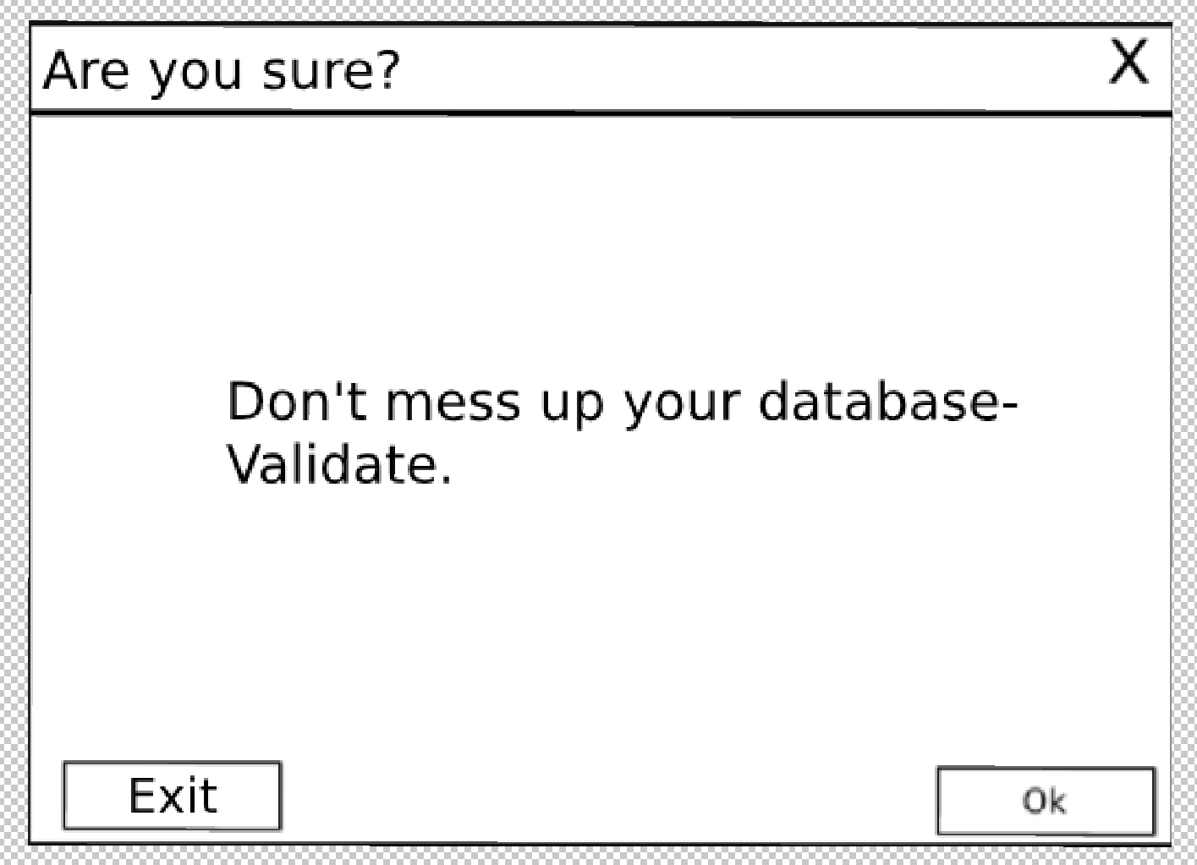

Configurations (not really a page, but I want to separate it)
You can open this pop-up page from the modify fighter list page.

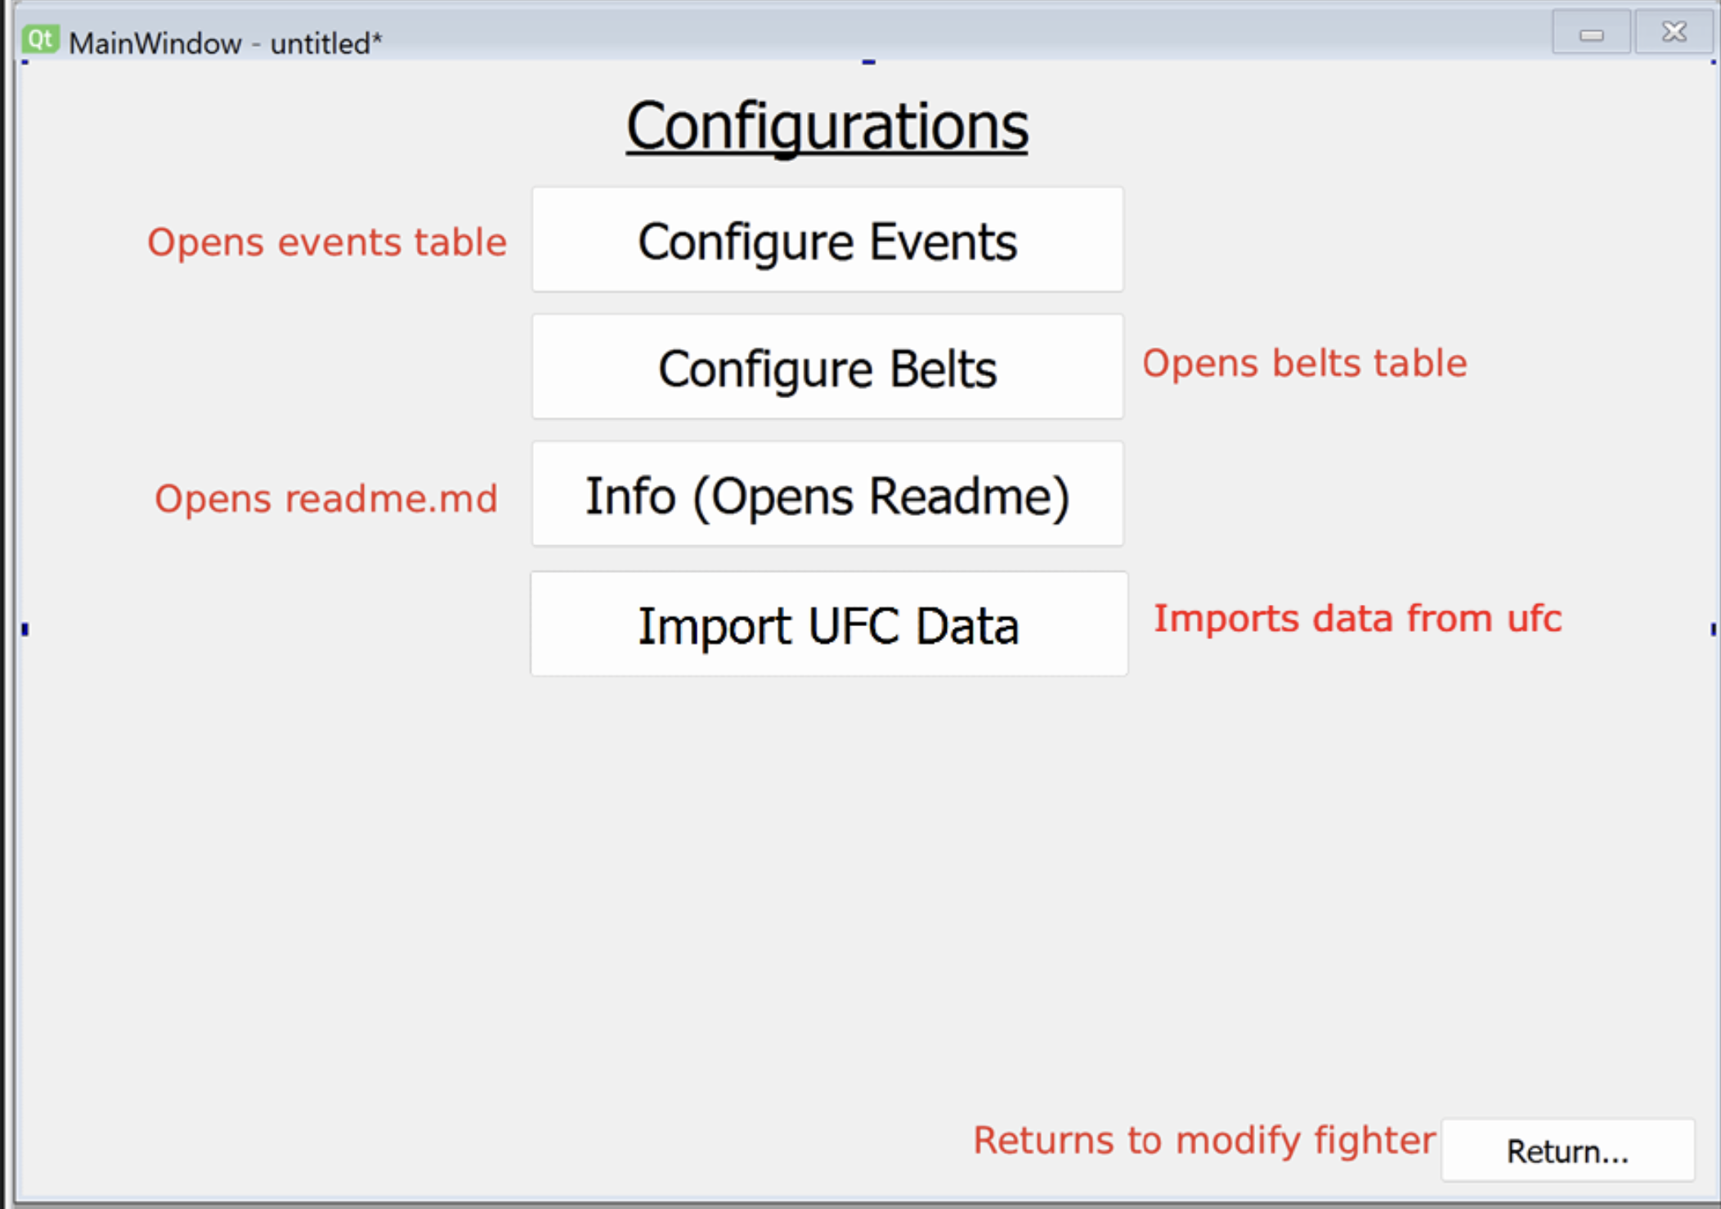
Configurations table page
Show the data of the belts table
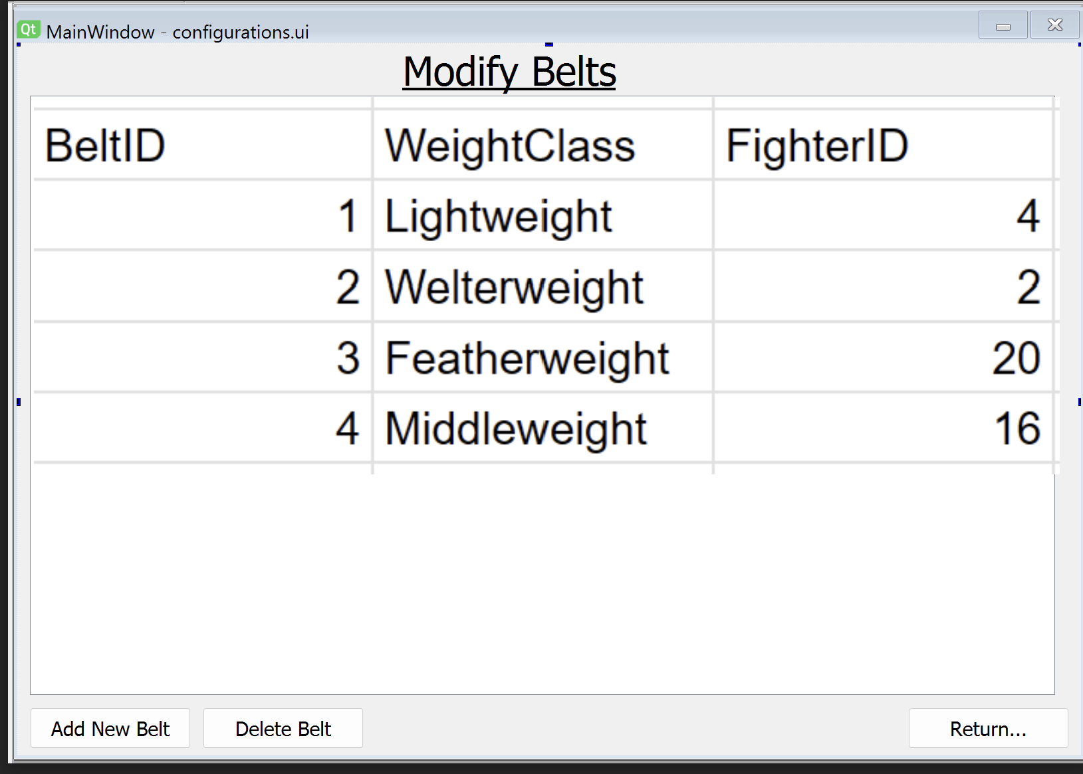
If you hover over a fighter ID, you will get the fighter’s name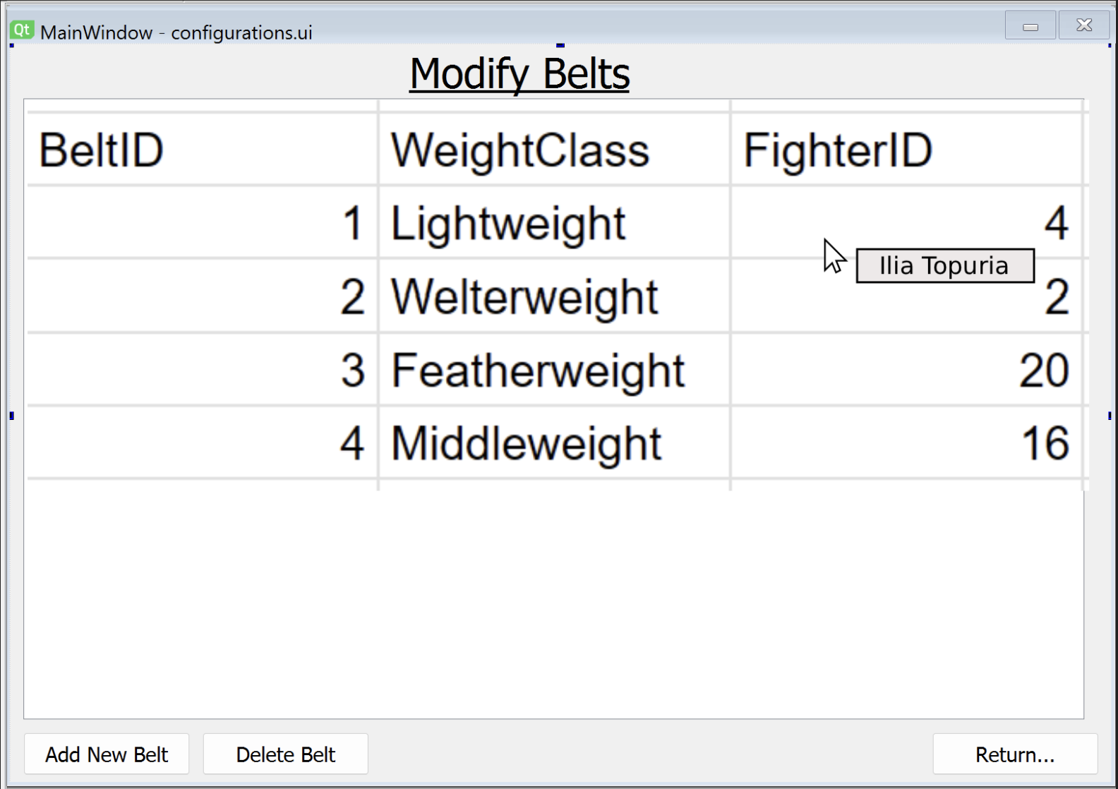
When the admin clicks add belt the ui will add a blank belt
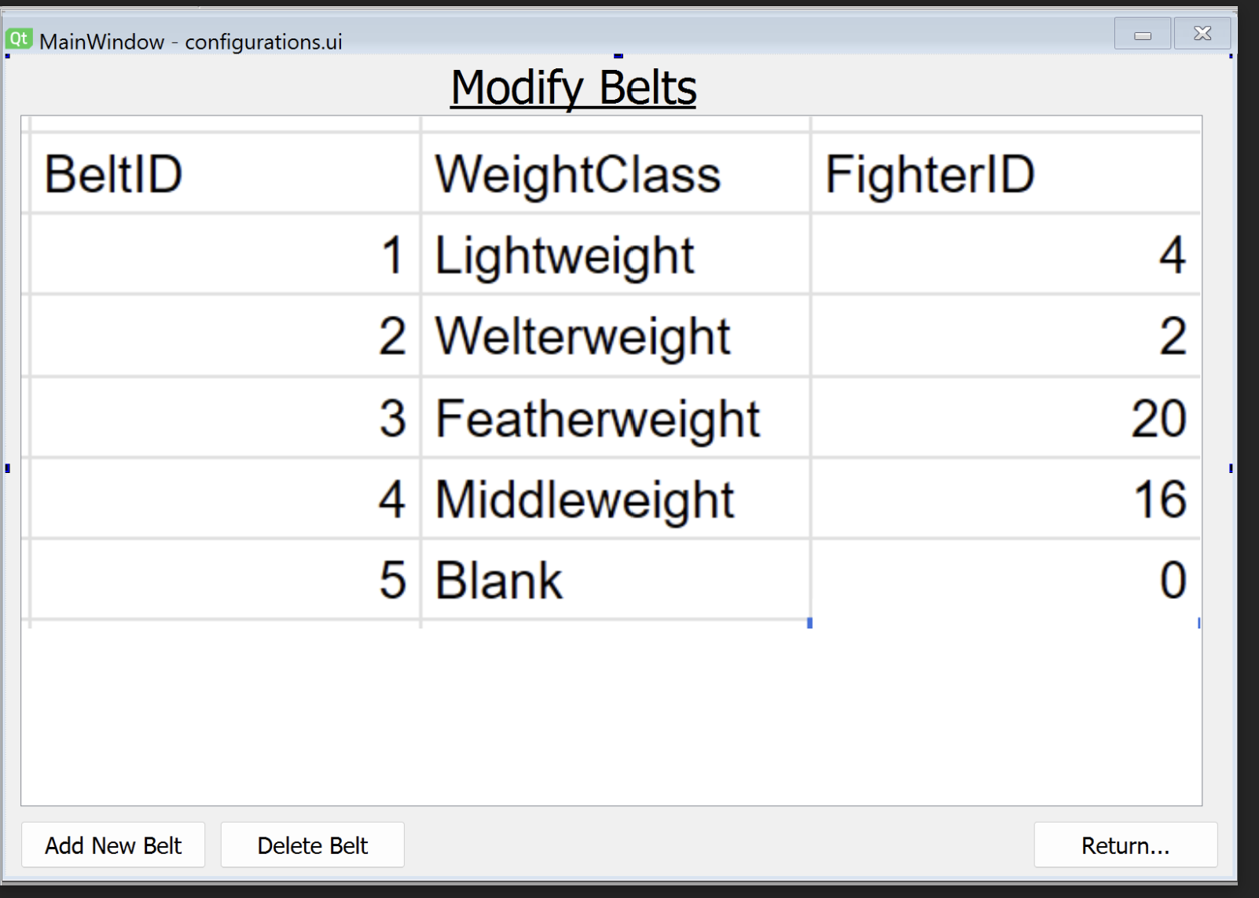
If you click delete belt it will delete whatever belt you had selected.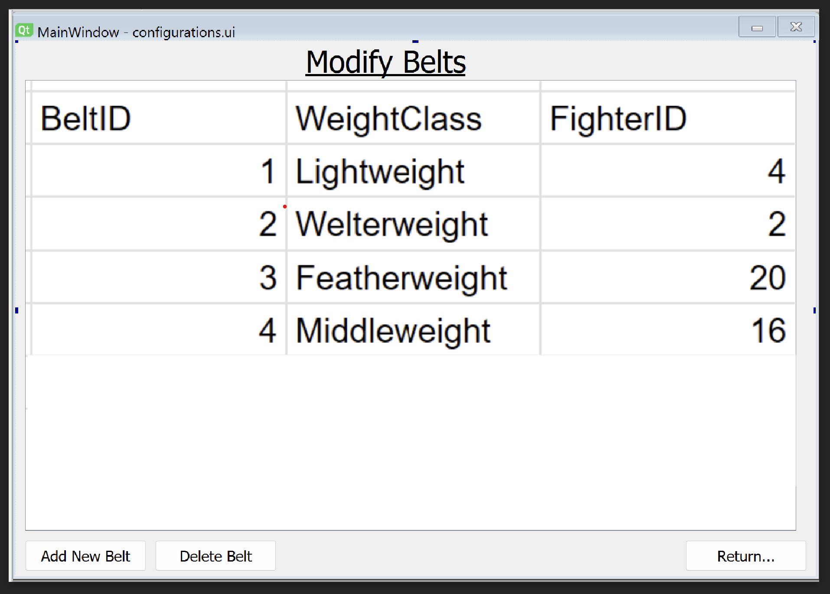
(IMPORTANT TO MENTION THAT BOTH TABLES ARE EDITABLE EXCEPT FOR THE IDs)
Modify events is very similar
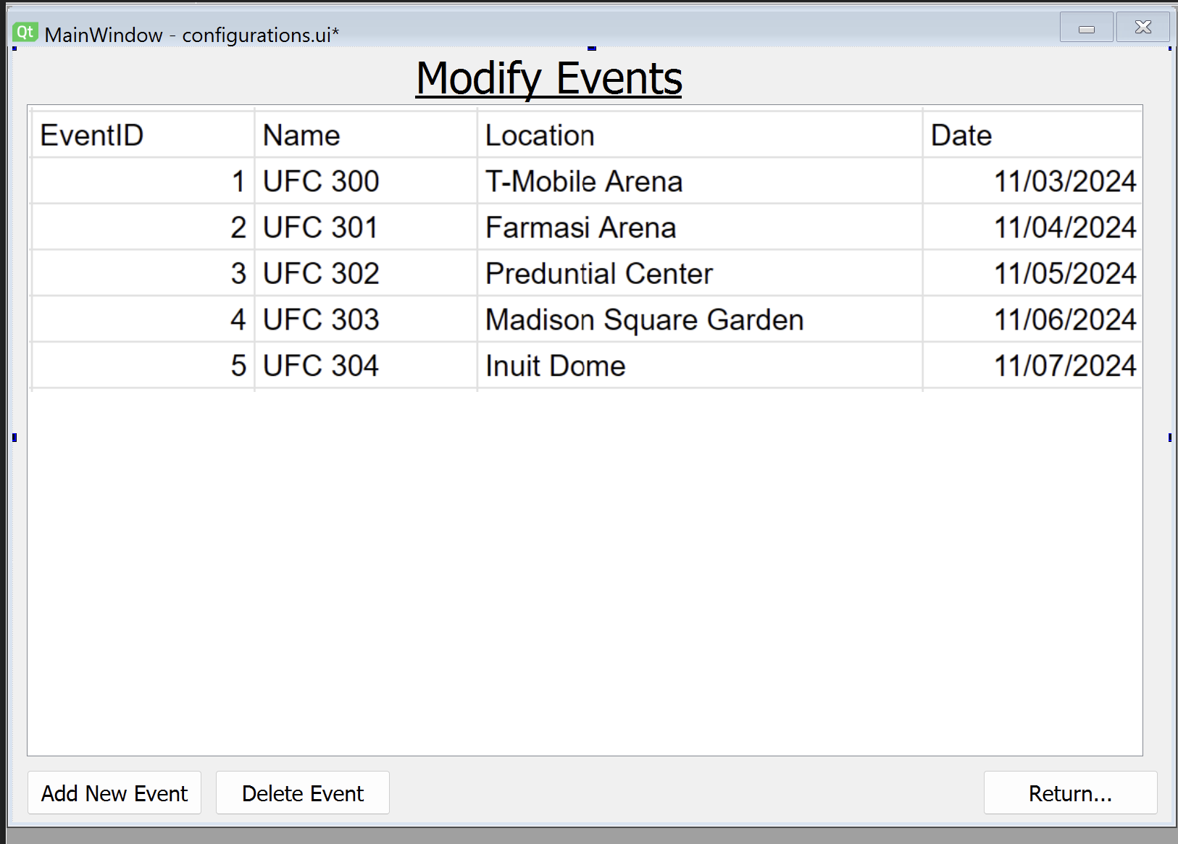
Add blank event
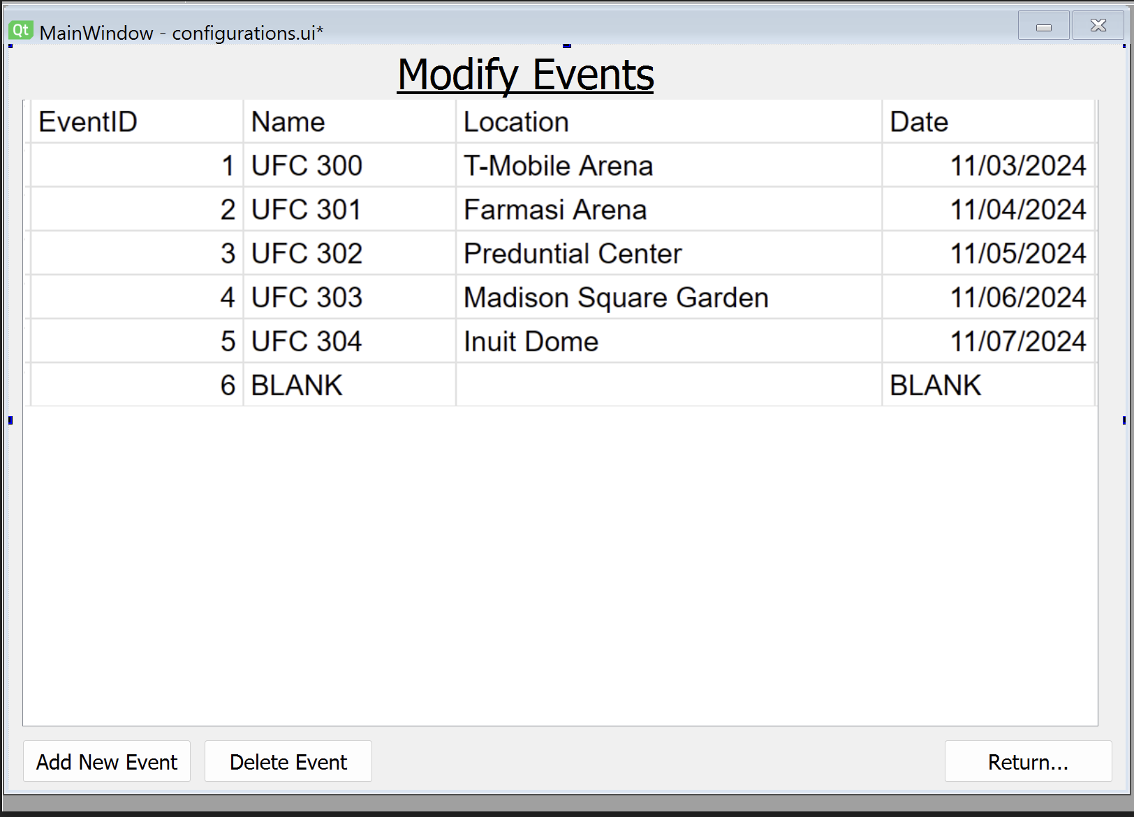
Leaderboard
This is what a baseline user will see if they open the leaderboard.
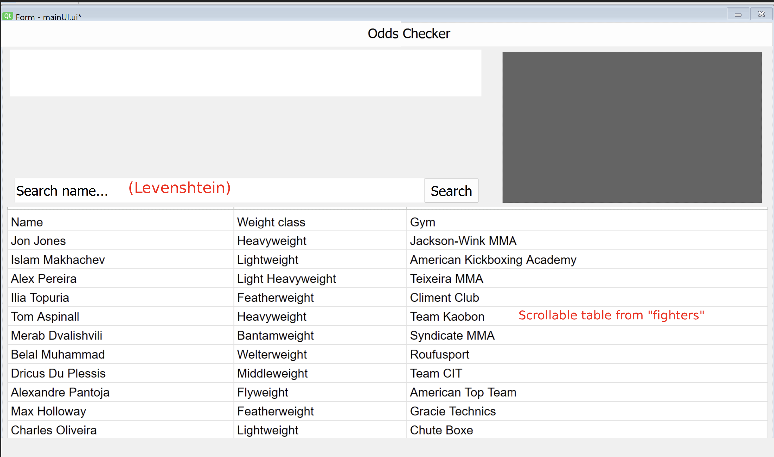
This is what they will see when they select a fighter.
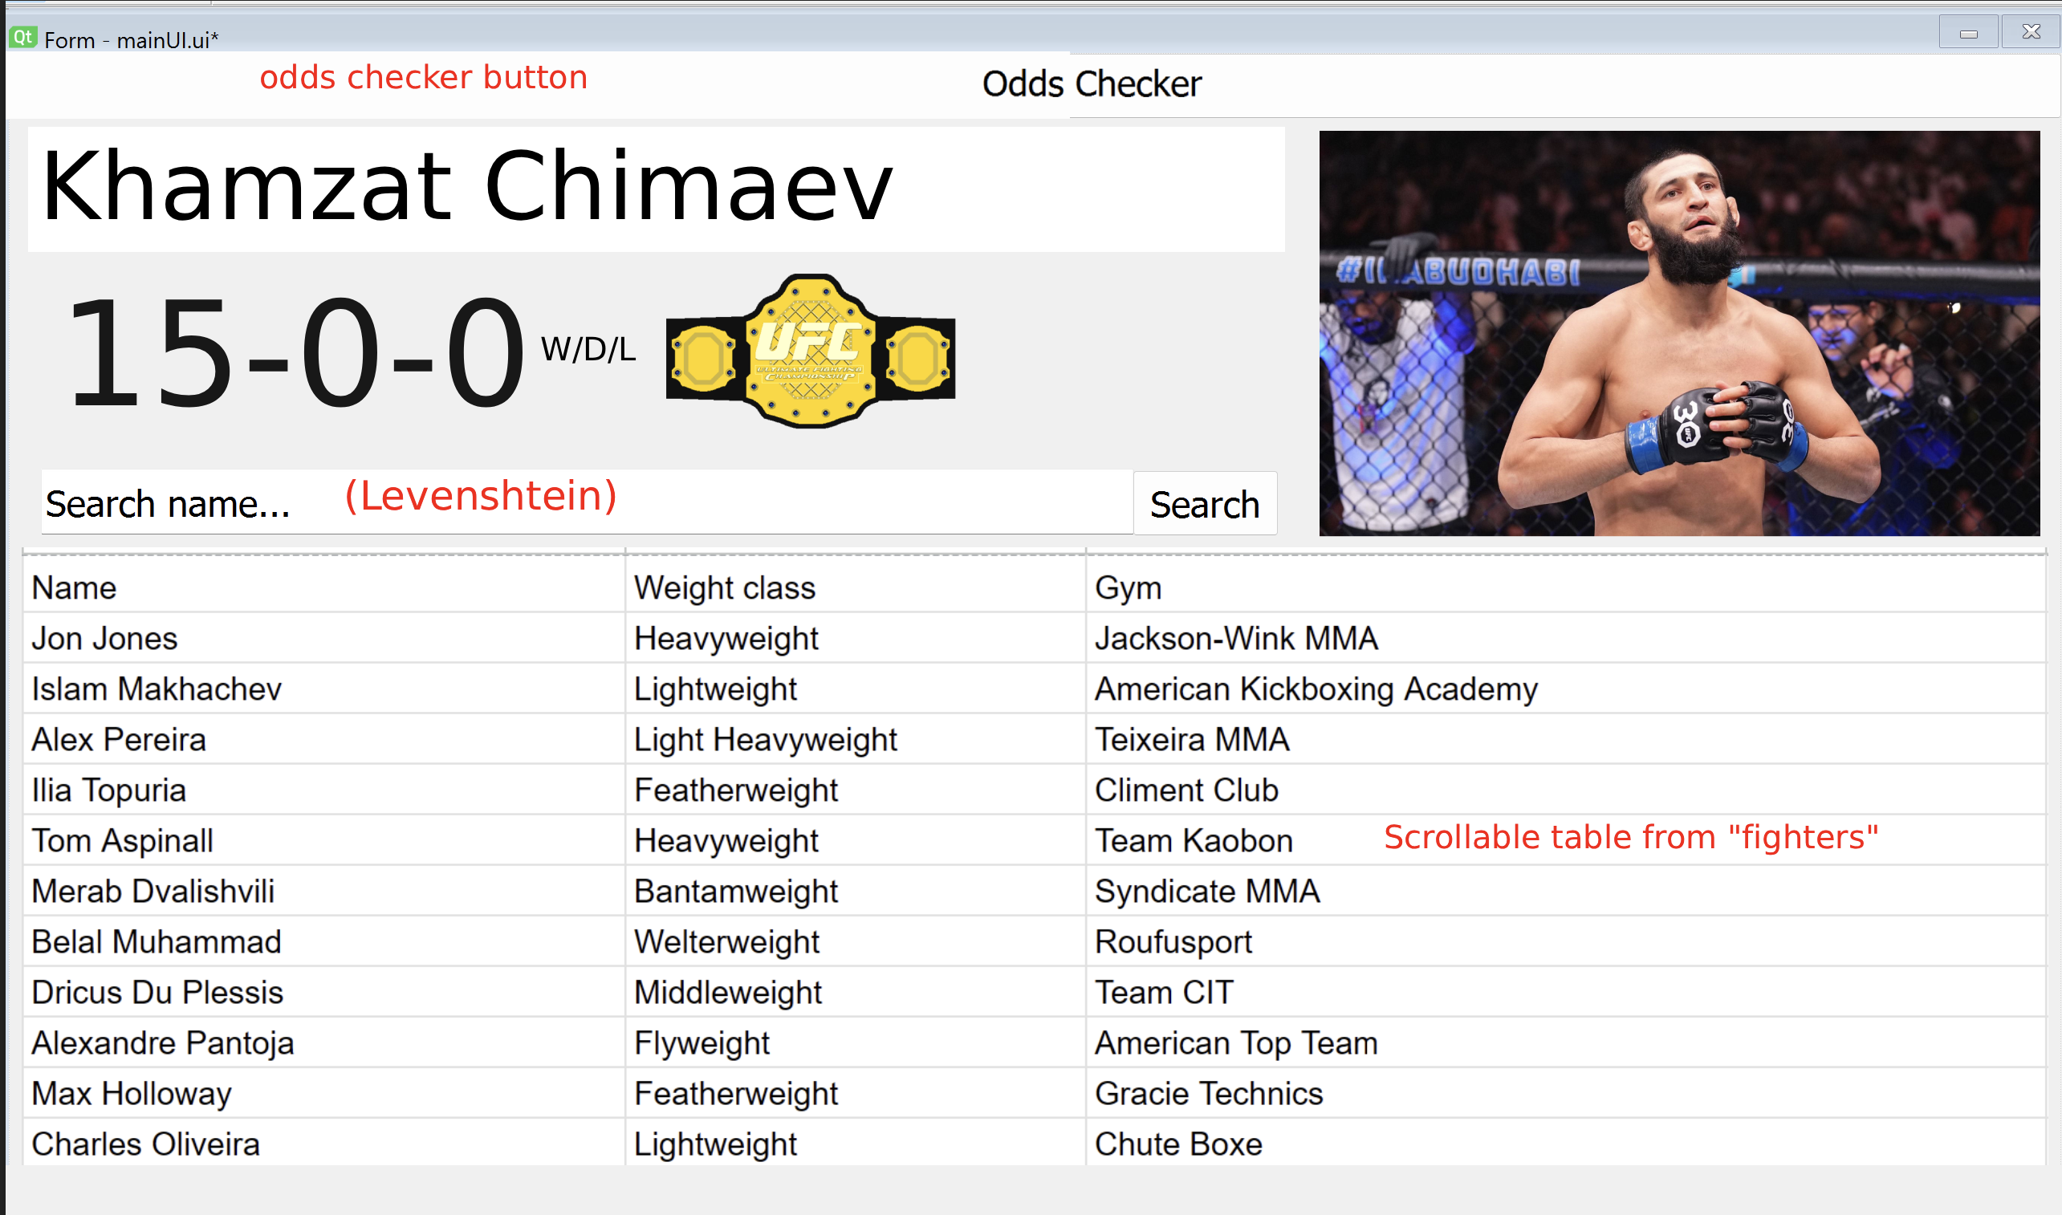
An admin will also have the modify fighters page available to go to.
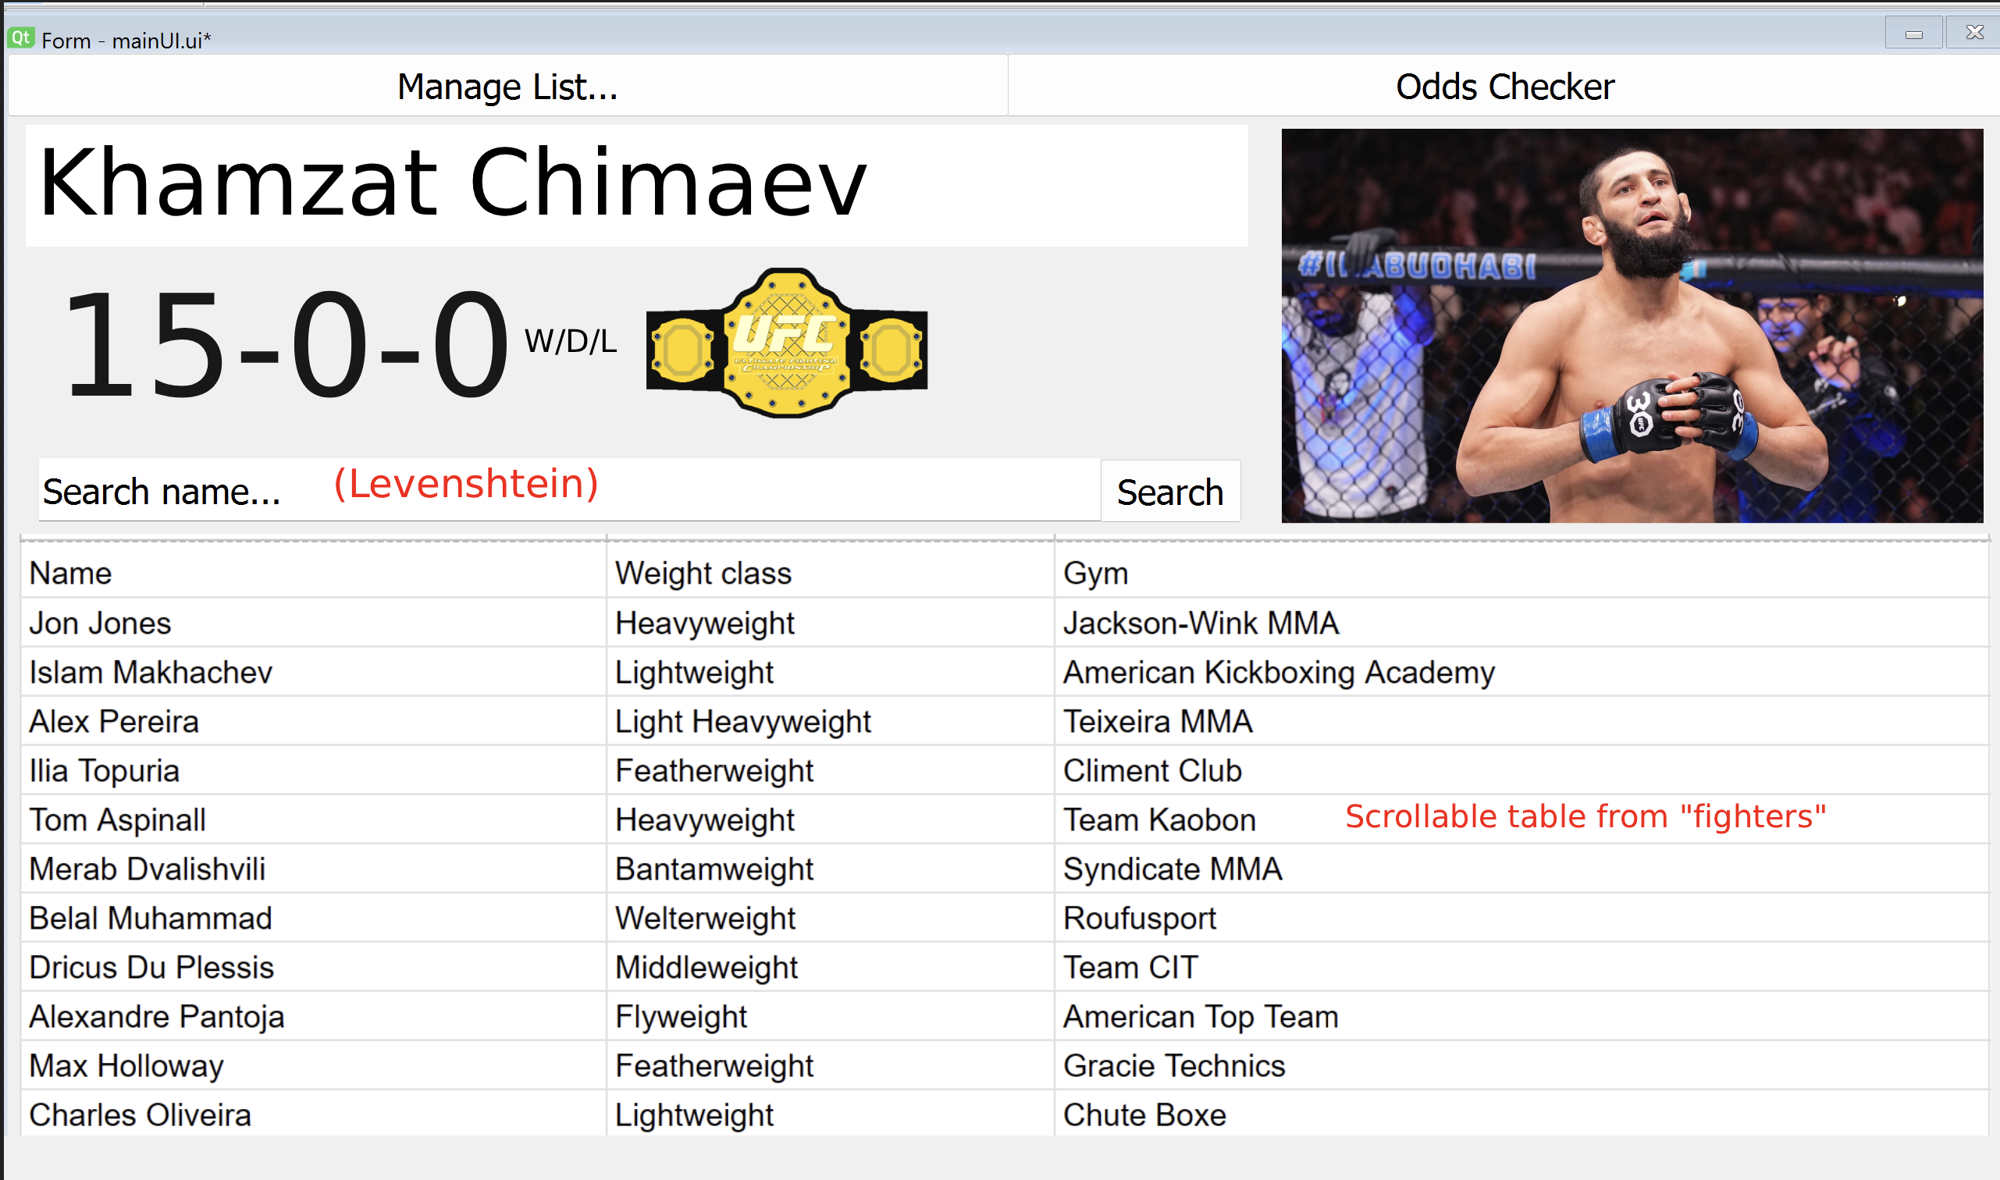
When the user double-clicks, they will be taken to that fighter’s page.

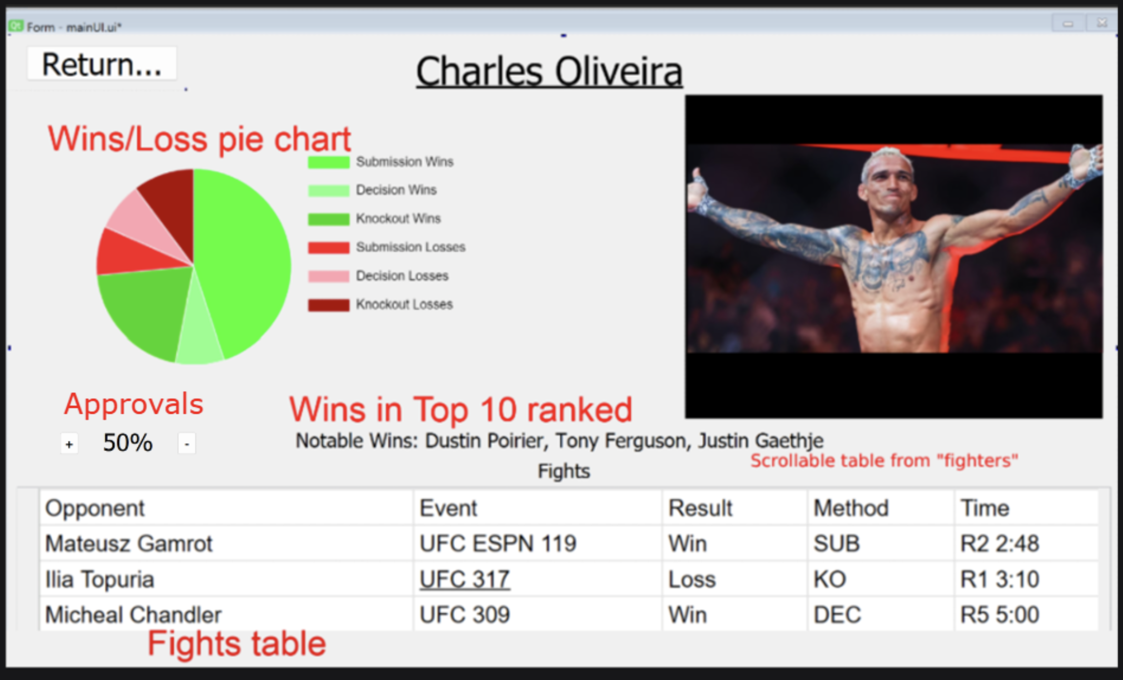

When the admin double-clicks a fighter on the modify fighter list page, they will get an alternative version of this profile, which features editing capabilities. Here is what that version looks like with no data
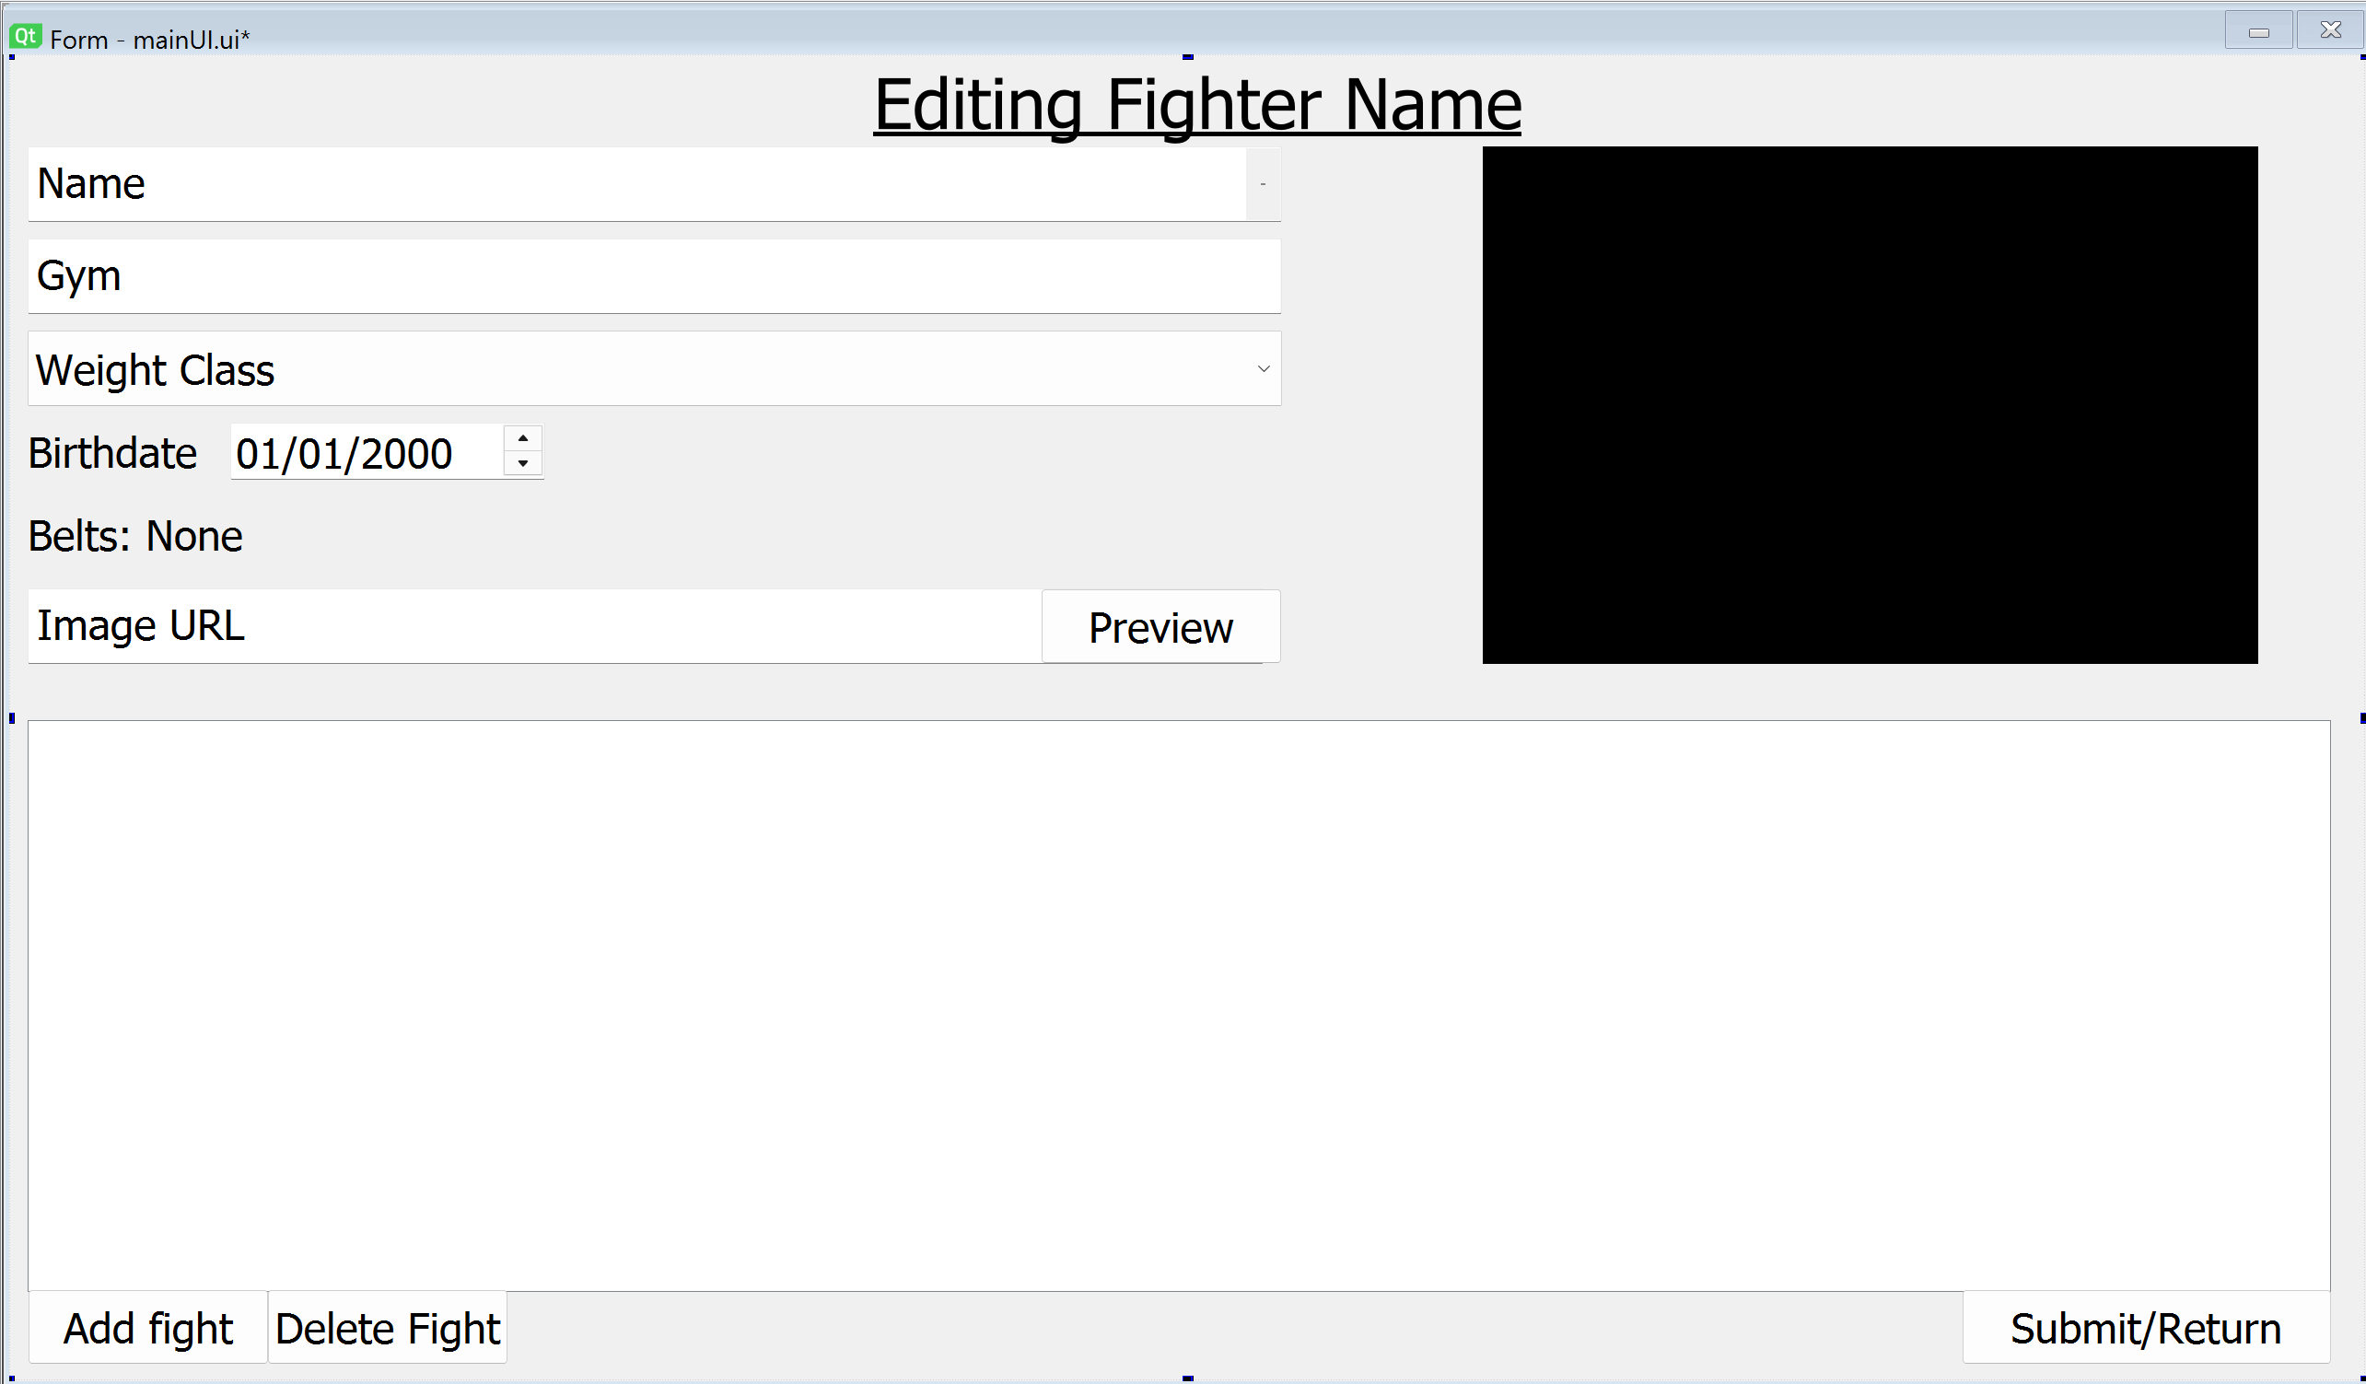
Here is what it should look like in action.
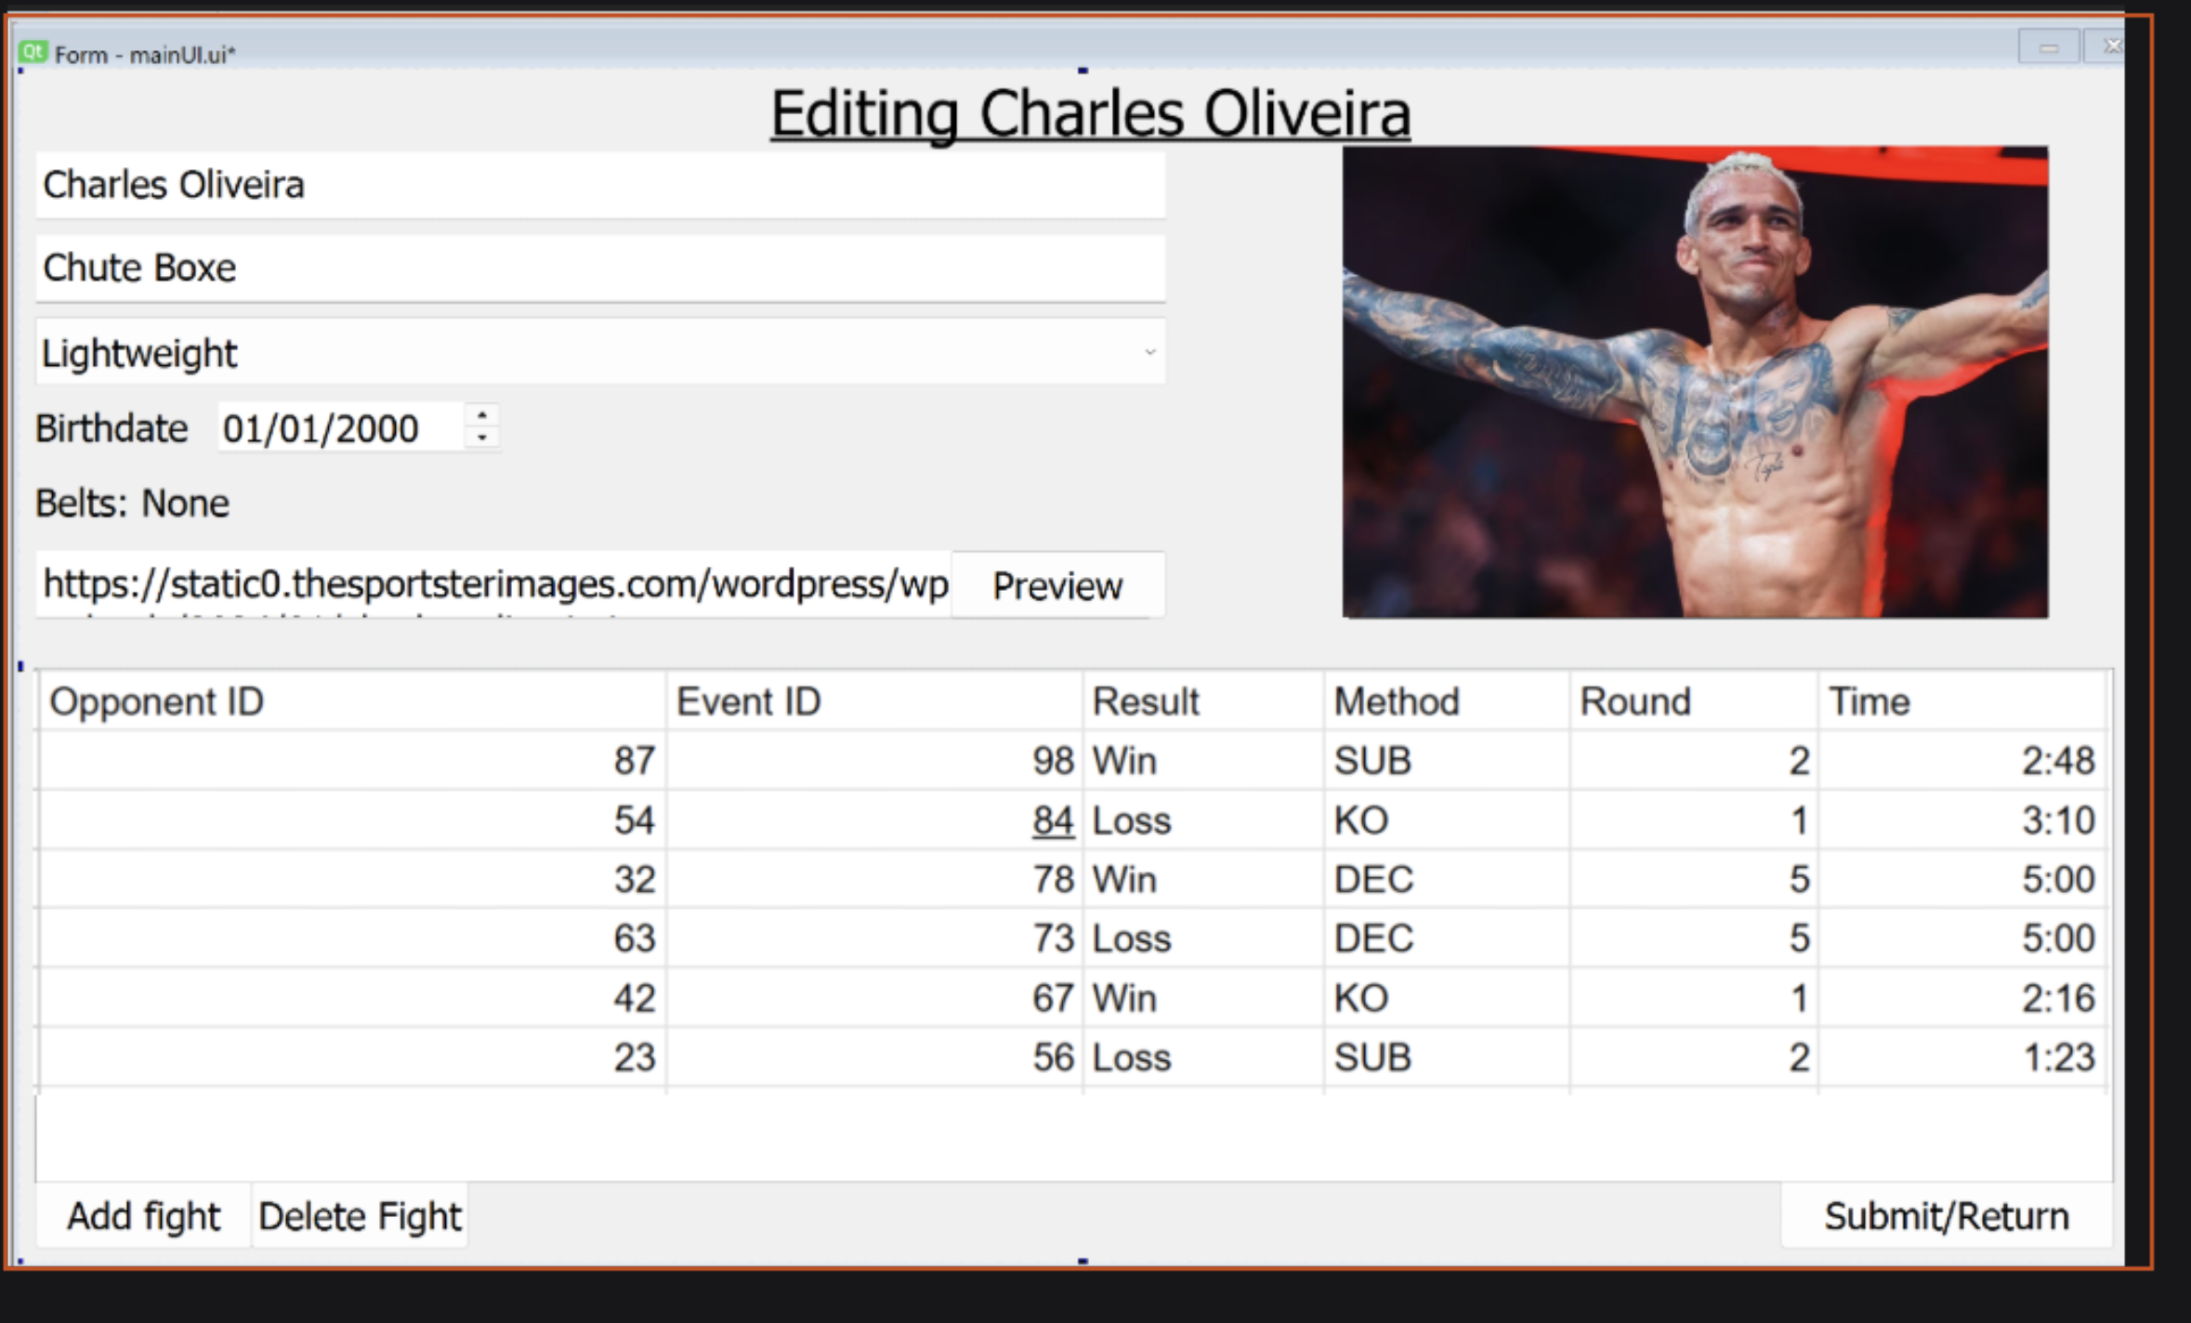

Data structure
For my project. I am using a relational SQL database. I have chosen to use an SQL database to store all my data. This is by far the most suitable way to store all my data for a multitude of reasons.
The reason I am using a relational database is because a relational database is well structured, making queries simpler. Also, a relational database allows all the connections between all my data to be represented efficiently with primary and foreign keys. A relational database is also good for data integrity. This is because you don’t have to repetitively refer to things, like you may do with other databases, which makes the database more vulnerable to data inconsistency. Relational databases are also more secure, as the database doesn’t have to return as much in a query that you could get in other databases.

The reason I am using SQL is that SQL is one of the best options for doing advanced database queries efficiently. I am going to be doing a lot of advanced calculations and queries, which SQL handles better than something like a Python flat file, for example. SQL also supports indexing. Without indexing, some of the queries I want to make will be extremely slow, especially when the database grows.
We are dealing with very valuable user data, so good security is an absolute must. SQL also helps with security since it supports simultaneous operations without messing up all the data. It also works well with hashing algorithms and requires authentication to access the database.
For management of queries, I am going to use Microsoft SQL Server. This is because Microsoft SQL server lets you deal with datatypes like dates which is really useful for when we handle event date ranges and things like that for validation’s sake

Methods of Access
Entity/Field in entity | Method Of Access | SQL Query | Sub Problem | Justification
Fighter Fights | Indirect | SELECT | 1.1 | The algorithm indirectly accesses each fight by accessing the results in the table of all the fights
Variance, ELO, RD from Fighters | Indirect | SELECT | 1.1 | The algorithm indirectly accesses each fighter by accessing the Elo stats of all the fighters in the table (using the foreign keys of Fighter Fights)
Fighter ELO from Fighters | Direct | UPDATE | 1.13 | The algorithm directly updates the fighter they’re checking’s ELO (using the foreign keys from Fighter Fights
Fighter volatility from Fighters | Direct | UPDATE | 1.10 | The algorithm directly updates the fighter they’re checking’s volatility (using the foreign keys from Fighter Fights)
Fighter rating deviation from Fighters | Direct | UPDATE | 1.13 | The algorithm directly updates the fighter they’re checking’s rating deviation using the foreign keys from Fighter Fights
Fighter stats from fighters | Indirect | SELECT | 1.16 | The algorithm indirectly accesses each fighter by putting them all onto a model for the admin/normal user to see
Find all fighter names from the fighters | Indirect | SELECT | 4.1 | Indirectly accesses each fighter by getting all their names up
Find the profile fighter’s image URL from the fighters | Direct | SELECT | 6.1 | Directly accesses the fighter’s image link using their primary key
Find fights where the profile fighter has fought in fighterfights and fights | Direct | SELECT | 6.2 | Directly accesses the fights that the fighter has fought in via a primary key, and then accesses the stats of those fights using a foreign key
Find Belts the profile fighter holds in belts | Direct | SELECT | 6.6 | Directly accesses the belts that the fighter holds via the fighter’s primary key.
Find the fighters who fight in the same division as the fighter profile in fighters | Indirect | SELECT | 8.1 | Indirectly accesses the fighters in the same weight division as the fighter we’re looking at
Find the fights that the top 10 fighters of the division have fought against the profile fighter in from fighters | Indirect | SELECT | 8.2 | Indirectly accesses the fights with fighters who are in the top 10 going against the fighter whose profile we are looking at
Find all fighters to display in the dropdown box alphabetically from fighters | Indirect | SELECT | 9.1 | Indirectly accesses all the names of the fighters in the leaderboard and puts them into a dropdown box
Find all fighters who fight in the weight class of the fighter selected in the other box from fighters | Indirect | SELECT | 9.1 | Indirectly accesses all the names of the fighters in the same weight class as the fighter in the other box
Checks the system for a duplicate username in users | Direct | SELECT | 10.1 | Directly accesses the one person who has the same username of the person trying to log in, in the users table, if they are there
Adds new user into users table | Direct | INSERT | 10.2 | Directly inserts new user with their data into users table
Logs user into their account by checking users table | Direct | SELECT | 10.3 | Directly accesses the hashed password of the profile the user is trying to log into in the users table using the username as the account’s unique identifier
Checks if user is an admin in users table | Direct | SELECT | 10.4 | Directly accesses the isAdmin bool of the user’s account in the users table
Updates user table with survey data | Direct | UPDATE | 10.5 | Directly accesses the user profile using their ID and adds their survey data to the users table
Add blank fighter onto the fighters table | Direct | INSERT | 11.1 | Directly inserts the blank fighter into the fighters table
Add blank fight onto the fights table | Direct | INSERT | 11.2 | Directly inserts the blank fight into the fights table
Autofills fights onto fighter fights | Direct | INSERT | 11.2 | Automatically enters info into fighter fights based off of fighter ids and outcomes
Insert a UFC event into the events table | Direct | INSERT | 12.1 | Directly inserts UFC events into the events table from a given date
Insert a UFC fight into the fights table | Direct | INSERT | 12.2 | Directly inserts UFC fights referenced to the events they are from via a foreign key
Insert the UFC fighters onto the database | Direct | INSERT | 12.3 | Directly inserts each fighter referenced by fights onto the database
Insert the UFC fight results onto fighter fights table | Direct | INSERT | 12.3 | Directly inserts each fight result referenced to a fight and two fighters
Select fighters in groups based off matching names and birthdays | Indirect | SELECT (GROUP BY) | 13.1 | Indirectly accesses each fighter to group them up if duplicated
Select events in groups based off of matching names and dates | Indirect | SELECT (GROUP BY) | 13.1 | Indirectly accesses each event to group them up if duplicated
Select fightIDS in groups from fighter fights based on matching fighters and events | Indirect | SELECT (GROUP BY) | 13.1 | Indirectly accesses each fighter fight record to group them up if they are a duplicate
Select weight from belts, all of events, method/end round/end time/title in fights, name/weight/birthday  /Gym in fighters, result/corner in fighterFights | Indirect | SELECT  (GROUP BY) | 13.1 | Indirectly accesses each of these records to validate them (format and range, and presence checks)
Find approval votes that are the same user and fighter | Direct | SELECT | 14.1/14.2 | Directly accesses a single rating by the userID and fighterID to see if the user has already voted the same way to stop them from voting twice
Add approval rating to the fighters rating (approvals) | Direct | INSERT | 14.1/14.2 | Directly inserts into the approvals table to add negative/positive rating to fighter rating table
Select all approval ratings to a fighter to figure out their rating (approvals) | Direct | SELECT | 14.3 | Directly accesses a single fighter’s rating from their fighterID
Select all fight results to total up the fights a fighter has fought in (fighterfights) | Direct | SELECT | 15.1 | Directly accesses a fighter’s results by their id
Select all fight results where a fighter has won via submission  (fighterfights and fights) | Direct | SELECT | 15.1 | Directly accesses fights referred to by fighter id where the method is a submission
Select all fight results where a fighter has won via ko  (fighterfights and fights) | Direct | SELECT | 15.1 | Directly accesses fights referred to by fighter id where the method is a ko
Select all fight results where a fighter has won via decision  (fighterfights and fights) | Direct | SELECT | 15.1 | Directly accesses fights referred to by fighter id where the method is a decision
Get the opinion survey results of the user currently using the table (Users) | Direct | SELECT | 15.2 | Directly accesses the opinion survey of the user account with the same id as the user who’s using the program’s id (i.e. the user)
Look for fights where they last equal to or less than 1s | Indirect | SELECT | 16.1 | Indirectly accesses all fights that are impossibly short
Look for fighters with a fight count of more than 12 | Indirect | SELECT with a SELECT GROUP BY subquery | 16.2 | Indirectly accesses all fights to count them up for each fighter , for every year
Bring up all belts from belts table | Indirect | SELECT | 18.1 | Indirectly accesses all belts to put them onto a table model
Add blank belt into belts table | Direct | INSERT | 18.2 | Directly insert a blank belt into the belts table
Delete belt from belts table | Direct | DELETE | 18.3 | Belt is directly deleted by its ID
Set title fight status of fights involving deleted belt to RETIRED (fights) | Indirect | UPDATE | 18.4 | Each fight is indirectly accessed to update the fights that include the title that just been retired to have the title as RETIRED
Find out how many weight classes there are in fighters | Direct | SELECT DISTINCT | 20.1 | Directly selects one example for each weight class
Find most recent title fight in individual weight class | Direct | SELECT | 20.2 | Selects one distinct title fight for each weight class (being the most recent ones)
Insert new belt with recent title fight winner onto database | Direct | INSERT | 20.3 | Directly inserts auto-generated belts onto table

Database design – ERD
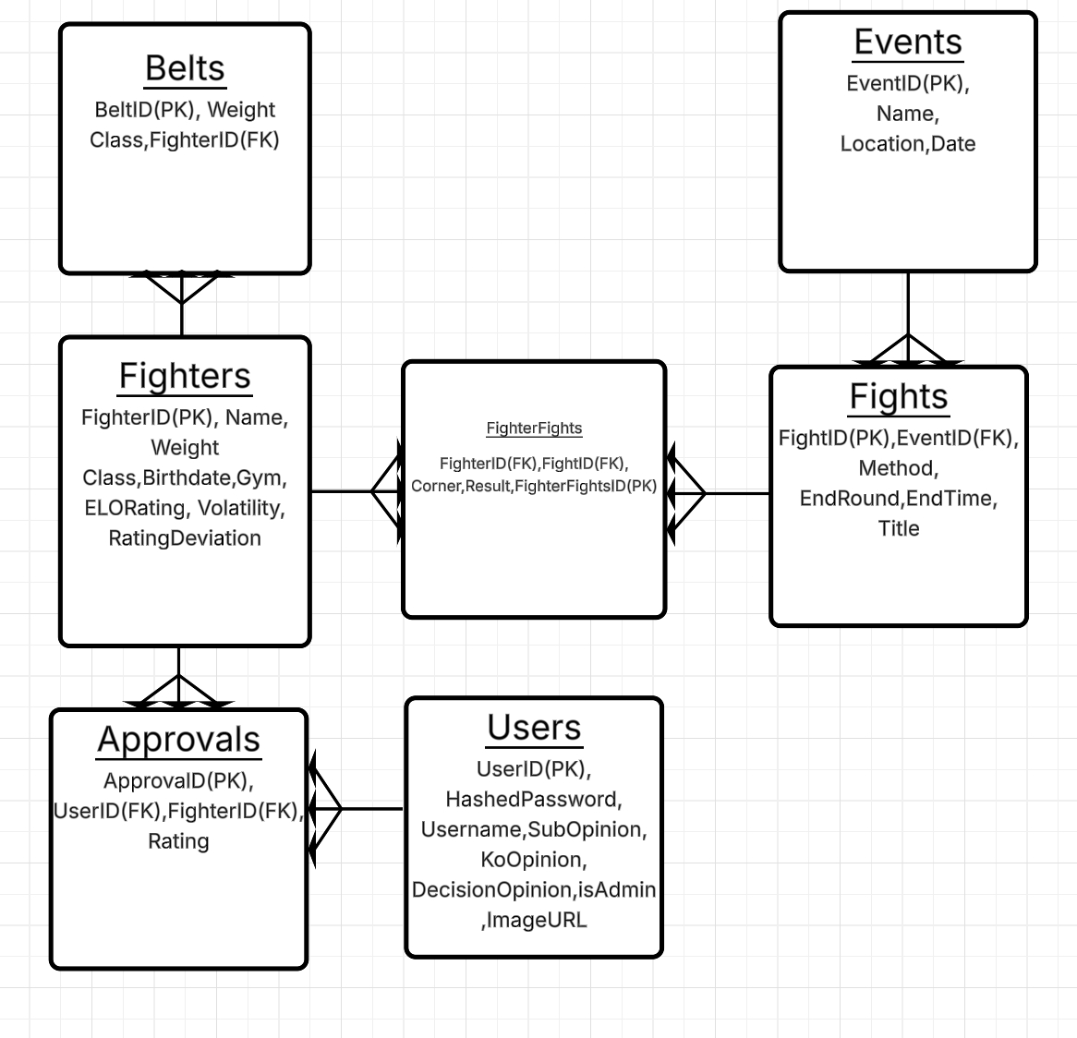

Justification of ERD
These are the main entities that are interacted with in the system. This entity relationship diagram shows how each of them interacts with the other. The admin enters an event into the system. Every event has many fights. Many fighters have many fights, so I have an intermediate Fighter Fights table. A belt can only be held by one fighter, and a fighter can have multiple belts
The way the User interacts with the fighter’s data is through their approval ratings. A user will vote a fighter up or down. One user has many Approval ratings. Many approval ratings are linked to one fighter.

Data Dictionary.

EVERY table you have identified in your ERD MUST have its own Data Dictionary!! Each one should have its own separate table.

 | Table Name: Belts
Field Name | Data Type | Description | Example | Validation | Key
BeltID | Int | Identifier for belt | 12 | Presence | Primary
Weight | Varchar | Weight class or just the belt title if it’s a special title | Welterweight | Length
FighterID | Int | The fighter who holds the belt | 75 | Lookup | Foreign

 | Table Name: Events
Field Name | Data Type | Description | Example | Validation | Key
EventID | Int | Event Identifier | 3 | Presence | Primary
Name | Varchar | Event name | UFC 300 | Length
Location | Varchar | Event Location | Madison Square Garden | Length
Date | Varchar (Date) | Date of event | 11/03/2024 | Format/Range  (dd/mm/yyyy)

 | Table Name: Users
Field Name | Data Type | Description | Example | Validation | Key
UserID | Int | Identifier for user | 32 | Presence | Primary
HashedPassword | Varchar | User’s Password hashed and salted | b834aac0f6… | Presence
Username | Varchar | User’s Username | 24jubbt476 | Presence
SubOpinion | Int | Submission survey answer 1-5 | 3 | Range
KoOpinion | Int | Ko survey answer 1-5 | 5 | Range
DecisionOpinion | Int | Decision Survey Answer | 1 | Range
isAdmin | Boolean | Checks if the user is an admin or not | False | Presence

 | Table Name: Approvals
Field Name | Data Type | Description | Example | Validation | Key
ApprovalID | Int | Identifier for approval vote | 12 | Presence | Primary
UserID | Int | Identifier for user | 53 | Lookup | Foreign
FighterID | Int | Identifier for a fighter | 24 | Lookup | Foreign
Rating | Boolean | Nature of approval (+1/positive if true, -1/negative if false) | True | Type

 | Table Name: Fights
Field Name | Data Type | Description | Example | Validation | Key
FightID | Int | Identifier for a fight | 20 | Presence | Primary
EventID | Int | Event the fight is in | 42 | Lookup | Foreign
Method | Varchar | The way the fight ended | KO | Lookup
EndRound | Int | Round the fight ended | 4 | Length
EndTime | Varchar  (Time) | The time the fight ended | 2:32 | Format/Range
Title | Varchar | If it’s a title fight, the title that the fight was fought for | Welterweight | Length

 | Table Name: FighterFights
Field Name | Data Type | Description | Example | Validation | Key
FighterFightsID | Int | Identifier for intermediate | 23 | Presence | Primary
FighterID | Int | Identifier for Fighter | 45 | Lookup | Foreign
FightID | Int | Identifier for the fight | 21 | Lookup | Foreign
Corner | Varchar | Corner the fighter was in | Red | Lookup
Result | Varchar | Result of fighter in fight | W | Lookup

 | Table Name: Fighters
Field Name | Data Type | Description | Example | Validation | Key
FighterID | Int | Identifier for a fighter | 24 | Presence | Primary
Name | Varchar | Name of fighter | Khalil Rountree | Length
WeightClass | Varchar | Weight class of the fighter | Light Heavyweight | Lookup
Birthdate | Varchar | Fighter’s birthday | 11/04/1993 | Format
Gym | Varchar | Gym that fighter fights at | American Kickboxing Academy | Length
ELORating | Float | ELO rating of a fighter | 1500 | Presence and range
Volatility | Float | Variation in the performance of the fighter | 1.2 | Presence and range
Rating Deviation | Float | Certainty of fighter’s rating | 50 | Presence and range
ImageURL | Varchar | URL of image of fighter |  | Length

Validation

Data Validation techniques I use:
Presence check
A presence check is where you ensure that a required field has not been left empty or blank. For example, all primary keys cannot be left empty to prevent nulls.
Length check
Confirms the string data is inside of a character limit. For example, an event name can only be up to 80 characters long
Range check
Confirms that a number falls inside of a boundary. For example an opinion rating has to be from 1 to 5.
Format check
Confirms that data adheres to a specific structure. For example, the end time column in the fights table has to be in the format mm:ss or m:ss
Lookup check
Ensures that a foreign key actually exists as a primary key in the other table or if it matches a list of pre-defined values (domain lookup). For example, a gym name can only be up to 80 characters long
Type check
Confirms that an input is a specific data type. For example, an approval rating needs to be boolean
It’s important to note that in actual deployment (and most definitely with the final copy of my project) In the readme it will go through all the types of validation rules I use for the admin to understand what each mean.
Data validation cases
(When I refer to a list in the error messages the contents of that list will be output as a validation error table to the admin)
Table | Field | Valid. Type | Validation Rule | Error Message
Belts | BeltID | Presence | BeltID cannot be left empty. | User:Validation Error, please contact admin.  Admin:[Presence,Belts,BeltID, Name=Welterweight]
Belts | Weight | Length | Up to 60 characters long | User:Validation Error, please contact admin.  Admin:[Format,Belts,Weight,  BeltID={BeltID}]
Belts | FighterID | Lookup | FighterID must really exist as a fighter. | User:Validation Error, please contact admin.  Admin:[Lookup,Belts,FighterID,BeltID={Fighter}]
Events | EventID | Presence | EventID cannot be left empty | User:Validation Error, please contact admin.  Admin:[Presence,Events,EventID,  Name={Events}]
Events | Name | Length | The name of the event cannot be longer than 80 characters | User:Validation Error, please contact admin.  Admin:[Length,Events,Name,  EventID={EventID}]
Events | Location | Length | The location name cannot be longer than 100 characters | User:Validation Error, please contact admin.  Admin:[Length,Events,Location,  EventID={EventID}]
Events | Date | Format/Range | The format of the date must follow dd/mm/yyyy format and can’t be in the future | User:Validation Error, please contact admin.  Admin:[Format,Events,Date,  EventID={EventID}]
Users | UserID | Presence | UserID cannot be left empty | User:Validation Error, please contact admin.  Admin:[Presence,Users,UserID,  Username={Username}]
Users | HashedPassword | Presence | The password can’t be left empty | User:Validation Error, please contact admin.  Admin:[Presence,Users,UserID,HashedPassword,  Username={Username}]
Users | Username | Presence | Username can’t be left empty | User:Validation Error, please contact admin.  Admin:[Presence,Users,UserID,Username,  UserID={UserID}]
Users | SubOpinion | Range | The opinion ratings should be from 1-5 | User:Validation Error, please contact admin.  Admin:[Range,Users,UserID,SubOpinion  UserID={UserID}]
Users | KoOpinion | Range | The opinion ratings should be from 1-5 | User:Validation Error, please contact admin.  Admin:[Range,Users,KoOpinion,  UserID={UserID}]
Users | DecisionOpinion | Range | The opinion ratings should be from 1-5 | User:Validation Error, please contact admin.  Admin:[Range,Users,DecisionOpinon,  UserID={UserID}]
Users | isAdmin | Presence | The admin identifier cannot be left empty | Automatically reverted to False but errors will be handled to be safe  User:Validation Error, please contact admin.  Admin:[Presence,Users,isAdmin,  UserID={UserID}]
Approvals | ApprovalID | Presence | ApprovalID can’t be left empty | User:Validation Error, please contact admin.  Admin:[Presence,Approvals,ApprovalID,  UserID={UserID}]
Approvals | UserID | Lookup | The user the approval is referring to must be real | User:Validation Error, please contact admin.  Admin:[Lookup,Approvals,UserID,  ApprovalID={ApprovalID}]
Approvals | FighterID | Lookup | The fighter the approval is referring to must be real | User:Validation Error, please contact admin.  Admin:[Lookup,Approvals,FighterID,  ApprovalID={ApprovalID}]
Approvals | Rating | Type | The Rating itself needs to be Boolean | User:Validation Error, please contact admin.  Admin:[Type,Approvals,Rating,  ApprovalID={ApprovalID}]
Fights | FightID | Presence | The fight ID cannot be left empty | User:Validation Error, please contact admin.  Admin:[Presence,Fights,FightID,  EventID={EventID}]
Fights | EventID | Lookup | The event the fight is on must exist | User:Validation Error, please contact admin.  Admin:[Lookup,Fights,EventID,  FightID={FightID}]
Fights | Method | Lookup | (normalised into uppercase) The result must be either [SUB,KO,DEC,NC,DRAW] | User:Validation Error, please contact admin.  Admin:[Lookup,Fights,Method,  FightID={FightID}]
Fights | EndRound | Length | The number must be up to 5 rounds | User:Validation Error, please contact admin.  Admin:[Length,Fights,EndRound,  FightID={FightID}]
Fights | EndTime | Format/Range | The time must be in the format mm:ss or m:ss and from 0:00 to 25:00 | User:Validation Error, please contact admin.  Admin:[Format,Fights,EndTime,  FightID={FightID}]
Fights | Title | Length | Must be up to 60 characters | User:Validation Error, please contact admin.  Admin:[Lookup,Fights,Title,  FightID={FightID}]
FighterFights | FighterFightsID | Presence | FighterfightsID cannot be left empty | User:Validation Error, please contact admin.  Admin:[Presence,FighterFights,FighterFightsID,  FightID={FightID}]
FighterFights | FighterID | Lookup | Fighter must exist | User:Validation Error, please contact admin.  Admin:[Lookup,FighterFights,FighterID,  FighterFightsID={FighterFightsID}]
FighterFights | FightID | Lookup | Fight must exist | User:Validation Error, please contact admin.  Admin:[Lookup,FighterFights,FightID,  FighterFightsID={FighterFightsID}]
FighterFights | Corner | Lookup | (Normalised into lowercase) Corner must be either Red/A or Blue/B) | User:Validation Error, please contact admin.  Admin:[Lookup,FighterFights,Corner,  FighterFightsID={FighterFightsID}]
FighterFights | Result | Lookup | Must be either W/D/L/NC | User:Validation Error, please contact admin.  Admin:[Lookup,FighterFights,Result,  FighterFightsID={FighterFightsID}]
Fighters | FighterID | Presence | FighterID can’t be left blank | User:Validation Error, please contact admin.  Admin:[Presence,Fighters,FighterID,  Name={Name}]
Fighters | Name | Length | Name can’t be greater than 60 characters | User:Validation Error, please contact admin.  Admin:[Length,Fighters,Name,  FighterID={FighterID}]
Fighters | WeightClass | Lookup | (Will be normalised into lowercase) must follow the weight classes of sanctioned MMA. Being Atomweight,Strawweight,Flyweight,Bantamweight,Featherweight,Lightweight,Welterweight,Middleweight,Light Heavyweight,Heavyweight,Super Heavyweight, Catchweight. All these weight classes also can have the prefix of Women’s for WMMA | User:Validation Error, please contact admin.  Admin:[Lookup,Fighters,WeightClass,  FighterID={FighterID}]
Fighters | Birthdate | Format and range | Must be in date format dd/mm/yyyy and can’t be in the future | User:Validation Error, please contact admin.  Admin:[Format,Fighters,Birthdate,  FighterID={FighterID}]
Fighters | Gym | Length | Can’t be greater than 80 characters | User:Validation Error, please contact admin.  Admin:[Length,Fighters,Gym,  FighterID={FighterID}]
Fighters | ELORating | Presence and range | Must be a float and in a sensible range being minimum 0 and maximum 3000 | User:Validation Error, please contact admin.  Admin:[Presence/Range,Fighters,EloRating,  FighterID={FighterID}]
Fighters | Volatility | Presence and range | Must be a float and in a sensible range being minimum 0 and maximum 1 | User:Validation Error, please contact admin.  Admin:[Presence/Range,Fighters,Volatility,  FighterID={FighterID}]
Fighters | Rating Deviation | Presence and range | Must be a float and in a sensible range being minimum 0 and maximum 350 | User:Validation Error, please contact admin.  Admin:[Presence/Range,Fighters,Rating Deviation,  FighterID={FighterID}]
Fighters | ImageURL | Length and format check | Must be up to 255 characters | User:Validation Error, please contact admin.  Admin:[Length/Format,Fighters,ImageURL,  FighterID={FighterID}]

Exception handling/ python validation
Sub-Problem | Operation | Description | Error Message
1 during updates (7-11) | Asserts wrapped in Try | When doing the calculations the possible boundary will be asserted to make sure nothing goes wrong. If there is a mathematical error an exception will be raised and then displayed on a dialog box. | {Quality} calculation error. For example, if its ELO it will be “ELO calculation error”
2 | Connection and execution wrapped in a try | When doing the SQL connections and executing a query it will be wrapped in a try statement to make sure that if the server fails the whole program doesn’t break | Outputs SQL request exception in dialog box
6.1 | HTTP request to get image from URL wrapped in a try statement | When sending the http request to get the image data it will be put into a try statement to stop the program from breaking if the request fails | Outputs http request exception in dialog box
19 | General exceptions caught by sys | When there is an error it will go through an sys excepthook for it to be caught before it has any proper impact | Outputs error in a dialog box and also logs the traceback of the error for debugging
General | Nonetype catching | When the user does an input to avoid the program breaking if the result doesn’t exist the program will first check if it exists | The program will deal with the subroutine sensibly most probably either replacing the value or returning the subroutine

Data integrity insurance
These features I have make sure the data is correct.
Technique | Description | Example
Data duplication flagging | The system will flag data that is most probably duplicated | The system will flag fights that involve the same fighters on the same dates
Statistical anomaly flagging | The system will flag features in the data that can’t possibly happen | The system will flag a fighter who has fought equal to or more than 12 times in a year

Algorithms
Subproblem | Algorithm
1 | 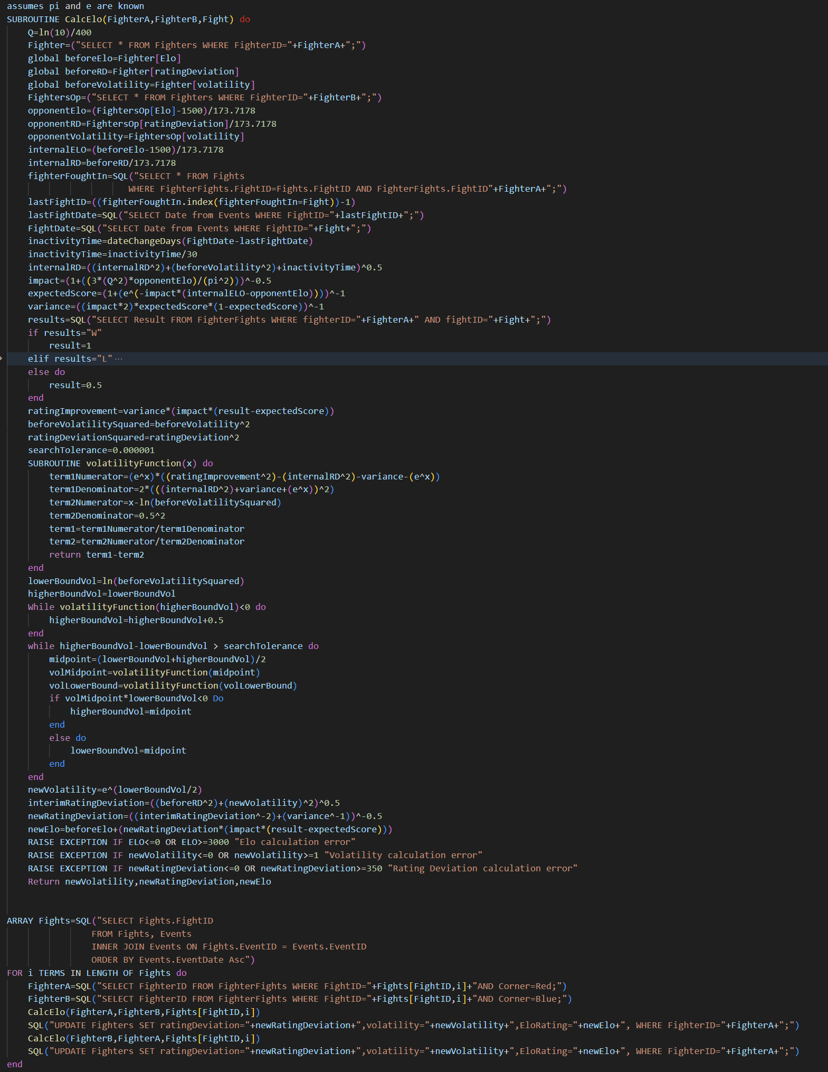
2 | 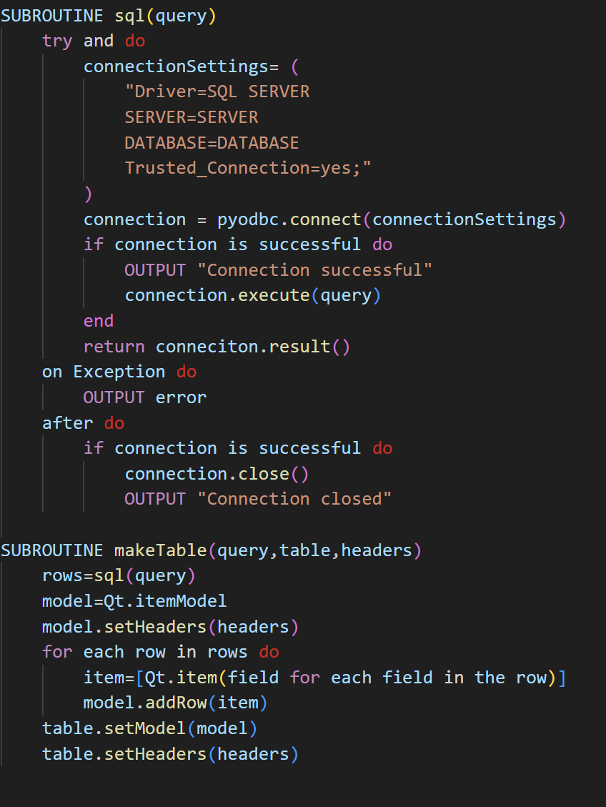
3 | 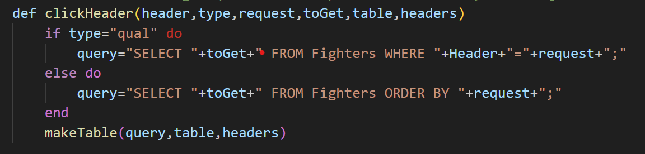
4 | 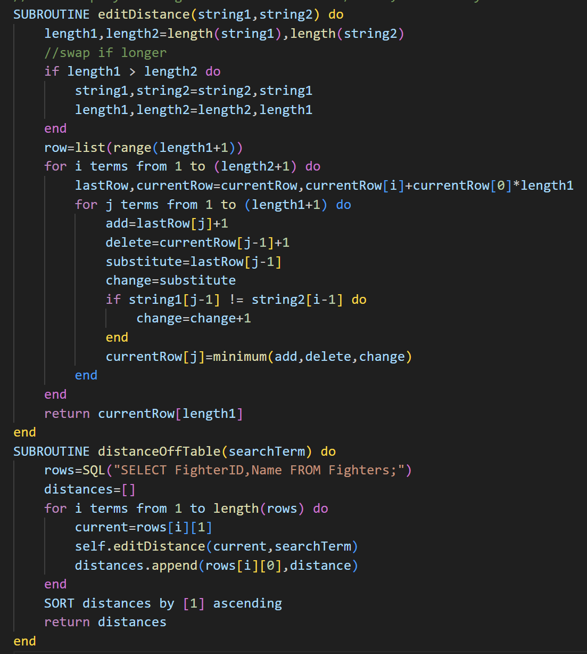
5/6  ProfileID is a global | 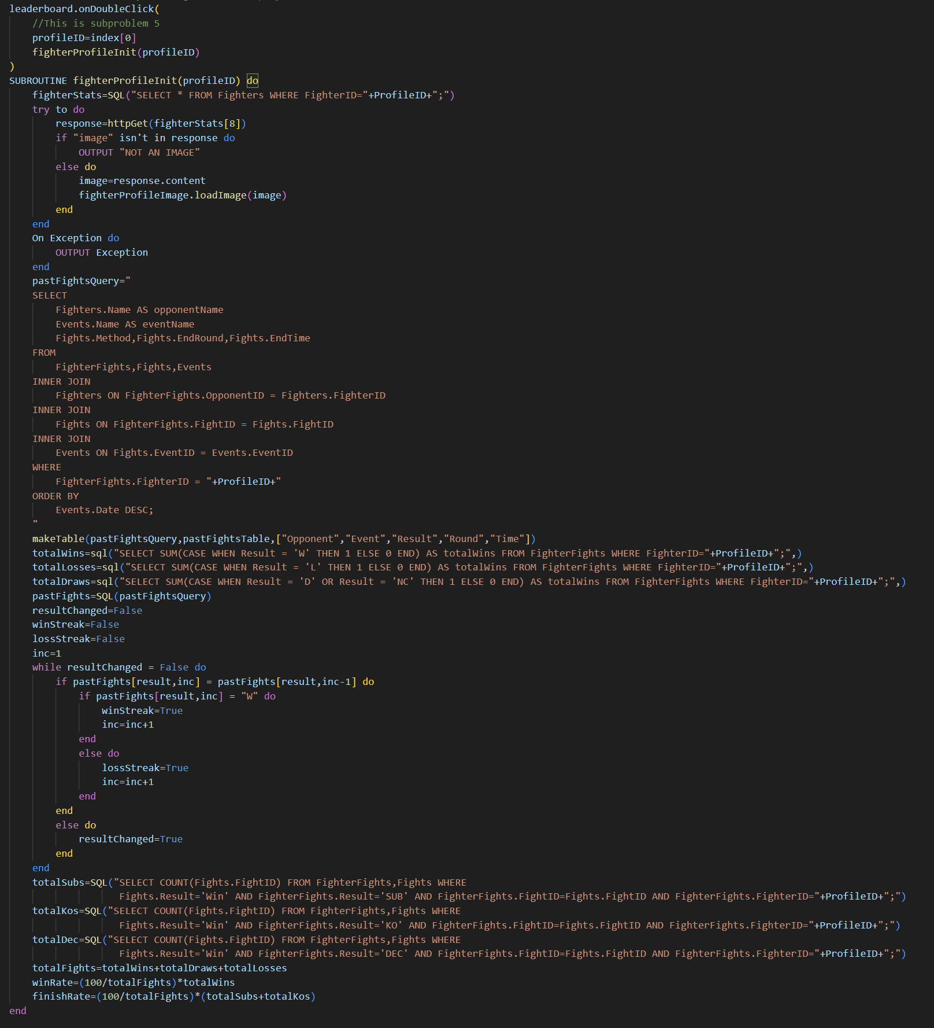
8 | 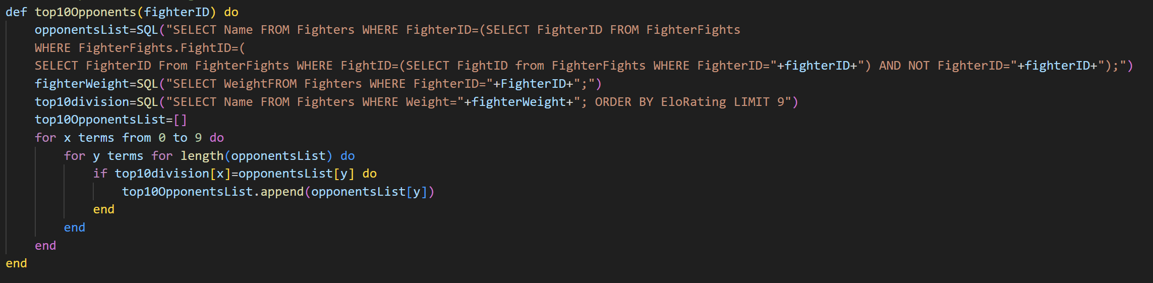
9 | 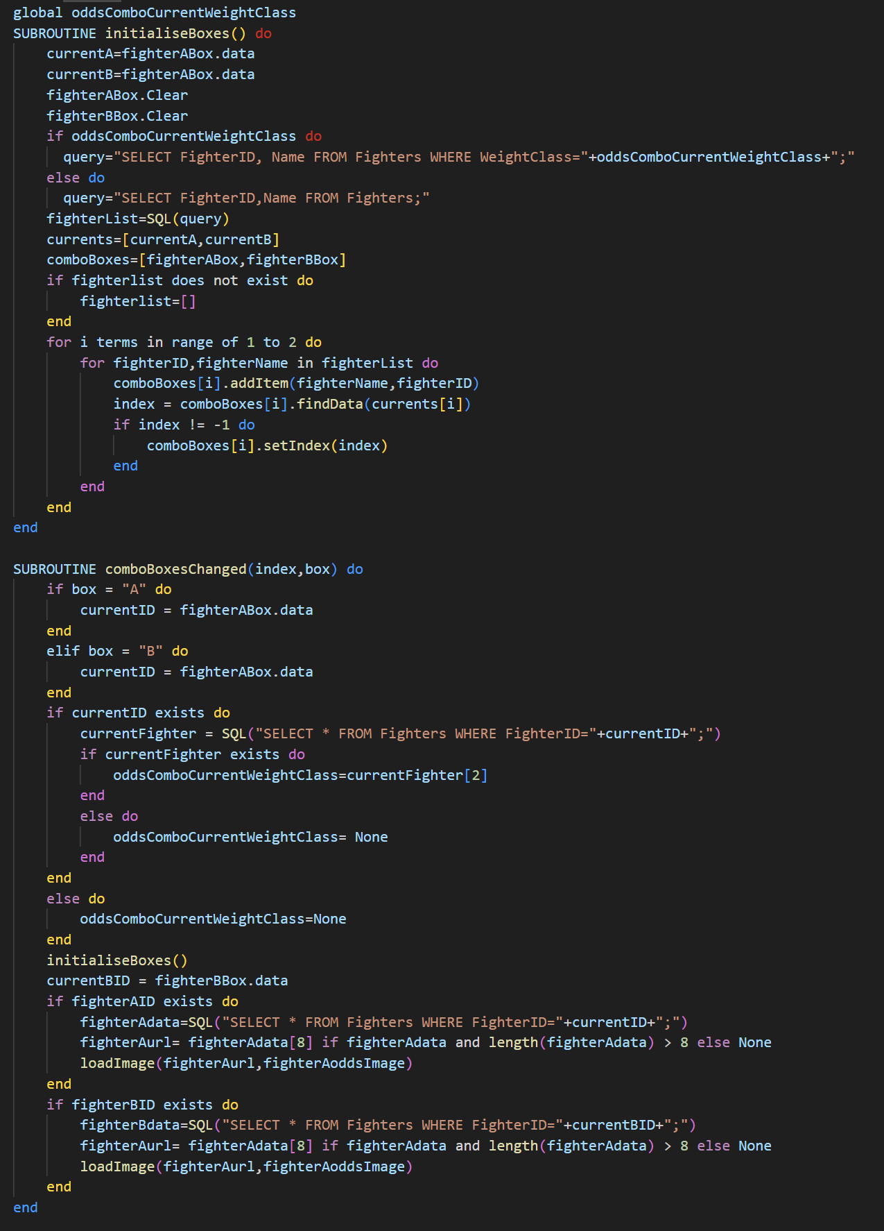
10.1 | 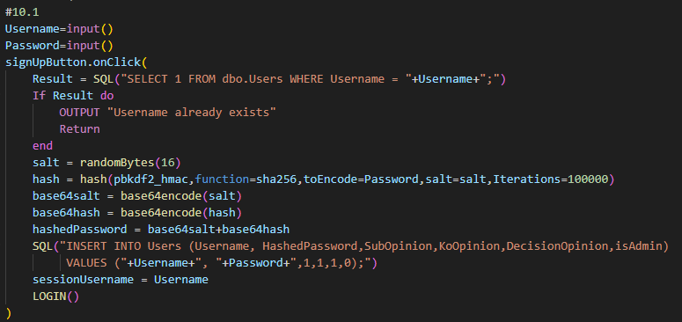
10.2 | 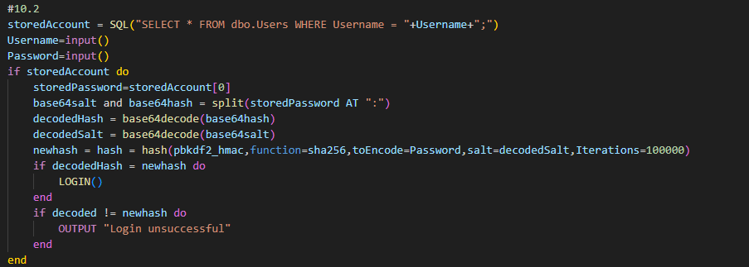
10.3 | 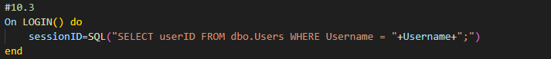
10.4 | 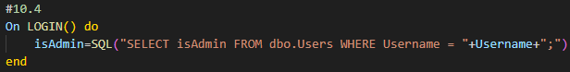
10.5 | 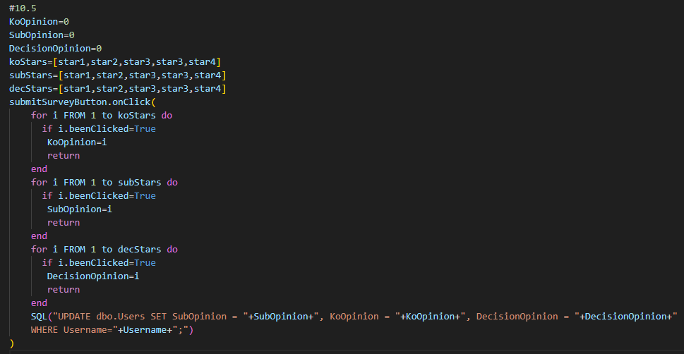
11
12 | 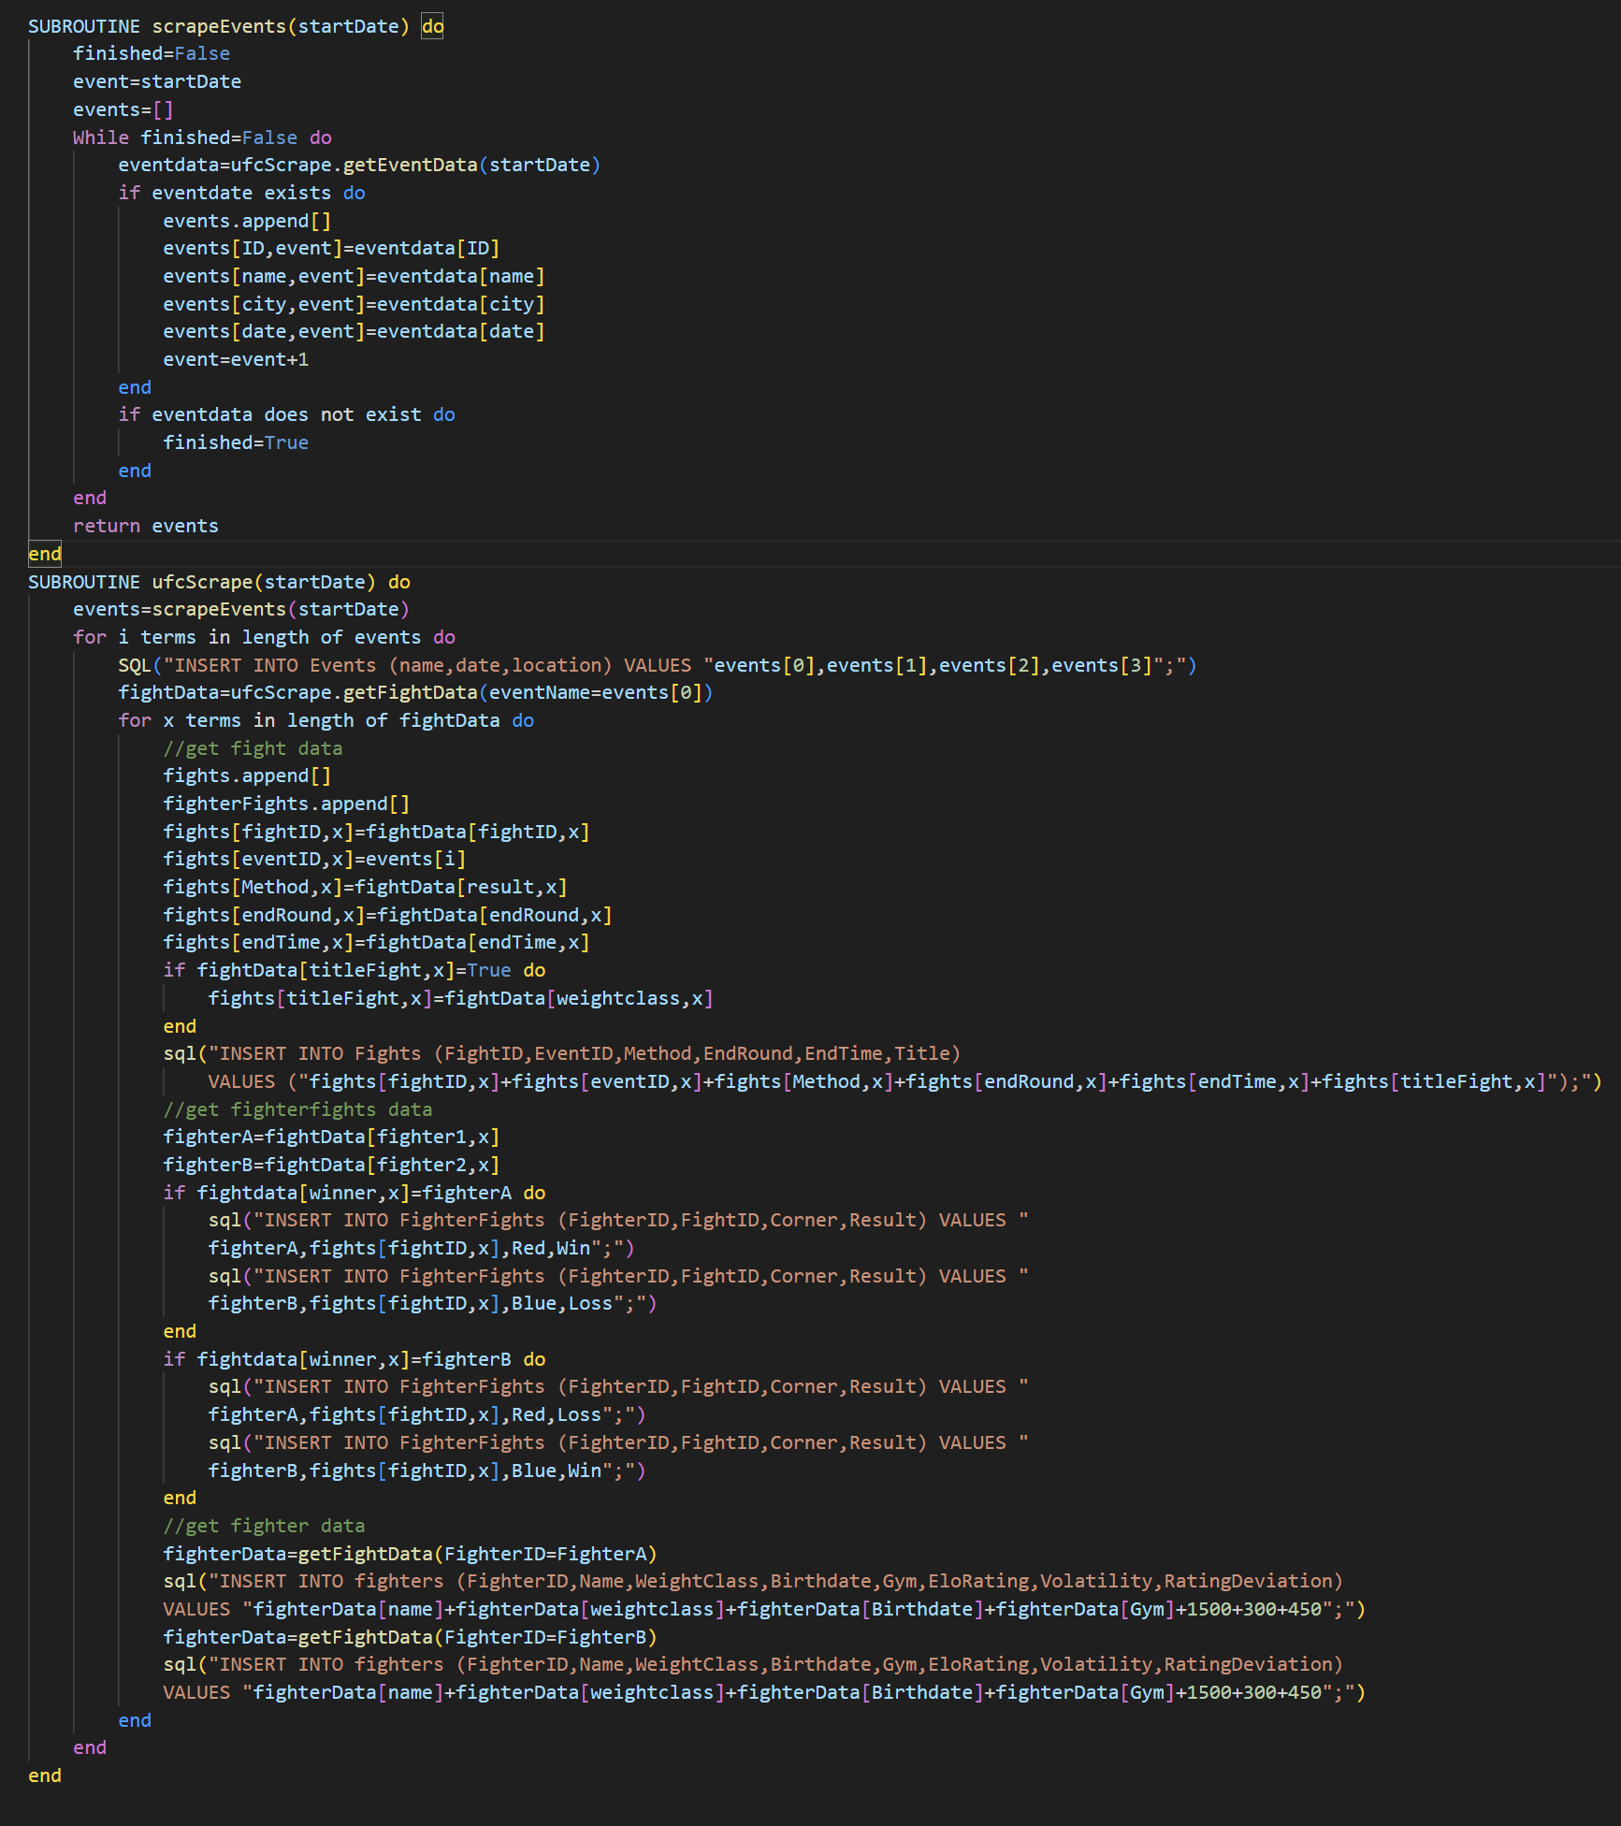
13  (Should be done on any ui input subroutine) | 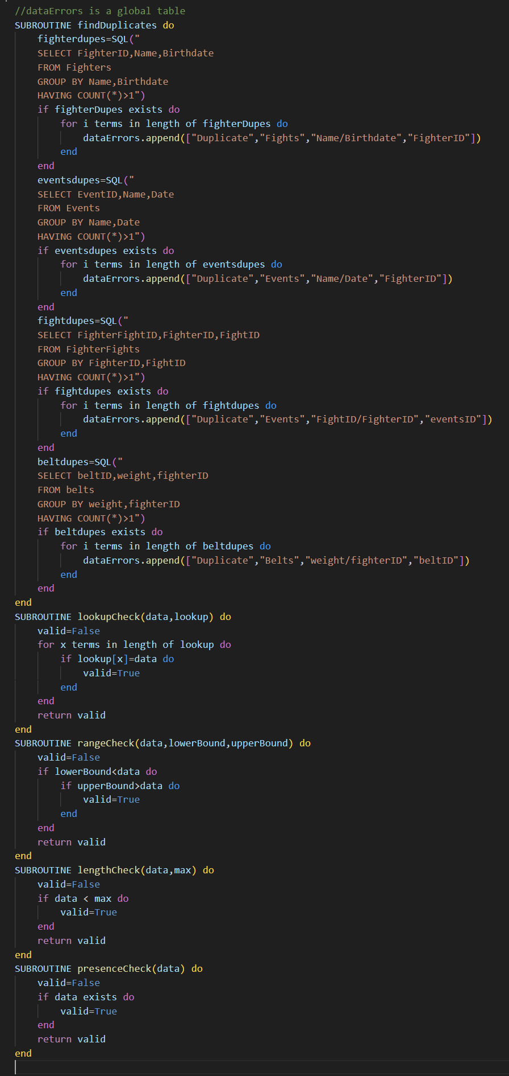
14 | 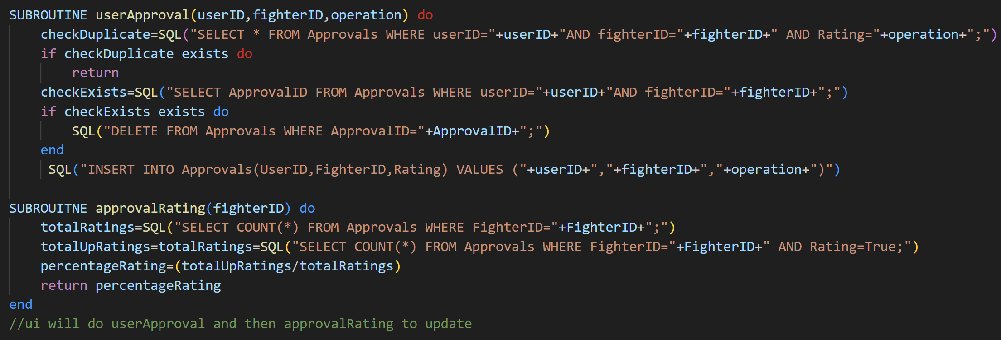
15 | 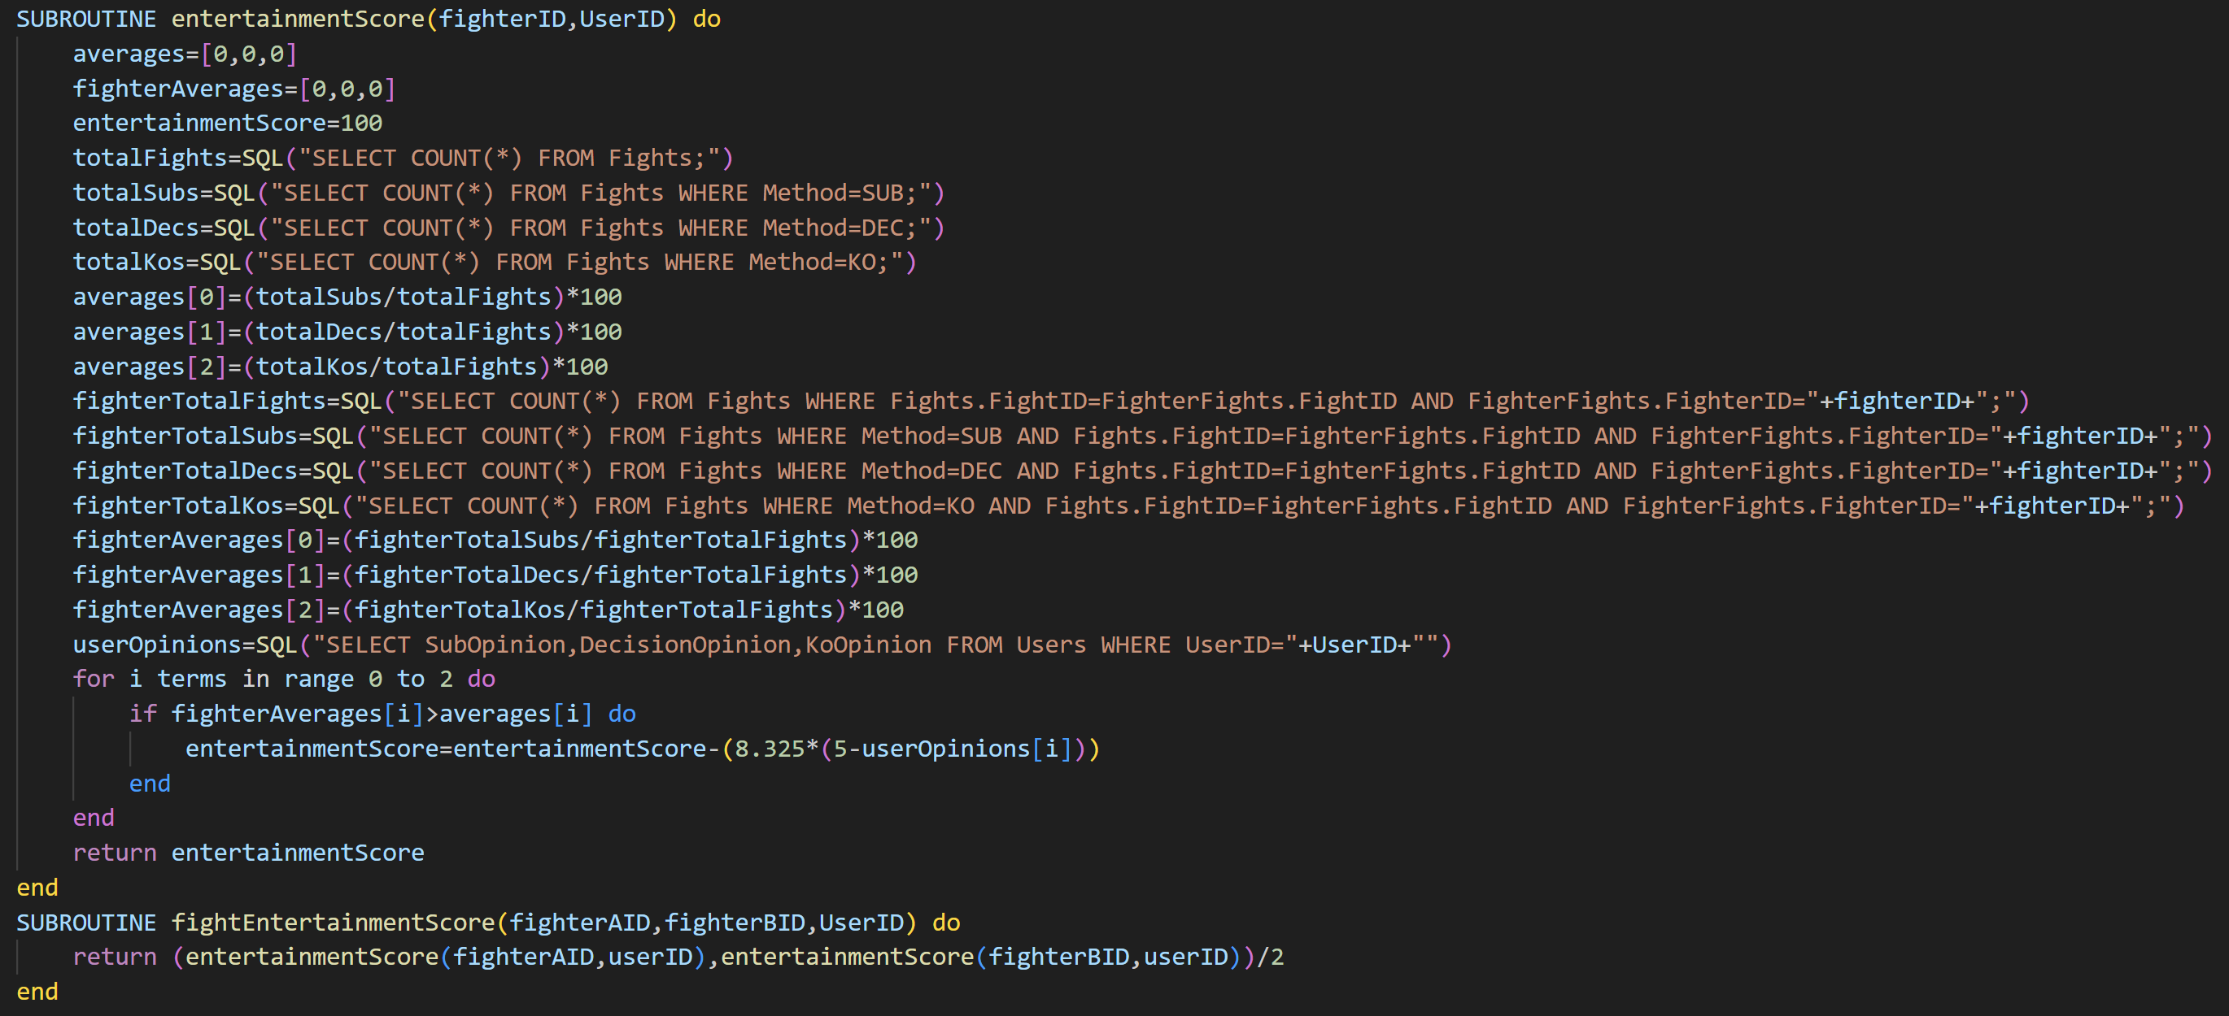
16 | 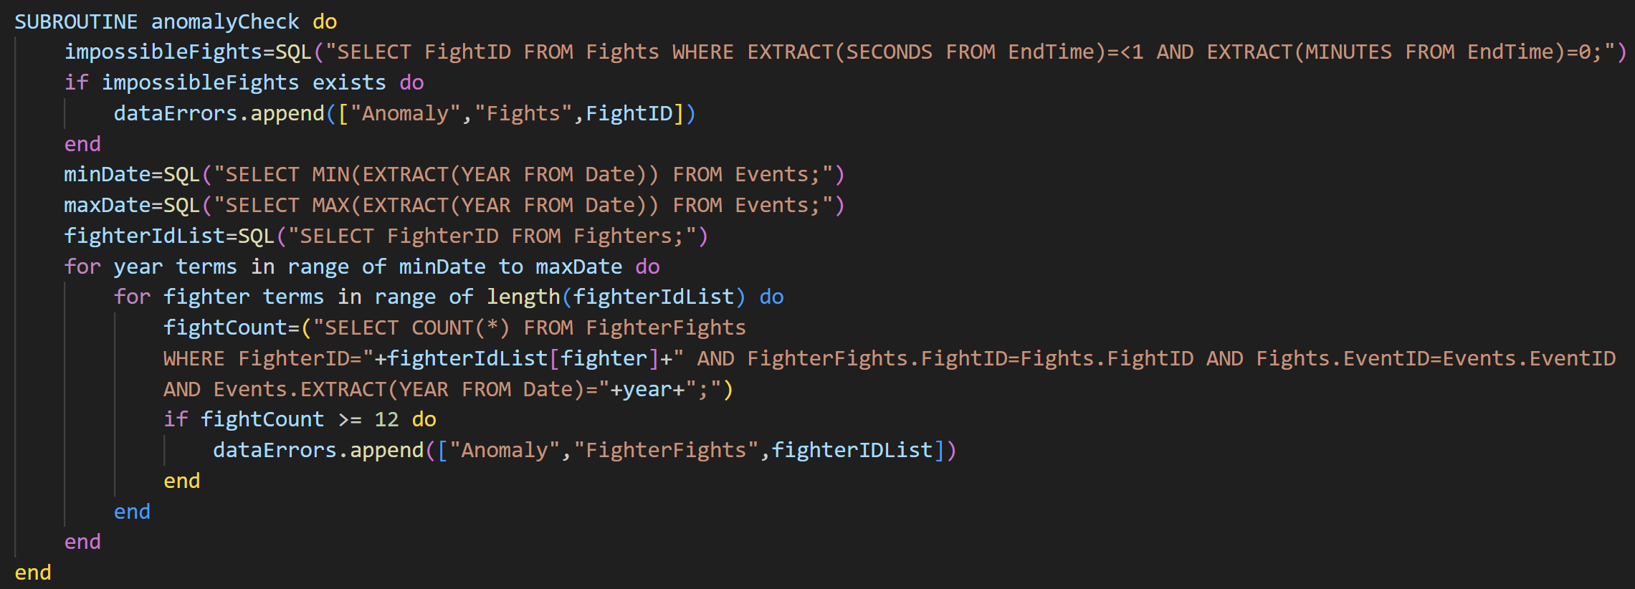
17.1 | 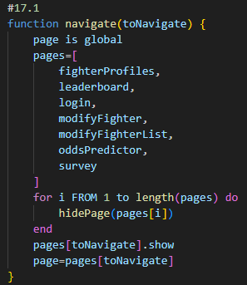
17.2 | 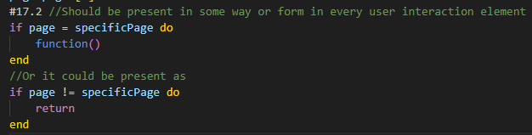
18 | 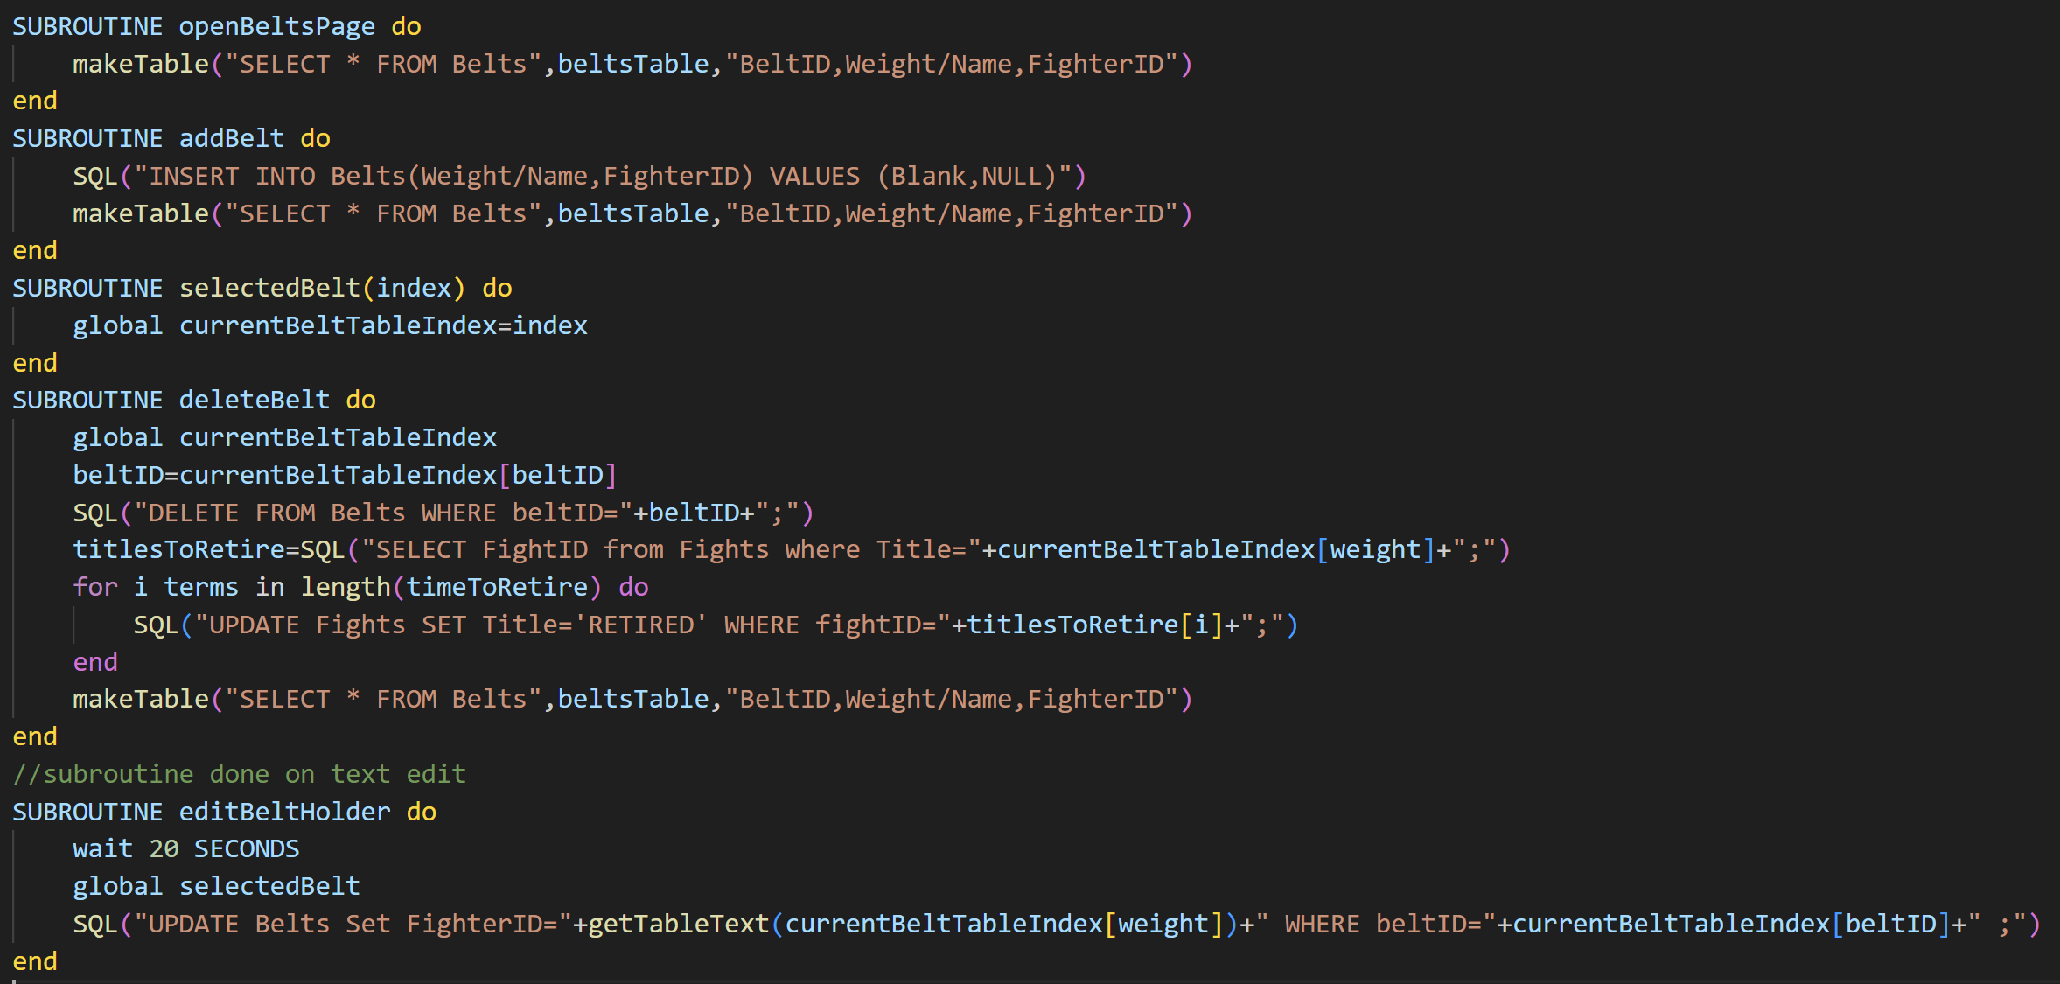
20 | 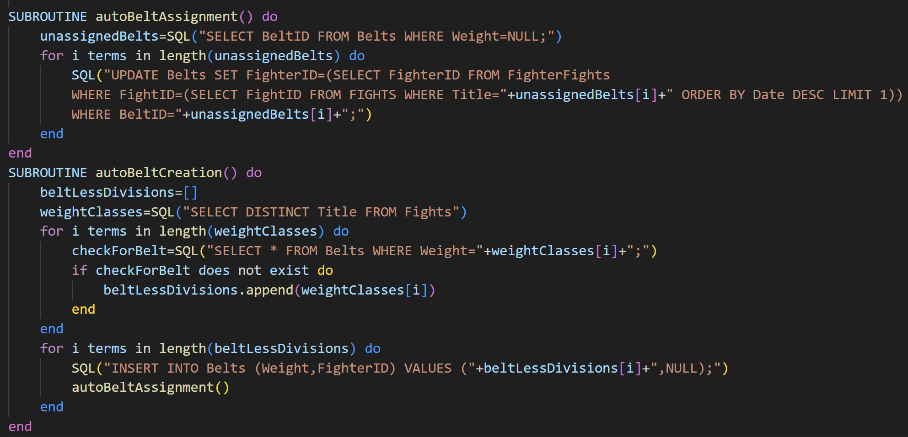
21.1 | 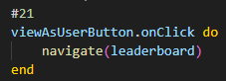
21.2 | 